CHAPTER 10
Q1: What is the purpose of using pen Blocks?
Ans: Pen Blocks provide a trail for the sprite and give instructions to change the colour, size and shade of the trail.
Q2: Write the shapes to draw a line in scratch.
Ans: The steps to draw a line are as follows.
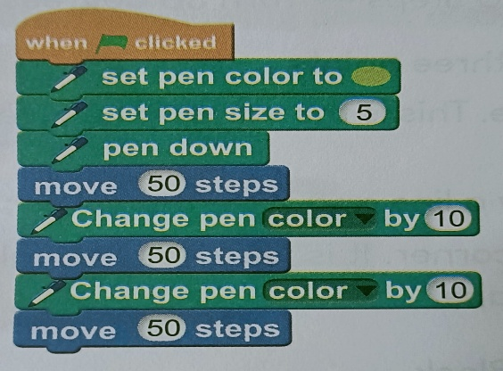

Q3: How does ‘Wait Block’ affect the execution of a script in scratch?
Ans: The wait block makes the script wait for number of seconds specified by us, before the next block follows.
Q4: Write the steps to draw a circle in scratch.
Ans: The steps are
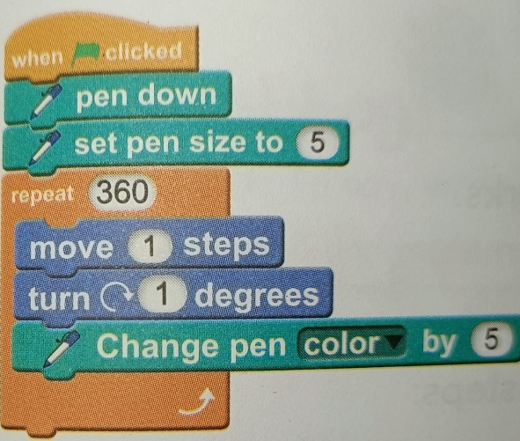
Q5: What is the function of “FOREVER” Blocks?
Ans: Forever block is used to make the sprite do something infinitely until a command is passed over it by the user

