MENSURATION
CASE STUDY
STD 8
- Raghu, who have bought a new house, wants to paint the walls and ceiling of his hall. The cuboidal hall is having length 25 m, breadth 20 m and its height 21 m.
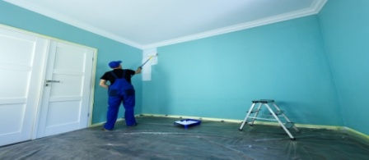
On the basis of above information, answer the following questions:
- Find the area of 4 walls.
- What is the total painted area?
- If from each can 30 square meter of area is painted, then how many cans Raghu need to paint 4 walls?
- Rahul and his brother were playing on the roof of his house. From the roof, they saw a water tanker, sprinkling the water on the road to reduce pollution level. Rahul noticed that water tanker was in the shape of cylinder whose diameter was 4 m written on the tanker.
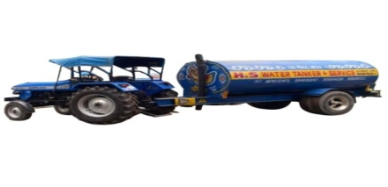
On the basis of above information, answer the following questions:
- If the length of the water tanker is 7 m, then find the volume of the tank.
- If the quantity stored in the tanker is 76000 litres, then find the length of the tanker.
- Find the total surface area of water tank, if its length is 5 m.
- Sourav after retirement thought to stay in village’s house. After going there he found there was shortage of water in village. So he thought of constructing a well. He hired some labourers and guided them that well should be 7 m diameter and 20 m deep.
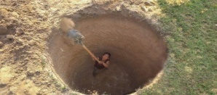
On the basis of above information, answer the following questions:
- What will be the radius of the well?
- What will be the volume of earth dug out?
- What will be the total surface area of the well?

- A village has a well which needs to be cleaned. It is a vertical open cylinder of radius 1.2 meter and height 5 meter. The well contains water to a depth of 3 meter.
On the basis of above information, answer the following questions:
- Find the amount of water in the well.
- Find the amount of water needed to fill the tank.
- Find the total surface area of the well to be cleaned.
- The area of the base of a cylinder is π(9a²–24a + 16) cm² and the volume of that cylinder is π (9a²–16)(3a–4) cm³.
Based on the above information, answer the following questions:
- Find the radius of the base of the cylinder.
(ii) Find the height of the cylinder.

