Detection of low quality cloves in cloves
Materials Required- glass beaker, cloves, water
Method- 1.Take some water in a beaker. 2.Put cloves.
Observation- Some cloves may float, some may settle down at the bottom.
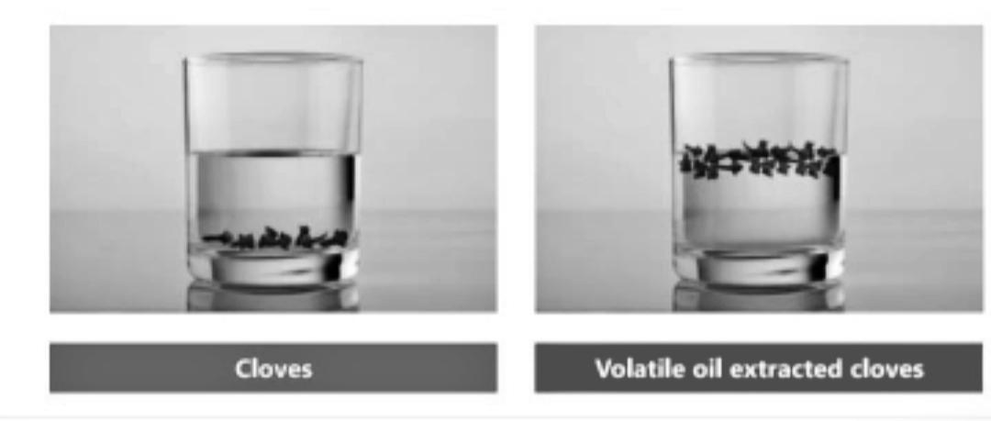
Inference- Genuine cloves will settle down at the bottom. Low quality cloves will float on the surface.
Detection of chalk in common salt
Materials Required- Beaker, salt
Method- 1. Take a beaker of water.
2. Add a small quantity of salt and dissolve in it.
Observation- Water may be clear or white.
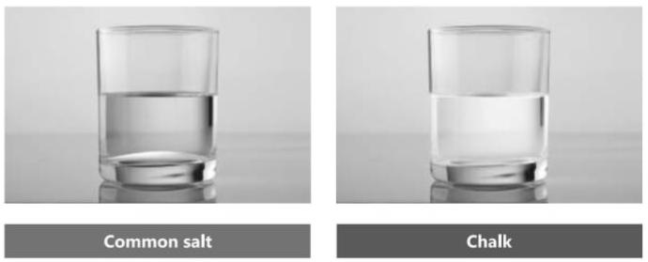
Inference- If chalk is present in salt, water will become white and insoluble particles will settle down in the bottom. There will be no change in colour of water if chalk is absent.

