A Seed Tells A Farmer’s Story
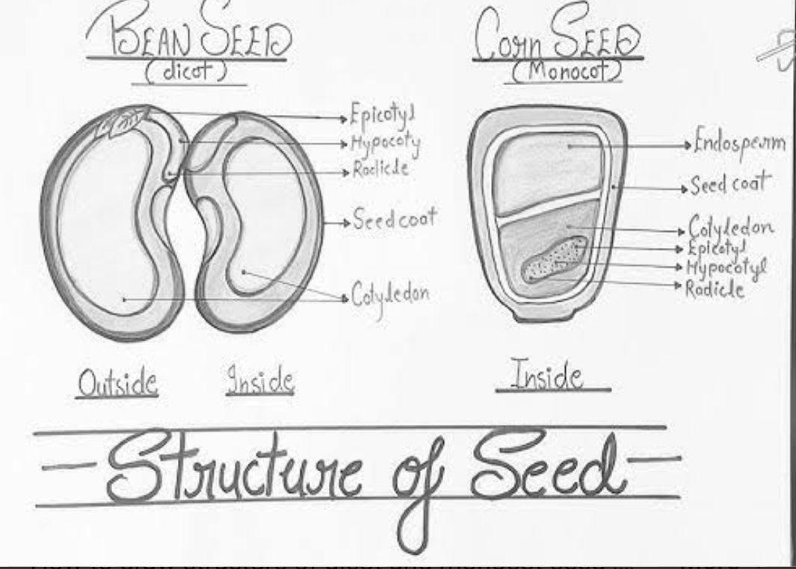

Monocot (monocotyledon) – It is a flowering plant whose seed contains one cotyledon (seed leaf).

Dicot (dicotyledonous)- It is a flowering plant whose seed contains two cotyledons (seed leaves).

Agriculture – It is the practice of cultivating soil, growing crops for food, fiber, and other useful products.

Traditional farming – It is a method of agriculture that uses age-old techniques, simple tools, and natural inputs with little use of modern technology.

Organic farming- It is a method of agriculture that uses natural inputs and processes to grow crops and raise animals without synthetic chemicals or genetically modified organisms.

Modern farming – It is a method of agriculture that uses advanced technology, machinery, improved seeds, and chemical inputs to increase crop production.

Q1.Trace the development of seed storage methods from traditional practices to modern scientific techniques.
Answer :Seed storage methods have developed from traditional practices like drying seeds in sunlight and storing them in earthen pots with neem leaves or ash for protection, to modern scientific techniques such as using moisture-proof containers, chemical treatments, cold storage, and seed banks to preserve seed quality and viability for longer periods.

Q2. After visiting an organic farm, what differences did you observe between organic farming and chemical farming?

Answer : I have observed that organic farming uses natural manure, compost, and biological pest control instead of chemical fertilizers and pesticides. The soil looked healthier, there were more insects and earthworms, and the farming methods were more eco-friendly and safe for the environment.

Q3 . " Hasmukh’s farm might become less fertile in the future" give reason for this statement .
Answer : Hasmukh’s farm might become less fertile in the future because the repeated use of chemical fertilisers and pesticides can damage the soil, reduce natural nutrients, and kill helpful organisms like earthworms.
Overuse of machines and too much watering from tube wells can also make the soil hard and less productive over time.
Q4 .All farmers in a region decide to grow only one kind of crop. Predict the possible effects of this decision on farmers, soil, and people.

Answer:If all farmers grow only one crop, the soil may lose certain nutrients quickly, making the land less fertile over time.
Pests and diseases could spread faster because they would find the same crop everywhere.
Farmers might face big losses if that one crop fails due to bad weather or disease.
People would also get less variety of food, which is not healthy. Growing different crops helps keep soil healthy, reduces risk, and provides a balanced diet.

Q5 . State the problems farmers face with modern farming.
Answer by students .

