Chapter – 26
Defence Officer Wahida Prism
Important Days
- Army Day - 15th January
- Navy Day - 4th December
- Air force Day – 8th October
Q.1 As per your understanding write about defence services.
Ans: Defence services are the armed forces—Army, Navy, and Air Force—that protect India’s borders, safety, and citizens from external threats. They work under the Ministry of Defence to maintain national security and help in rescue operations during disasters. These brave personnel wear uniforms and serve the nation.
2. Write the importance of defence services for a nation.
Ans:The key points are-
- Protection: They keep our country safe from enemies.
- Disaster Relief: They help people during emergencies like floods and earthquakes.
- Values: They teach us discipline, courage, and to love our country.
- Bravery & Sacrifice: Soldiers work in tough conditions (snowy mountains, hot deserts) to protect us.
- Equality: Women also serve as officers in the armed forces.

3.Write about parade in defence services.
Ans: A parade in the defence services is a formal, organized march or formation of soldiers, sailors, or air force personnel, often done to showcase discipline, teamwork, and precision. It involves marching in step, following commands.

- Wahida was a ‘Girl Guide’ at school.
  - What is a ‘Girl Guide’?
  - Write about the benefits of being a Girl Guide.
Ans: a) A Girl Guide is part of a global, fun, and adventurous organization for girls. It is a movement that helps girls become confident, independent, and responsible citizens.
b) Benefits of Being a Girl Guide-
- Confidence: It helps girls believe in themselves.
- Adventure: Girls get to try new activities like climbing, canoeing, and camping.
- Friendship: Making new friends and being part of a team.
- Service: Learning to help the community and the environment.
5.Define the term – ‘hospital on a ship’.
Ans: Each navel ship has one medical officer and two or three assistants. Necessary medicines and some equipment are kept in a small room on the ship. This is termed as ‘hospital on a ship’.
6.a)Wahida’s father called her prism from her childhood . Why?
b) What is a prism?
Ans :a)Wahida's father called her prism as he wanted her to be multi talented and shine like a prism.
  - A prism is a piece of glass which reflects7 colours when a ray of white light passes through it.
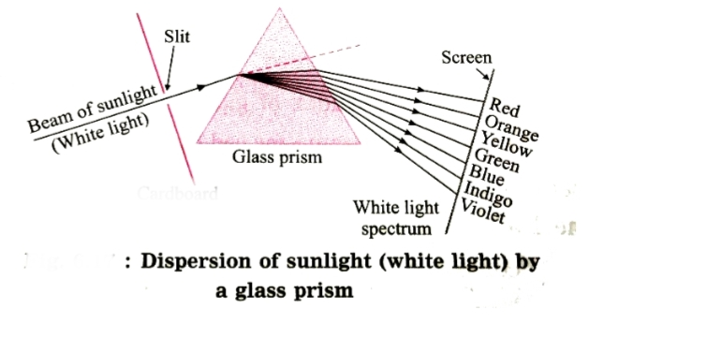

7. Write some common comments given during a parade (any five).
8. Write name of five occupations where people need to wear uniform other than Indian armed forces.
9. In Indian Navy a navel doctor does not chest give medicines to patients. What are the responsibilities of a medical officer on a naval ship?
Home work
10.Write about Submarine.
11. Girls going for higher education face a lot of problems. In fact , Wahida during her service period, waited for the opportunity to go in a Submarine. What do you think is the reason behind this?

