
SATISH CHANDRA MEMORIAL SCHOOL
ACADEMIC SESSION: 2025-26
CASE STUDY & ASSERTION-REASON QUESTION BANK-CLASS VII
SEGMENT: MENSURATION
CHAPTER 09: PERIMETER & AREA

$$CASE STUDY 01$$

After coming back from school, Rituja along with her two friends-Nitu and Baishali go to the playground regularly to ride the merry-go-round and play with it.
A roundabout or merry-go-round is a piece of playground equipment, a flat circular disk, about 3 m in diameter, with bars on it that act as both hand-holds and something to lean against while riding. The disk can be made to spin by pushing or pulling on its handles, either by running around the outside, or by pulling and re-grabbing as it spins, from a stationary stance.
The circular disk is divided into 8 equal sectors, out of which four are coloured red and rest of them are coloured black. There are four handholds of equal length at the edge of the flat disk from where children can take support while riding. The gap between any two successive handholds is 1.2 m. In the middle there is another circular shaped handhold of diameter 77 cm.
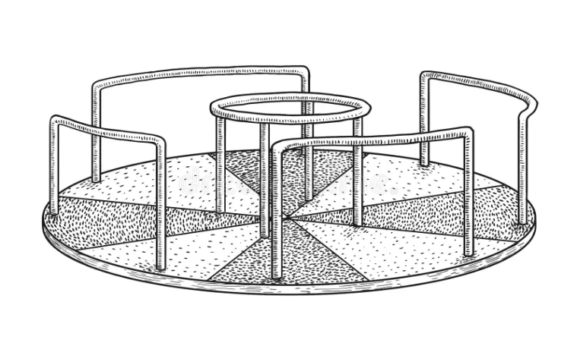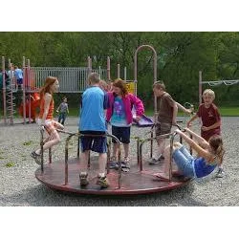
$$Q1. Find the area of the circular disk of the merry-go-round .\left(π=3.14\right)$$
$$Q2. Find the total sum of area of all red sectors on the circular disk \left(upto 2 decimal places\right).$$
$$Q3. Find the circumference of the circular ring of the handhold in the center\left(neglecting the width of the ring\right)$$
$$\left(π=\frac{22}{7}\right)$$
$$Q4. What is the length of each handhold at the edge of the circular flat disk ?\left(π=3.14\right)$$
$$Q5. If Rituja rode the merry-go-round for four consecutive rounds, then how much distance did she$$
$$cover?\left(π=3.14\right)$$

$$CASE STUDY 02$$

According to International Federation of Association Football rules, A standard football ground measurement should be 105 m x 68 m.The football ground has a center circle of radius of 9.15 m. A football game starts/resumes with a kick-off from the center spot at the start of each half and after the scoring of every goal. The team that concedes a goal restarts the play. The penalty area is the goalkeeper’s area and is marked by a rectangular box. The penalty area is 16.5 m deep and originates at 16.5 m from each goal post. The distance between the two penalty area lines remains at 40.3 m.
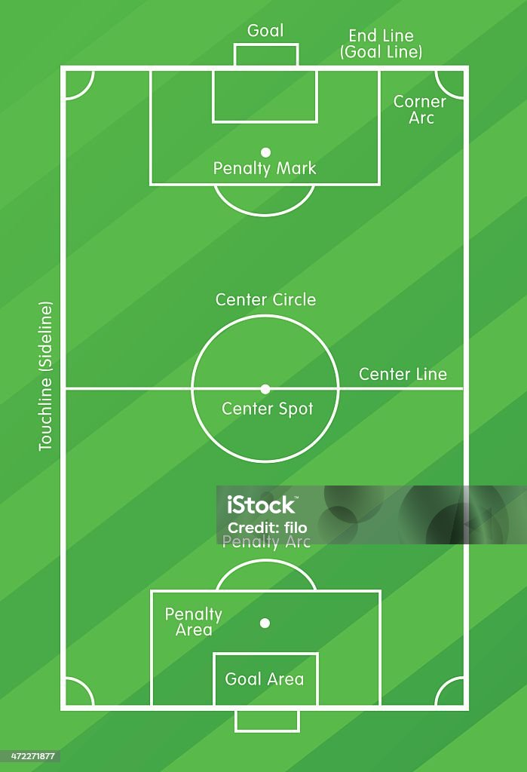
Q.1) Find the area of the center circle of a football ground upto two decimal places. (Take 𝜋 = 3.14)
Q.2) Find the area of a penalty box where the goalkeeper can penetrate.
Q.3) If a player takes5 rounds of the football ground for warming up, how much distance will he cover?
Q.4) find the area of the football field except two penalty boxes and the center circle.
$$CASE STUDY 03$$

A park has a semi-circular wooden bench placed around a tree, as shown in the image. The bench follows the curve of a semi-circle with a radius of 2.75 meters. The park management wants to calculate the length of the curved bench, the total area occupied by the bench, and the cost of adding a protective border along the curved edge.
Q1. What is the length of the curved part of the bench?
(Use π=3.14)

Q2. Find the total perimeter of the semi-circular bench, including both the curved and straight edges.
Q3.Calculate the area covered by the semi-circle if the bench is designed to occupy the full ground space within the curved boundary.
Q4.If the cost of adding a protective border along the curved edge is ₹150 per meter and the cost of polishing the bench surface is ₹200 per square meter, find the total cost for both improvements.

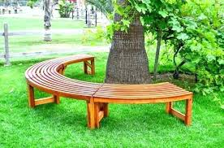
$$CASE STUDY 04$$

A packaging company is designing a unique storage box in the shape of a triangular prism to store stationery items like pens and pencils. The company needs to determine the perimeter of its triangular base and the surface area to calculate the amount of material required for production.
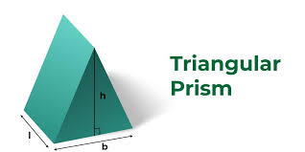
The company plans to manufacture the box with the following dimensions:
- Base of the triangular face (b) = 6 cm
- Height of the triangular face (h) = 5 cm
- Slant side of the triangle (s) = 7 cm
- Length of the prism (l) = 10 cm
Q.1) Find the perimeter of one triangular base of the prism.
Q.2) Calculate the area of one triangular base of the prism.
Q.3) Find the total area of all three rectangular faces of the prism.
Q.4) Calculate the total surface area of the triangular prism by adding the areas of all its faces.

$$CASE STUDY 05$$
A world-renowned architectural firm has designed this parallelogram-shaped office building to stand out along the waterfront. The structure's angled facade and geometric precision make it a perfect example of how mathematical concepts like height, perimeter, and area play a crucial role in construction. Engineers and architects must calculate these measurements to ensure stability, aesthetics, and space utilization.
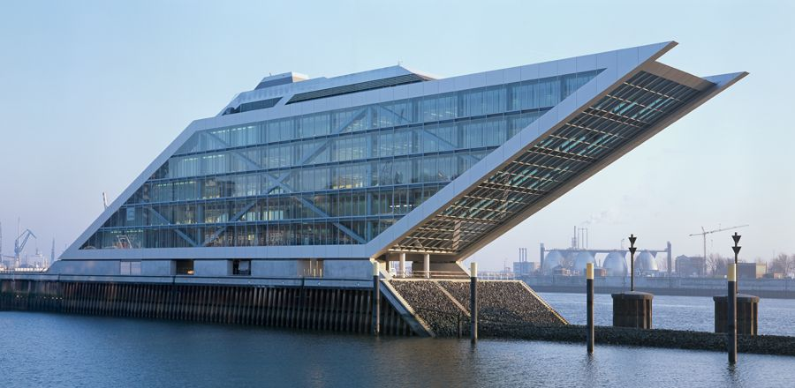
Given data for the building:
- Base (b) = 128.6 m
- Side length (s) = 157.4 m
- Height (h) = 95.8 m
Q1. Find the perimeter of the parallelogram-shaped building.
Q2. Calculate the area of the building’s front view (parallelogram-shaped facade).
Q3. If the base increases by 15%, find the new area of the building's facade.
Q4. Suppose an elevator needs to travel $\frac{3}{4}$ of the exact vertical height of the building. Find the height that the elevator needs to reach.
$$Assertion-Reason Based Questions$$
$$INSTRUCTIONS: All the questions given below are Assertion\left(A\right) and Reason(R) based$$
$$questions. Two statements are given, one labelled as Assertion(A) and$$
$$the other is labelled as Reason(R). Select the correct options from$$
$$the codes \left(a\right), \left(b\right), \left(c\right), \left(d\right)as given below.$$
$$\left(a\right) Both Assertion\left(A\right) and Reason\left(R\right) are correct and Reason\left(R\right) is the correct explanation$$
$$of Assertion(A).$$
$$\left(b\right) Both Assertion\left(A\right) and Reason\left(R\right)are correct but Reason(R) is not the correct explanation$$
$$of Assertion(A).$$
$$\left(c\right)Assertion\left(A\right) is true but Reason(R) is false.$$
$$\left(d\right)Assertion\left(A\right) is false but Reason(R) is true.$$
$$Q1. Assertion(A): The perimeter of a parallelogram is the sum of the lengths of all its sides.$$
$$Reason(R): The perimeter of a parallelogram is twice the sum of the lengths of its$$
$$adjacent sides.$$

$$Q2. Assertion(A): The area of a circle is π times the square of its radius.$$
$$Reason(R): The area of a circle is π times the square of its diameter.$$

$$Q3. Assertion(A): The perimeter of a parallelogram can be calculated by adding the lengths$$
$$of its diagonals.$$
$$Reason(R): The diagonals of a parallelogram bisect each other.$$

$$Q4. Assertion(A): The circumference of a circle with a radius of 7 cm is 44 cm.$$
$$Reason(R): The circumference of a circle is 2π times its radius.$$

$$Q5. Assertion(A): The area of a triangle with base 15 cm and height 8 cm is 60 {cm}^{2}.$$
$$Reason(R): The area of a triangle=2×base×height$$

