SATISH CHANDRA MEMORIAL SCHOOL
ANNUAL EXAM SUB- COMPUTER
PRACTICAL EXAM
1. CREATE THE BELOW GIVEN TABLE IN EXCEL BY FOLLOWING GIVEN RULES:
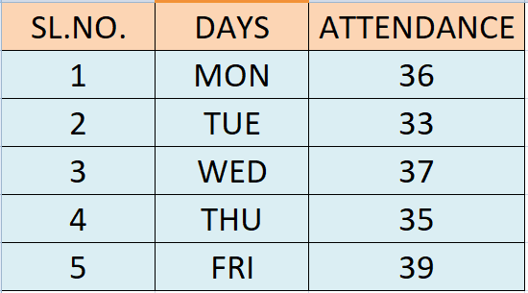
i. Apply Autofill feature for filling SL.NO. and DAYS.
2. CREATE A SCRATCH PROJECT BY USING ‘ASK A QUESTION’ BLOCK.

