Class IV HOTs
FM. –16
1. Assertion (A): The Indian Army soldiers serve in very
difficult places like the Siachen Glacier.
Reason (R): They protect the country’s borders from
external threats.
a. Both A and R are correct and R is the correct explanation of A.
b. Both A and R are correct and R is not the correct explanation of A.
c. A is true R is false.
d. R is true A is false.
2. Assertion (A): Roots absorb water and nutrients
from the soil.
Reason (R): Roots grow towards the sunlight to
make food.
a. Both A and R are correct and R is the correct explanation of A.
b. Both A and R are correct and R is not the correct explanation of A.
c. A is true R is false.
d. R is true A is false.
3. Mid day meal provides meal to students of
elementary school. The meal is
a. Cheap in nutrition
b. Balanced in money
c. Balanced in nutrition
d. Balanced in amount
4. If you have to make a dish without red chilli but
want it to be hot, what can you use?
- Cumin. b.black pepper
c.clove. d.asafoetida

5. There are_______ molars in each jaw in a human adult.
a. 4. b. 5. C.6. d.8
6. In a Langar, the food is served to everyone without
any discrimination. What does this mean?
a. Only rich people can eat.
b. Only children can eat.
c. People of any religion, caste, or gender can eat.
d. Only those who work in the kitchen can eat.
7. I am a green pod with a fresh, sweet, and pungent
aroma, often added to both sweet and savory dishes.
- Cardamom. b. Poppy
c.Green chilli. D. Mustard
8. If a factory is built on the bank of a river, what is the
best way to prevent the river from getting polluted?
a. Allow the factory to throw waste only at night.
b. Treat the chemical waste before releasing it
into the river.
c. Build a tall wall around the factory.
d. Close the river for public use.
9. A visually impaired person is a person
who is-
a.Deaf. b.Dumb
c.Blind. d. Lame
10. If a ray of white light is passed through a prism, it splits into a spectrum. What is this phenomenon called?
a. Reflection
b. Refraction
c. Dispersion
d. Absorption

11. A weaver bird makes a nest that hangs from
a tree, often woven by ________.
a. Female weaver bird
b.Male weaver bird
c. Both male and female
d. Tailor bird
12. .The "quarrel over the TV program" between family members show-
a. Families never share.
b. Everyone has the same preferences.
c. People in a family have different tastes and ideas.
d. There is only one type of television program.
13. When you see a stranger offering you to give a lift in his /her
car what should you do?
a.Inform elders b.Say NO
c.Accept the offer d.Both a and b
14. Fish live in water and takes the oxygen from water.
This is because –
a.Oxygen is soluble in water.
b.Oxygen forms bubble in water.
c. Fish drink water and get the oxygen.
d.Gases do not dissolve in water.

15. Label the given diagram-
a. i.charcoal, ii. Stones, iii.coarse sand, iv. Fine sand.
b.i. Stones, ii. Coarse sand, iii. Charcoal, iv. Fine sand.
c.i. Coarse sand, ii. Stones, iii. Charcoal, iv. Fine sand.
d. i.Fine sand, ii. Charcoal, iii. Coarse sand, iv. Stones.
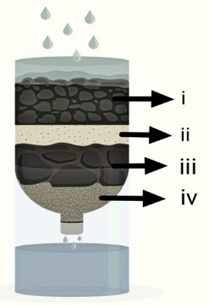

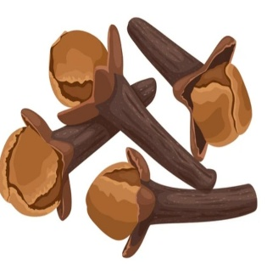
16.
This spice is not used for –
- Oral health
- Gum pain
- Toothache
- Healing wounds

