Identify the keys of keyboard and write it’s name in the given space:
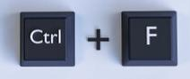
1.

2.

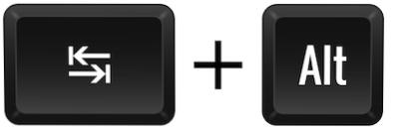


3.

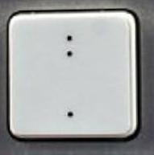
4.

