Map pointing
States with thin forest
- Haryana
- Punjab
- Rajasthan
- Uttar pradesh
- Gujarat
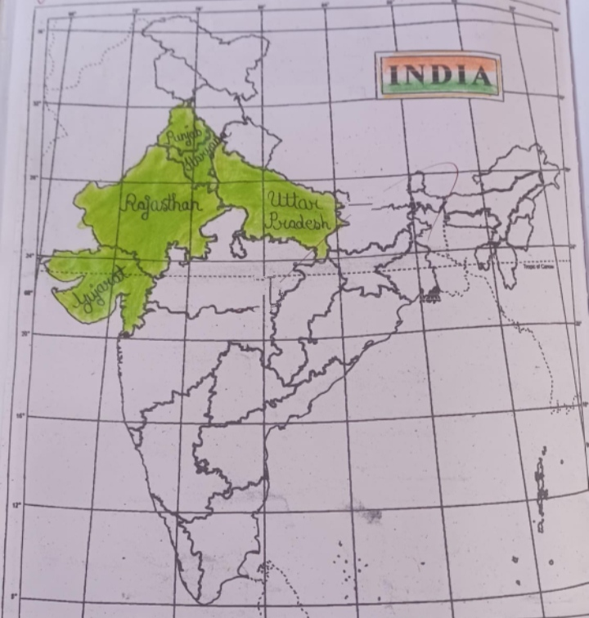

States with thick forest
- Madhyapradesh
- Arunachal pradesh
- Chhattisgarh
- Orissa
- Maharashtra
