Answer the following questions .
Q1 .Explain the adaptations of floating plants with examples.
Answer
- They have large air spaces that help them float on water.
- Their leaves are broad and flat to receive maximum sunlight.
- Leaves have a waxy surface to repel water.
Example – By students
Q2.Explain how salt is produced from seawater in Gujarat?
- Salt in Gujarat is produced through the evaporation of seawater in shallow ponds called salt pans.
- Seawater is allowed to flow into these pans and is then left under the sun.
- Due to the high temperature and strong sunlight, the water evaporates, leaving behind salt crystals that are collected and processed.
Q3.Write difference between Animals on land and animals on water.
Answer by students

Activity Based question
Q4 .
Look at picture and answer the following:
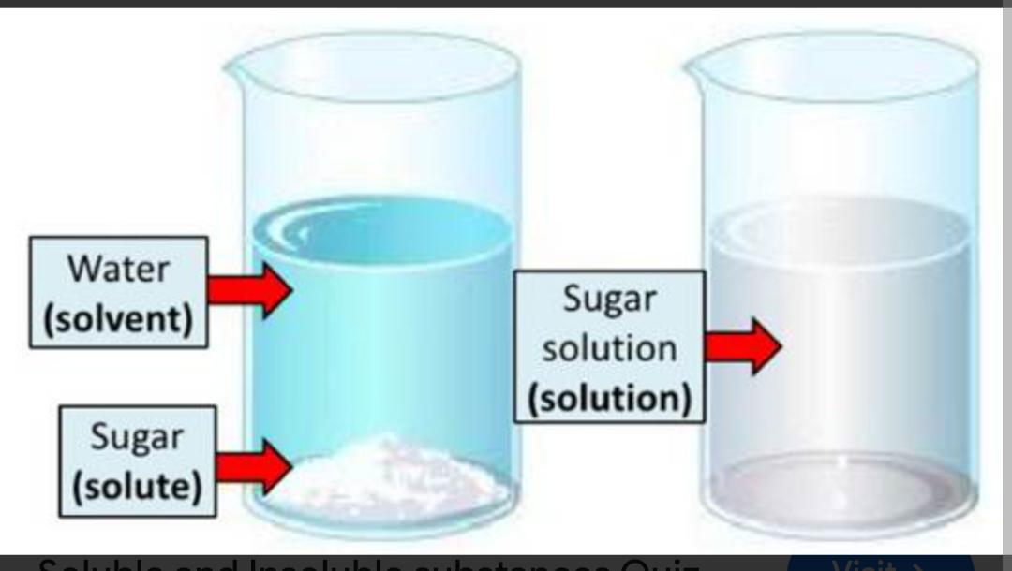
a.After stirring sugar in water, you cannot see it anymore. Where did it go?
Answer by Students
b. Write Difference between soluble and insoluble substance.
Answer - A soluble substance dissolves completely in a liquid (e.g., sugar in water), forming a solution. An insoluble substance does not dissolve and often forms a suspension (e.g., sand in water).

