CLASS TEST. F.M. 10
OBJECTIVE TYPE QUESTIONS:- (1×4=4)
1. Statement I: Ladakh is known as a cold desert.
Statement II: It receives very little rainfall due to its location in the rain shadow region.
A. Both Statement I and II are correct, and II explains I
B. Both Statement I and II are correct, but II does not explain I
C. Statement I is correct, but II is incorrect
D. Statement I is incorrect, but II is correct

2. Which evidence best supports that the Himalayas are young fold mountains?
A. Presence of volcanic rocks
B. Smooth and low hills
C. High peaks with sharp and rugged features
D. Absence of rivers

3. Kumbhalgarh Fort is built in the Aravalli Range. What is the most likely reason for choosing this location?
A. It provided fertile land for farming inside the fort
B. It made trade and transport easier for merchants
C. It ensured easy availability of river water nearby.
D. It acted as a natural barrier, making enemy attacks difficult

4. Assertion (A): The Western Ghats create a rain shadow region on the Deccan Plateau.
Reason (R): The Eastern Ghats are lower in height compared to the Western Ghats.
A. Both A and R are true, and R is the correct explanation
B. Both A and R are true, but R is not the correct explanation
C. A is true, but R is false
D. A is false, but R is true

SUBJECTIVE BASED QUESTIONS:-
5. In the water-scarce region of Rajasthan, people developed unique methods to store every drop of water. What are tankas, and how do they help people in such dry conditions? (3)

6. Study the satellite image showing uneven distribution of lights and identify the area. Why are some regions more brightly lit than others? (3)
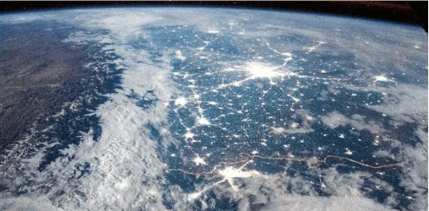

2.If you were to compare the Western Coastal Plains with the Eastern Coastal Plains, which of the following statements accurately reflects a key physical difference between them?
- ​A. The Western Coast is much broader than the Eastern Coast.
- ​B. The Eastern Coast is characterized by large deltas formed by rivers like the Mahanadi and Godavari.
- ​C. The Western Coast is a submerged coast with no natural harbors.
- ​D. The Eastern Coast is bordered by the Arabian Sea.

6. Imagine you are a structural engineer tasked with building a major highway connecting the Northern Plains to the Himalayan highlands. Identify the specific geological challenges you would face when moving from the Shiwaliks to the Himadri. How would the physical characteristics of these divisions dictate your construction strategy? (3)

