Chapter -2
JOURNEY OF A RIVER

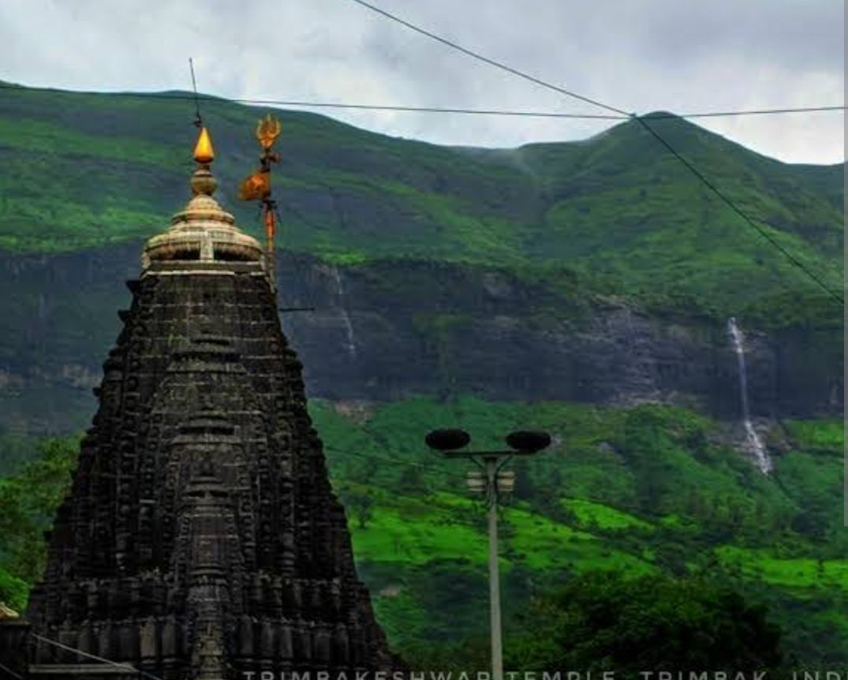
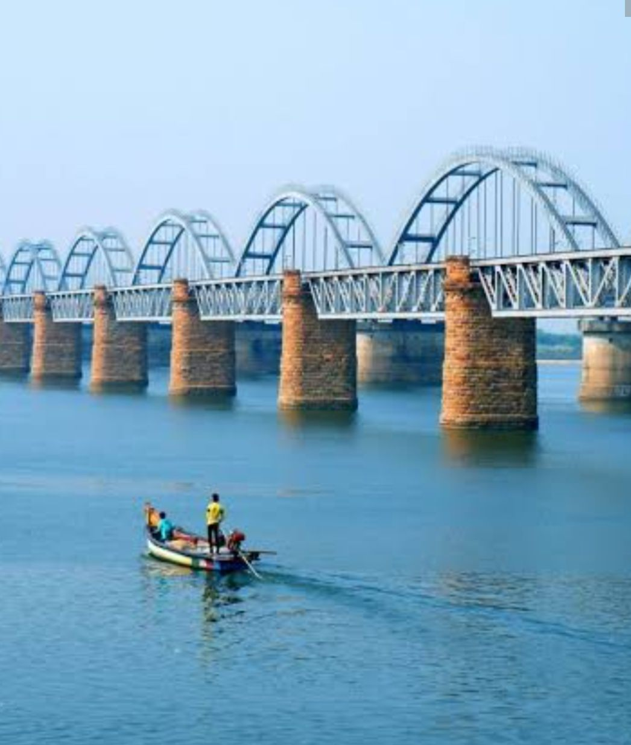
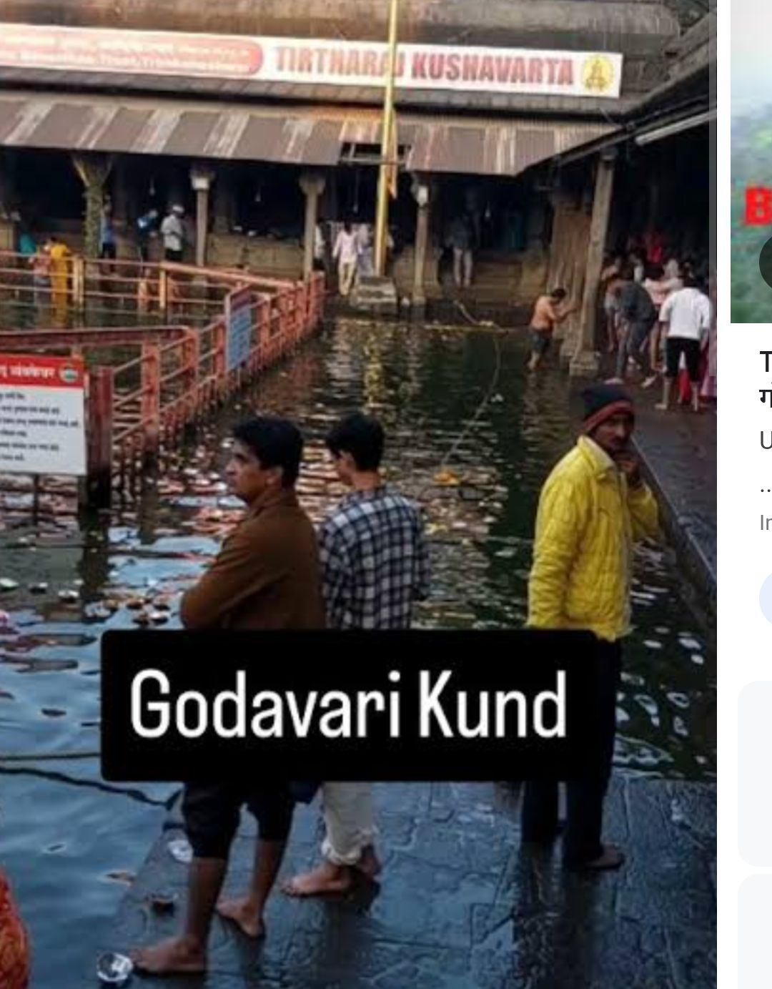
Today We will know about River Godavari
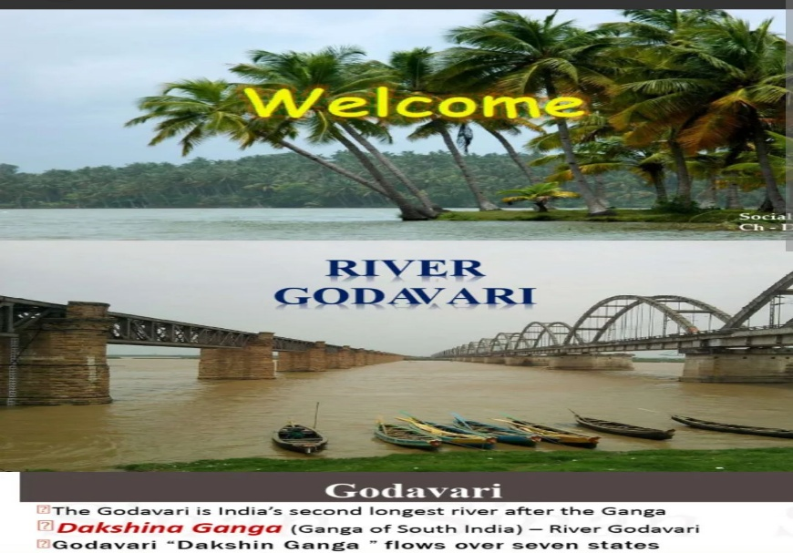

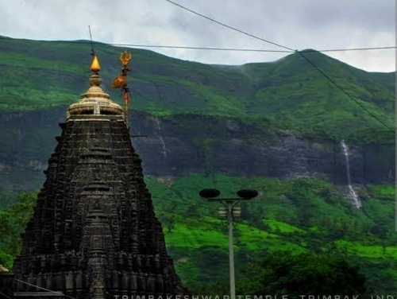
Godavari River
Origin: My journey begins high up in the Western Ghats at Trimbakeshwar in Maharashtra
Growth: Although I start out as a stream, as I move across the land, rainwater and other streams join me, making me wider and stronger.
Tributaries: The small streams joining me are called tributaries
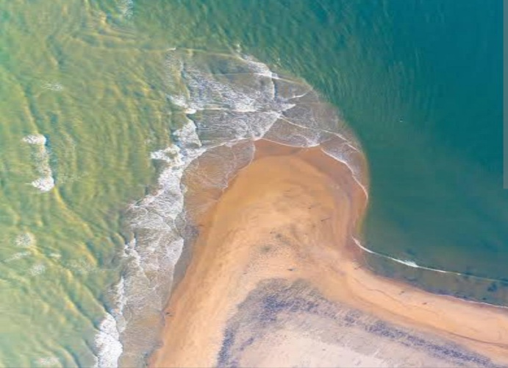
Length and Destination: I travel 1,465 kilometers before joining the Bay of Bengal.
Ranking: I am the second longest river in India after river Ganga.

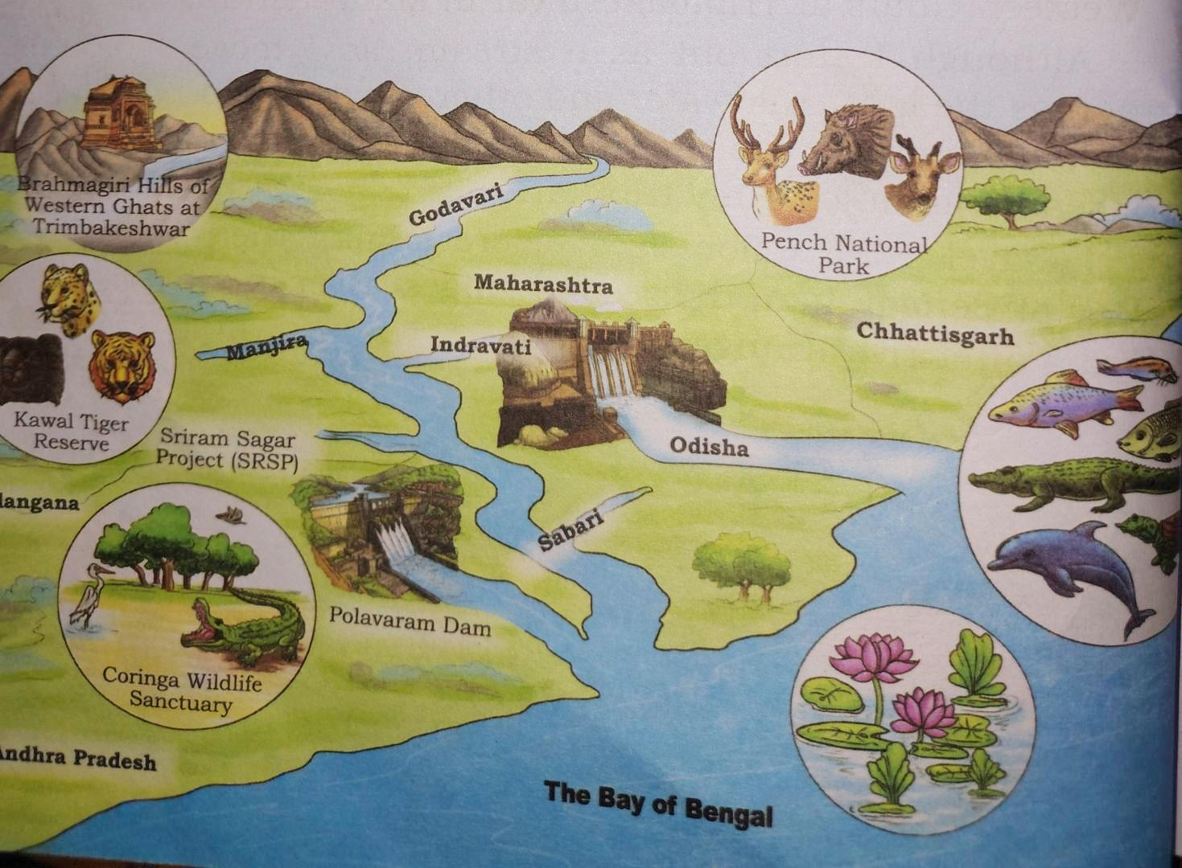
Observe the given picture carefully
Stories from Ramayana and Puranas
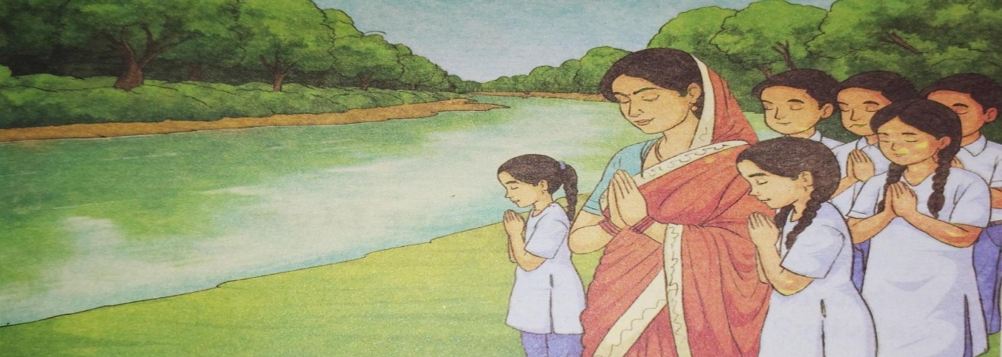
There are fascinating stories from the Ramayana and the Puranas.
I am called Dakshina Ganga because I flow through southern India and am the second longest river in India
In places like Nashik, devotees come from all around to take a dip in my holy waters during events like the Godavari Pushkaram."
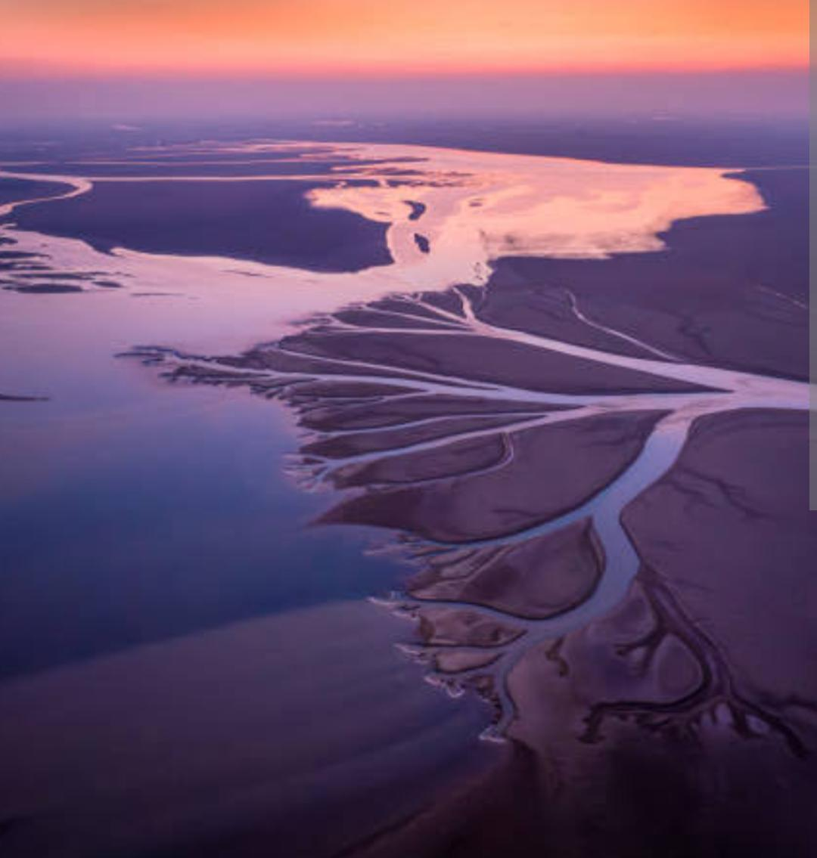

I spread out into many small streams that form a triangle shape. I meet the salty sea there. This place is called the delta.
It is where my journey ends
Side Note:Why delta Called (referring to the origin of the term based on the Greek letter ∆ Delta

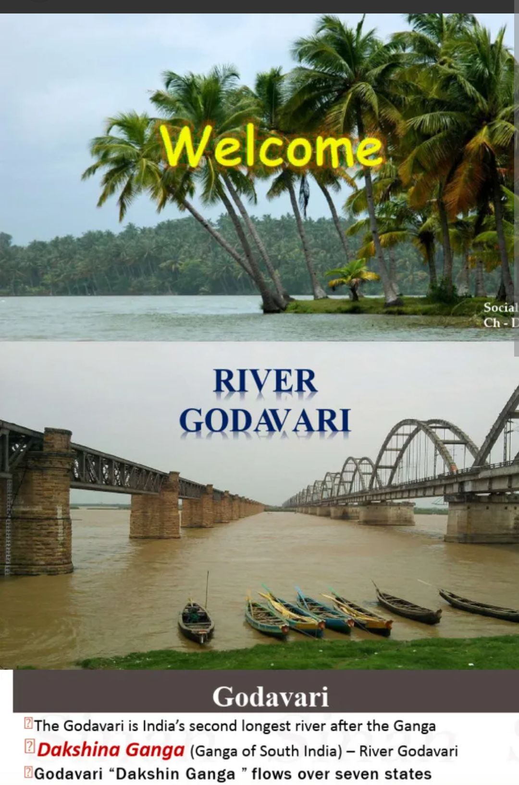
flow all year which makes me a perennial river.

Example of some Perennial rivers –
• Ganga (Ganges). • Brahmaputra
• Indus & Tributaries. • Yamuna

Seasonal rivers
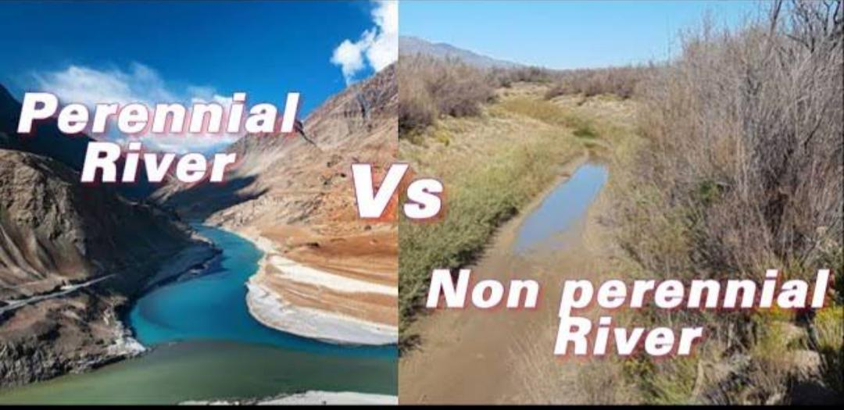
Some rivers flow only during the rainy season, which makes them seasonal."
Seasonal Rivers: These are rivers that do not have a constant flow of water year-round.
Rain-fed: Unlike perennial rivers (like the Ganga) that are fed by melting glaciers, seasonal rivers rely primarily on monsoon precipitation
Flow Variability: These rivers often experience high water levels and flooding during the wet season but may dry up completely during the summer or dry months.

Example of some seasonal rivers :
• Luni. • Godavari• Krishna & Kaveri• Mahanadi & Tapi

