EARLY HUMANS & THE
BEGINNING OF CIVILIZATION
CBSE Class IX Social Science | NCF 2023 Aligned Study Material

Understanding History
Definition: History is the systematic study and documentation of the human past. It is not just a collection of dates and names, but a continuous process of interaction between the historian and their facts, an unending dialogue between the present and the past. Derived from the Greek word 'historia' (meaning inquiry or knowledge acquired by investigation), history helps us understand how our societies, cultures, and identities have evolved over millennia.

Difference between History and Prehistory

Feature Prehistory History
Definition | The period of human past before the invention of writing. | The period of the past that is recorded in written form.
Sources | Purely archaeological (fossils, stone tools, pottery, cave paintings). | Literary sources (manuscripts, inscriptions) as well as archaeological evidence.
Timeframe | From the origin of humans to roughly 3500-3000 BCE. | From the development of writing systems to the present day.

Periodisation of Prehistory

The prehistoric period is primarily classified based on the type of tools and technology used by humans. This is often referred to as the "Three-Age System" (Stone, Bronze, and Iron), though the Stone Age itself is divided into distinct stages. Periodisation (chronology) is an essential method used by historians and archaeologists the vast and continuous flow of human history into meaningful segments. Since history stretches over millions of years, it would be very difficult to study and understand it without dividing it into clear phases. By classifying the past into periods such as the Stone Age, Metal Age, Prehistoric and Historic periods, scholars are able to trace patterns of development and identify points in human progress. Each period reflects significant changes in technology, economy, social organisation, political systems, and cultural life.

The Stone Age

The Stone Age is the earliest and longest period in human history. It began about 2.5 million years ago and lasted until humans started using metals around 3000 BCE (commonly in many regions). It is called the Stone Age because early humans primarily used stone to make tools and weapons. This long period witnessed the gradual development of human intelligence, skills, social life, and culture. During the Stone Age, humans moved from a simple hunting lifestyle to settled agricultural communities. This is age further divided into three ages.
  - Palaeolithic Age (Old Stone Age : Timeline: c. 2.5 million years ago – 10,000 BCE)
The Palaeolithic Age is the longest and earliest phase of the prehistoric stage. During this period humans lived as hunter-gatherers. They hunted wild animals, caught fish, and gathered fruits, nuts, and roots for food. People lived in caves, rock shelters, or temporary huts made of branches and animal skins. Stone tools were simple and rough, usually made by chipping stones. Humans discovered the use of fire, which helped them cook food, keep warm, and protect themselves from wild animals. Cave paintings found in places like Bhimbetka (India) and Lascaux (France) show early forms of art and communication, depicting hunting scenes and animals. Social life was simple, and people lived in small groups.

    - Lifestyle: Humans were nomadic hunter-gatherers. They did not produce food but collected it from nature. For most of early human history, humans lived as hunter-gatherers. This means they survive hunting wild animals, fishing, and collecting edible plants, fruits, nuts, and roots. The hunter-gatherer lifestyle required mobility. Early humans did not establish permanent settlements but lived in temporary shelters such as caves, rock overhangs, or simple huts made from branches and animal skins. Hunting demanded cooperation and planning. Groups worked together to track and capture animals using stone-tipped spears and other tools. Gathering activities were equally important, as plant-based foods provided a reliable source of nutrition. This way of life encouraged strong group bonds, sharing of resources, and collective decision-making.
    - Tools: One of the defining features of early human history is the gradual improvement in tool technology. Early humans created tools primarily from stone, but also used wood and bone. The earliest tools were simple flakes and choppers. Over time, they became more specialised and efficient. Hand axes, scrapers, spear points, and blades reflect increasing craftsmanship and understanding of materials. Tool-making was not merely a practical activity but also evidence of learning and teaching. Knowledge the of how to shape stones was passed from one generation to another, indicating the existence of cultural transmission. Technological advancements greatly enhanced survival. Improved tools allowed humans to hunt larger animals, process food more effectively, and defend themselves against predators.
    - Discovery: The most significant achievement was the discovery of fire.
    - Shelter: Lived in caves and rock shelters to protect themselves from wild animals and weather.
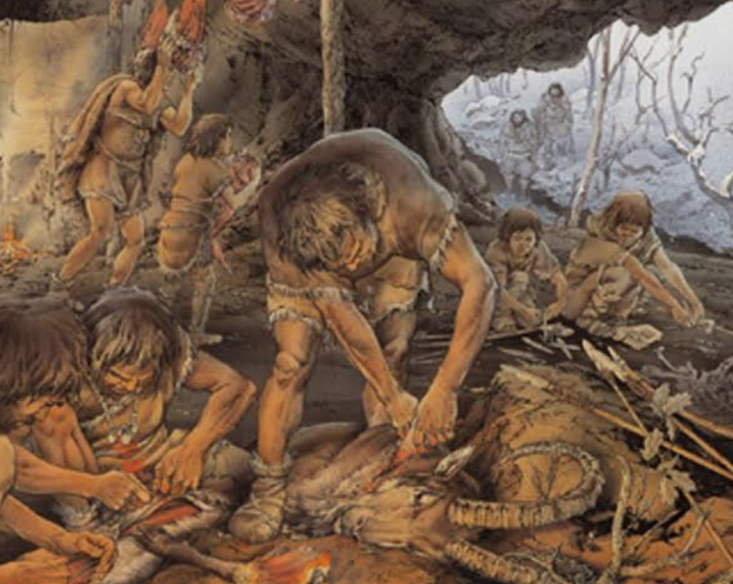

  - Mesolithic Age (Middle Stone Age:Timeline: c. 10,000 BCE – 8,000 BCE)
The Mesolithic Age represents an important transitional phase in human history between the Palaeolithic (Old Stone Age) and the Neolithic (New Stone Age). In the Indian subcontinent, this period roughly dates from about 10,000 BCE to 6,000 BCE, though in some regions it continued even later. It was a time of gradual transformation rather than sudden change. Human beings were still largely dependent on hunting, fishing, and gathering wild plants, but important developments began that eventually led to the production of food. For this reason, the Mesolithic period is considered a bridge between a purely food-gathering economy and an agricultural economy.

    - Mesolithic Sites : Archaeological evidence from various Mesolithic sites in India provides valuable information about this period. The Bhimbetka Rock Shelters are among the most important Mesolithic sites. The rock shelters contain paintings that depict hunting scenes, dancing, and daily activities, giving insight into the social and cultural life of Mesolithic people. These paintings, often made with natural colours such as red ochre, show groups of hunters using bows and arrows, which indicates technological advancement.
    - Tools: The most characteristic feature of the Mesolithic period was the use of microliths, which were small stone tools usually measuring between one and five centimeters. These tools were made of materials such as flint, chart, and jasper: They were carefully shaped into blades, points, scrapers, and burins. Often, microliths were fitted into wooden or bone handles to create composite tools like arrows, spears, and sickles. This shows that Mesolithic people had developed more refined and efficient technology compared to earlier periods. In addition The stone tools, bone tools such as needles, fish hooks, and harpoon were also used, indicating the importance of fishing and clothing preparation.

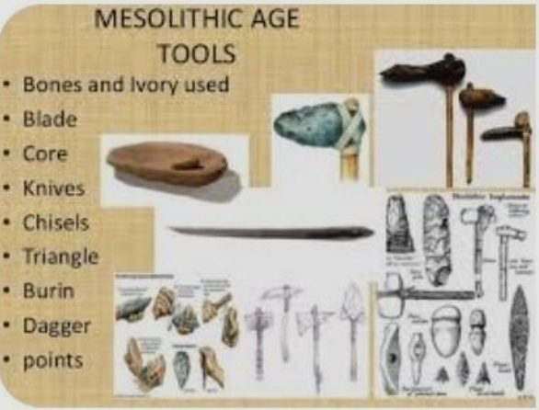

    - Transition: A transitional phase where climate became warmer, leading to changes in flora and fauna. They began hunting smaller animals such as deer and wild boar and increased their dependence on fishing and the collection of wild grains and fruits. Over time, people observed that seeds scattered on the ground sprouted into new plants. This observation may have encouraged them to protect useful plants and eventually sow seeds deliberately. Thus, the earliest steps toward cultivation were taken during this period.
    - Early Domestication: The Mesolithic period also witnessed the early stages of animal domestication. It began with animal domestication (e.g., dogs) and more permanent settlements near water bodies.
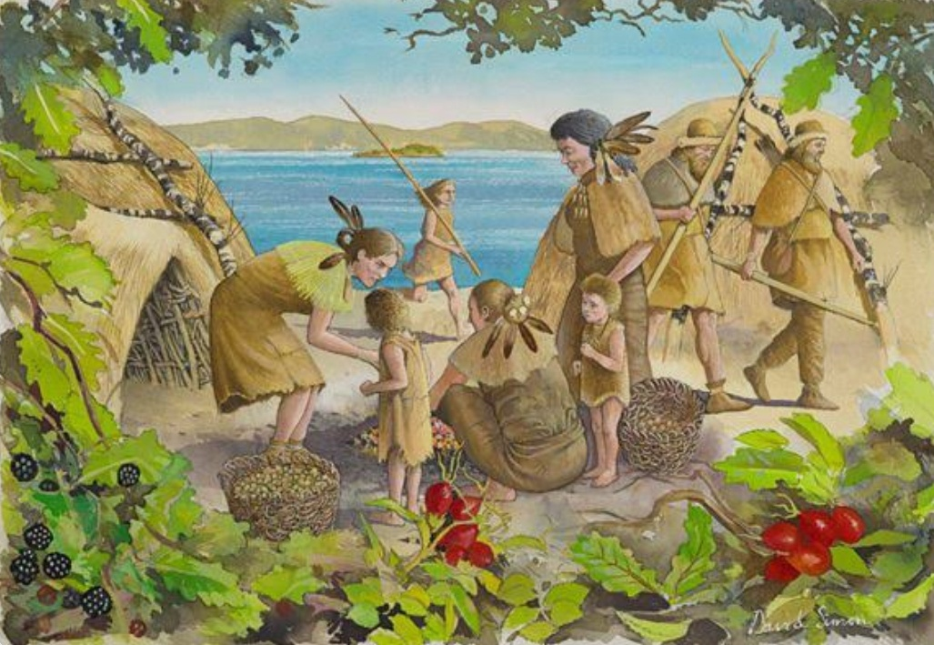
  - Neolithic Age (New Stone Age)Timeline: c. 8,000 BCE – 4,000 BCE
The Neolithic Age represents a major turning point in prehistoric life and is often called the Neolithic Revolution. Humans learned to grow crops and domesticate animals such as cattle, sheep, and goats. This led to the establishment of permanent villages. Tools became smoother and more polished, and people began making pottery, weaving cloth, and building houses. With surplus food production, population increased, and social structures became more organised. Religious beliefs also developed, as shown by burial practices and worship of nature and fertility symbols.

- Neolithic Revolution: One of the greatest contributions of the Stone Age, especially during the Neolithic period, was the beginning of agriculture. Instead of depending entirely on hunting and gathering, humans started growing crops such as wheat and barley and began domesticating animals like cattle, sheep, and goats. This shift from food gathering to food production is known as the Neolithic Revolution because it completely transformed human life. Agriculture ensured a steady food supply, which led to population growth and greater stability. People could now store surplus food for future use. Without this agricultural foundation, the rise of large civilisations would not have been possible. The practice of agriculture encouraged humans to settle in one place. During the Neolithic Age, people built permanent houses made of mud, clay, and wood and formed villages. This transition from a nomadic lifestyle to a settled life was extremely important. Living together in villages promoted cooperation, sharing of resources, and mutual protection. It also led to the development of community life and laid the groundwork for the growth of towns and cities in later periods. Settled life marked a major step toward organised society.
- Tools: Polished stone tools with sharp cutting edges.
- Settled Life: Since crops needed care, humans began living in permanent mud-brick houses and villages.
- Inventions: Invention of the wheel (for transport and pottery) and weaving of cloth.
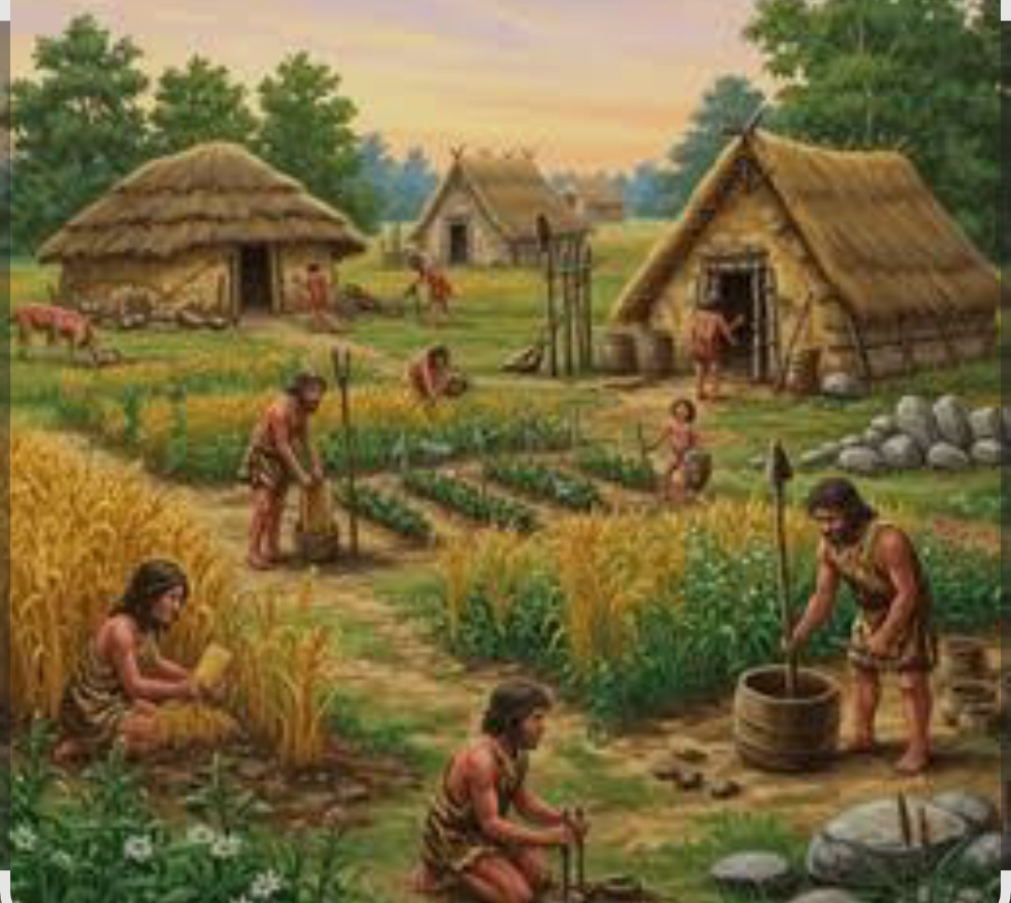

Chalcolithic Period (Stone-Copper Age)
Timeline: c. 4,000 BCE – 2,000 BCE

  - Definition: The period where humans used both stone and copper tools. It was the first time metal was used.

Characteristics:
    - Development of distinct pottery styles (e.g., Black and Red ware).
    - Expansion of rural settlements and beginning of social stratification.
    - Religious beliefs became more evident through terracotta figurines (e.g., Mother Goddess).

Bronze Age
Timeline: c. 3,300 BCE – 1,200 BCE

  - Innovation: Humans learned to mix copper with tin or arsenic to create
Bronze, a much harder and more durable metal.
  - Urbanization: This age saw the rise of the first great city civilizations (e.g., Indus Valley Civilization, Mesopotamia).
  - Trade and Script: Long-distance trade flourished, and the first systems of writing were developed to keep trade records.

Iron Age
Timeline: c. 1,200 BCE – Present (Historical era begins)

  - Impact: The widespread use of iron led to the creation of stronger tools (axes and plows).
  - Agriculture: Iron plows allowed humans to clear dense forests and cultivate hard soil, leading to a surplus in food production.
  - Polity: This surplus supported the rise of large kingdoms and empires (e.g., Mahajanapadas in India).

4. Evolution of Human Beings
Human evolution is the lengthy process of change by which people originated from
apelike ancestors. Based on archaeological findings, the stages of evolution are categorized as follows:

Stage Timeframe Key Characteristics
Ardipithecus | 4.4 – 6 million years ago | Early bipedal (walking on two legs) traits; still adapted for tree-climbing.
Australopithecus | 2 – 4 million years ago | Fully bipedal but small-brained; scavenged for food and used very basic natural tools.
Homo habilis | 1.4 – 2.4 million years ago | Known as the "Handy Man." Increased brain size; the first prolific stone toolmakers.
Homo erectus | 100k – 2 million years ago | The "Upright Man." First to leave Africa; first to master the use of fire; developed complex social structures.
Homo sapiens | 300,000 years ago – Present | "Wise Man." High, rounded skulls; developed advanced language, art, and culture. Modern humans belong to this species.

