PICTURE COMPOSITION
Observe and describe the picture in your own words:

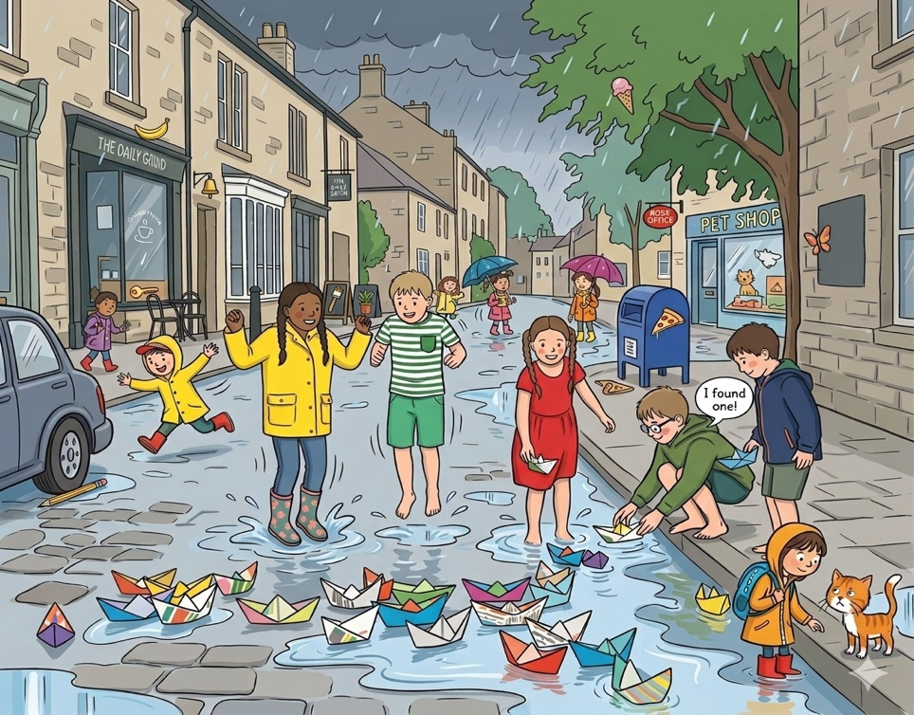
This picture depicts a joyful scene of children playing in the rain on a busy street. Dark clouds fill the sky, but the children are very happy. They are playing outside and jumping in the cool water.
The street has turned into a little river. Many colorful paper boats are floating. A girl in a bright yellow raincoat is jumping high to make a big splash. Nearby, a boy is bending down to place his paper boat in the water. His friend has also found a boat and is shouting with joy.
On the pavement, a girl is trying to make friends with the cute cat. The Pet Shop and the cafe are closed because of the heavy rain, but the street is full of life. The children love the rain and the magic of their paper boats.

