SATISH CHANDRA MEMORIAL SCHOOL
EVS. CLASS TEST
CH – 1 WTER THE ESSENCE OF LIFE
FM- 10

1.Assertion (A): Floating plants have broad and flat leaves.
Reason (R): Broad and flat leaves help floating plants receive maximum sunlight.
a) Both A and R are true, and R is the correct explanation of A.
b) Both A and R are true, but R is not the correct explanation of A.
c) A is true, but R is false.
d) A is false, but R is true.
2.Assertion (A): Salt is produced in Gujarat by heating seawater in factories.
Reason (R): Seawater is left in shallow salt pans under strong sunlight so that water evaporates, leaving salt behind.
a) Both A and R are true, and R is the correct explanation of A.
b) Both A and R are true, but R is not the correct explanation of A.
c) A is true, but R is false.
d) A is false, but R is true.
3 . The Luni River originates in the Aravalli Hills and ends in:
a)Arabian Sea. b) Bay of Bengal
c) Marshy land of Rann of Kutch. d) Gulf of Mannar
4. Which among the following is a source of fresh water?
a) Ocean . b) Sea. c) River. d) Gulf
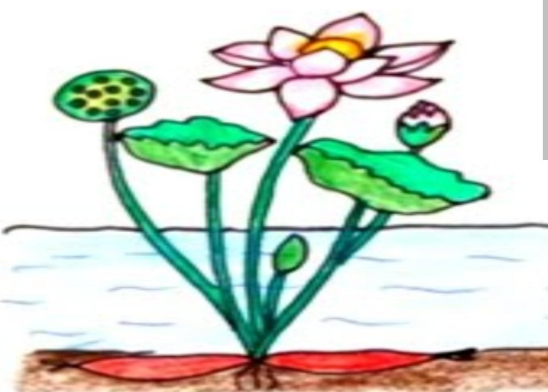
5 .Write down the steps included in the water cycle. Also draw a neat diagram showing the steps.( 1+2)
6 . Identify the plant shown in the picture as a rooted floating plant or free-floating plant. (1+2)
Also write one difference between these type of aquatic Plants with example of each.

Also write one difference between these types of aquatic plants with one example of each.Top of Form

Bottom of Form

