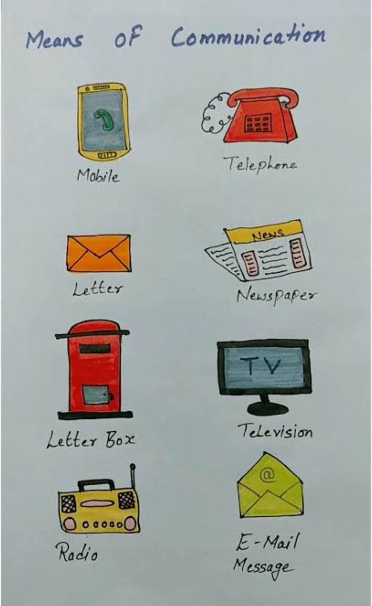
Transportation :
Transportation is the movement of people , animals and goods from one place to another.
Importance of transportation:
*Transportation allows us to travel for work education and leisure.
* It enables trade by moving products from factories to market.
* It facilitates communication by allowing for the transport of letters and goods.
Q.3 A: Transportation is the lifeline of a country.
R: It moves only people.
- A and R are true and R is the correct explanation of A
- A and R are true but R is not the correct explanation of A.
- A is true but R is false.
- A is false but R is true.
Q.4.Before the invention of wheel, how did people travelled from one place to another.
Ans:
Q.5 Name two eco- friendly vehicles.
Ans:

Highways
Highways are main, paved roads connecting major cities and towns, designed for fast-moving, long-distance traffic. Known as "pucca" roads, they are crucial for transportation.
Key types include National Highways, State Highways, and Expressways.
Q.5. Name the National Highway (NH) connecting Chakdaha to rest of India.
Ans;
Common Road/Highway Signs (Important to Know)

Stop Sign:
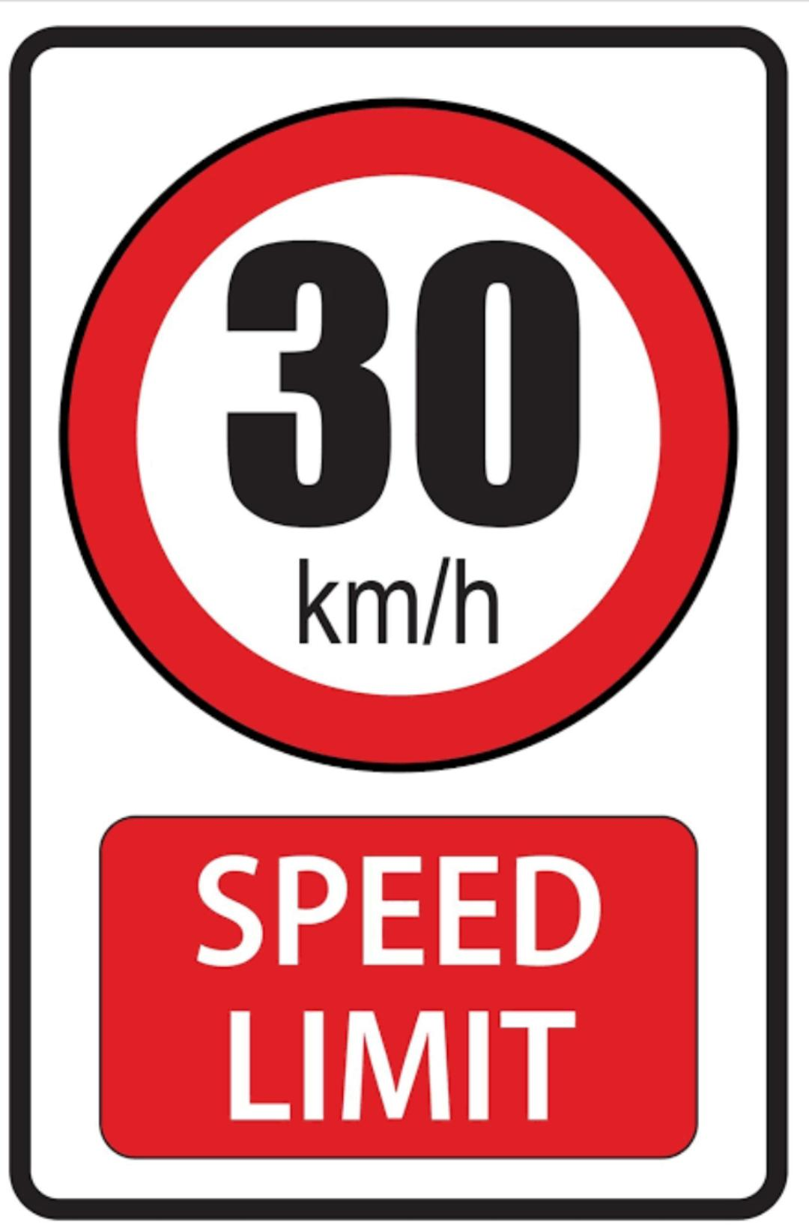
Speed Limit Sign:

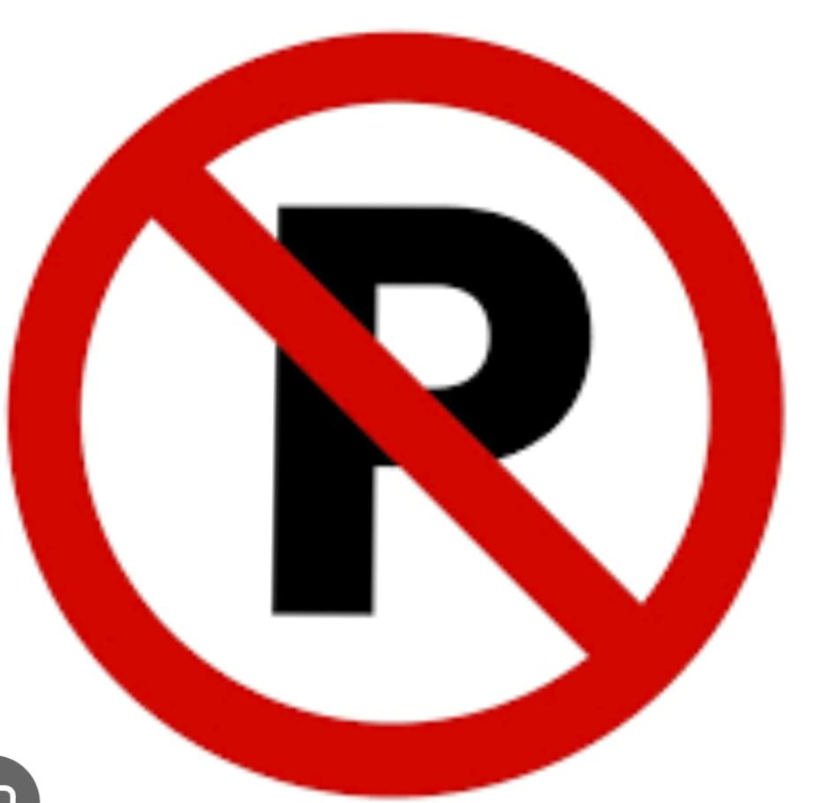
No Parking Sign:

Pedestrian Crossing (Zebra Crossing):
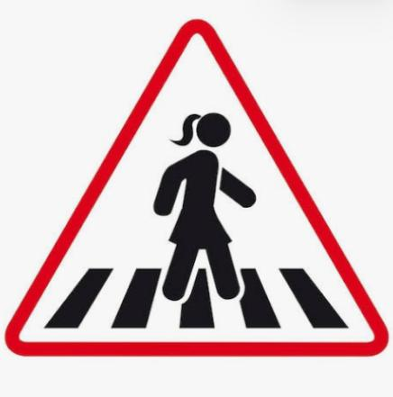

Key Roles of a Neighbourhood Hospital:
- Emergency Care: Provides urgent treatment for accidents or sudden illnesses, saving time and lives.
- Routine Health Services: Offers regular check-ups and medical advice to keep residents healthy.
- Preventive Care: Organizes health camps, immunizations, and educational programs on hygiene and nutrition.
- Specialized Care: Offers treatment for specific health conditions, such as skin diseases or broken bones.

Q6.It is important to have hospital nearby our locality. Why?Give reason.
Ans: The importance are -
- Accessibility: Saves time during emergencies and avoids long-distance travel for treatments.
- Safety: Ensures that immediate care is available in times of disasters or pandemics.
- Convenience: Makes it easier to get regular health check-ups .

Book page no.23
Do in cw copy.

Importance of bank –
Banks are essential for
* keeping money safe,
* promoting savings and
* helping people manage money easily through services like ATMS, debit cards, and online payments. They serve as key financial pillars, helping individuals and businesses grow.

Q. Write the significance of ATM.
Ans:

Q. 7.Write about Money Order.
Ans:A money order is a secure, paper-based method for sending a specific amount of money from one person to another, usually through a Post Office. The person sending the money is the remitter, and the person receiving it is the payee.
Q.8. Write about Mobile Banking.
Ans:Mobile banking is using a smartphone with internet connection to manage your bank account , allowing you to check balance, transfer money, pay bills, and deposit checks without visiting a physical bank branch. It is a fast, 24/7, and secure method .

