From Barter to Money
Class 7 Social Science Notes

Barter System
  - Barter system means direct exchange of goods and services without using money.
  - People exchanged things like crops, cattle, beads, salt, cloth, and shells.
  - Example: A farmer gives rice to a shoemaker and gets shoes in return.

Problems of the Barter System
  - Double Coincidence of Wants: Both people must want each other’s goods at the same time.
  - No Common Measure of Value: It was difficult to decide how much one item was worth.
  - Lack of Divisibility: Big items like cattle could not be divided for small purchases.
  - Difficulty in Storage: Goods like grains could rot or get damaged.
  - Problem of Portability: Carrying heavy goods from one place to another was difficult.

Evolution of Money
  - To solve the problems of barter, people started using money.
  - Early forms of money included cowrie shells, salt, metals, and coins.
  - Later, paper notes and coins became common.
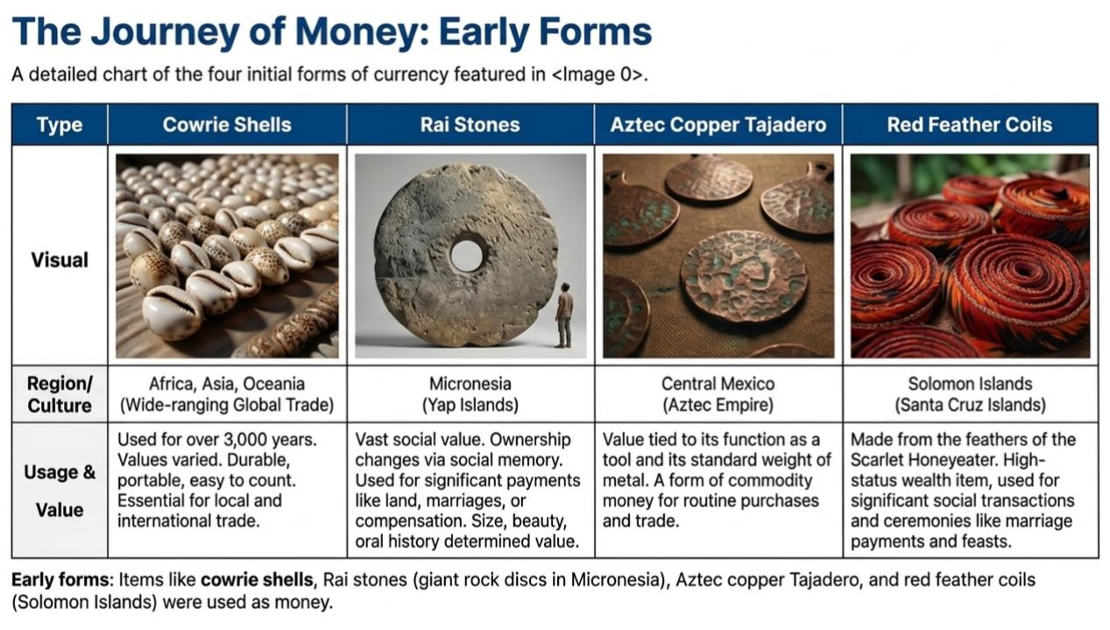
  - Today, digital payments like UPI, QR codes, and mobile banking are also used.

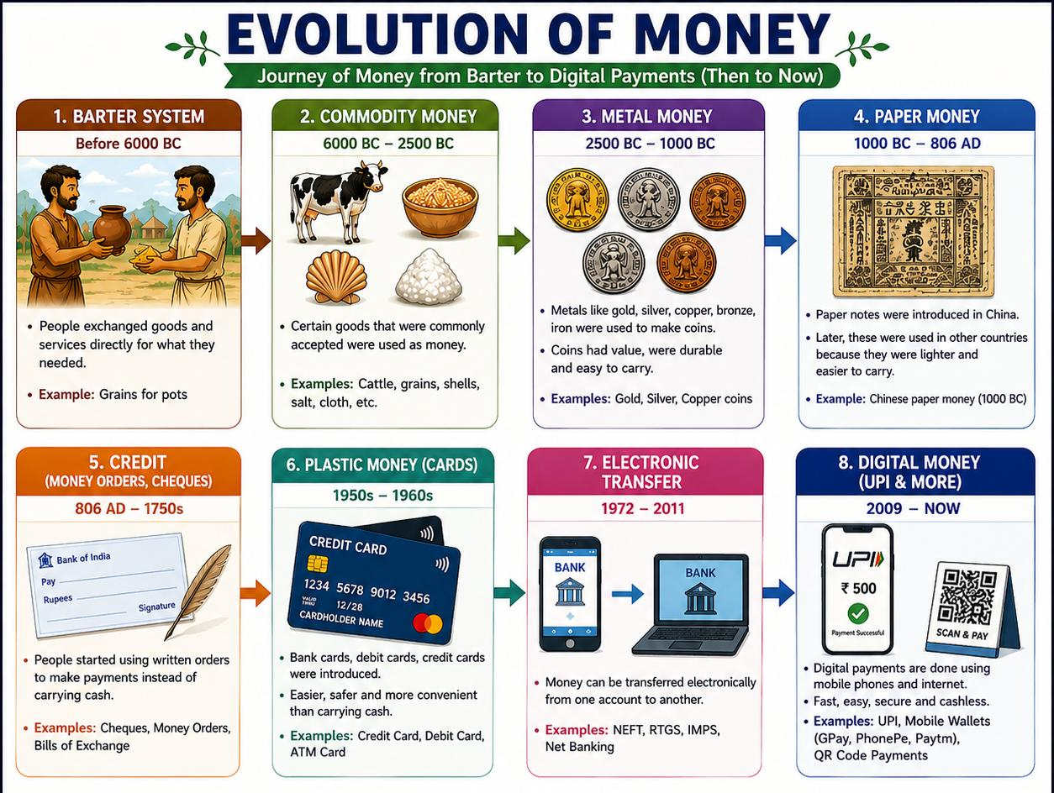

Stage of Evolution | Primary Medium | Key Characteristic |  | Major Advantage | Main Disadvantage / Limitation
1. Barter System | Goods and Cattle | Direct exchange of one commodity for another. |  | No need for a central currency or minting. | Double Coincidence of Wants: Finding someone who needs what you have.
2. Gold & Commodities | Gold nuggets, Salt, Shells | Using naturally valuable items as a standard. |  | Everyone accepted them because the material had value. | Difficult to divide into small parts or carry in large amounts.
3. Metal Coins | Gold, Silver, Copper | Pieces of metal with an official stamp or seal. |  | Standardized weight and value; easy to count. | Heavy to carry and at risk of being stolen or "shaved."
4. Paper Money | Banknotes / Currency | Government-backed paper representing value. |  | Extremely lightweight and easy to carry for large trades. | Can be damaged easily (torn/burnt) and can lose value (inflation).
5. Plastic Cards | Debit & Credit Cards | Plastic cards with magnetic strips or chips. |  | Safe; no need to carry physical cash; works globally. | Requires card machines and electricity to function.
6. Electronic Money | Digital Balance / UPI | Money exists only as numbers in a bank database. |  | Instant transfers; no physical contact needed. | Dependent on internet connectivity and prone to cyber-hacking.
7. Cryptocurrency | Bitcoin | Decentralized digital code not controlled by banks. |  | Extremely secure technology; works without a middleman. | Highly volatile (prices change fast); not accepted everywhere yet.

Why Money is Important
  - Money is accepted by everyone for buying and selling goods.
  - Money acts as a common measure of value.
  - Money is portable, divisible, and durable.
  - Money helps people save for future use.

Functions of Money
  - Medium of Exchange: Used to buy and sell goods and services.
  - Store of Value: Can be saved for future use.
  - Measure of Value: Helps compare prices of goods.
  - Deferred Payment: Useful for paying loans and debts later.

Modern Examples of Barter
  - Book exchanges where old books are swapped for new ones.
  - Trading old clothes for utensils.
  - Junbeel Mela in Assam where goods are exchanged without money

Quick Comparison

Barter System | Money System
Direct exchange of goods | Exchange using money
No fixed value | Standard value
Difficult to carry goods | Easy to carry money
Goods may spoil | Money can be stored safely

Conclusion: The barter system was useful in ancient times, but it had many problems. Money made trade easier, faster, and more convenient. Today, people use coins, notes, and digital payments in daily life.

