From Barter to Money
Class 7 Social Science Notes

Barter System
  - Barter system means direct exchange of goods and services without using money.
  - People exchanged things like crops, cattle, beads, salt, cloth, and shells.
  - Example: A farmer gives rice to a shoemaker and gets shoes in return.

Problems of the Barter System
  - Double Coincidence of Wants: Both people must want each other’s goods at the same time.
  - No Common Measure of Value: It was difficult to decide how much one item was worth.
  - Lack of Divisibility: Big items like cattle could not be divided for small purchases.
  - Difficulty in Storage: Goods like grains could rot or get damaged.
  - Problem of Portability: Carrying heavy goods from one place to another was difficult.

Evolution of Money
  - To solve the problems of barter, people started using money.
  - Early forms of money included cowrie shells, salt, metals, and coins.
  - Later, paper notes and coins became common.
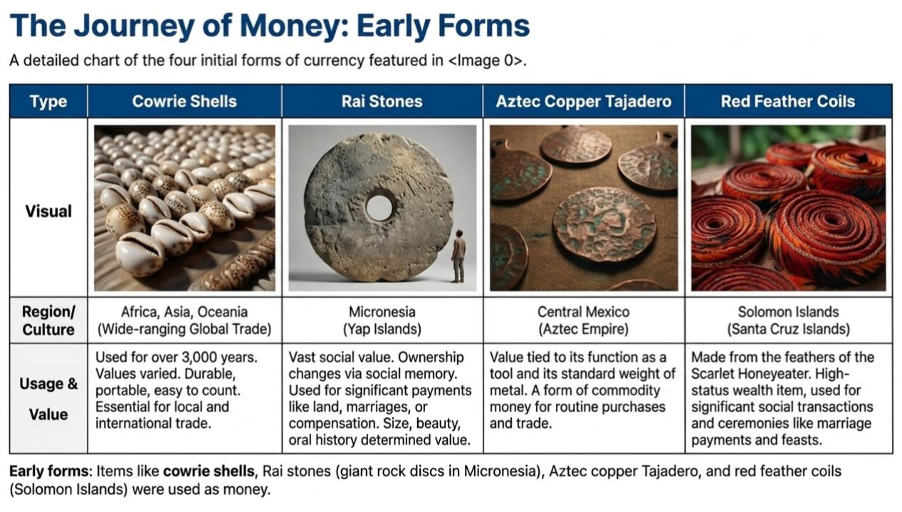
  - Today, digital payments like UPI, QR codes, and mobile banking are also used.

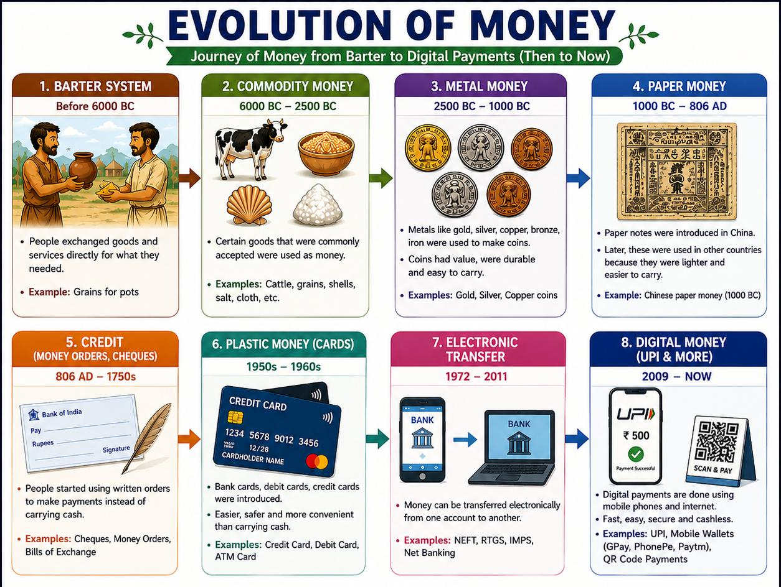

Stage of Evolution | Primary Medium | Key Characteristic |  | Major Advantage | Main Disadvantage / Limitation
1. Barter System | Goods and Cattle | Direct exchange of one commodity for another. |  | No need for a central currency or minting. | Double Coincidence of Wants: Finding someone who needs what you have.
2. Gold & Commodities | Gold nuggets, Salt, Shells | Using naturally valuable items as a standard. |  | Everyone accepted them because the material had value. | Difficult to divide into small parts or carry in large amounts.
3. Metal Coins | Gold, Silver, Copper | Pieces of metal with an official stamp or seal. |  | Standardized weight and value; easy to count. | Heavy to carry and at risk of being stolen or "shaved."
4. Paper Money | Banknotes / Currency | Government-backed paper representing value. |  | Extremely lightweight and easy to carry for large trades. | Can be damaged easily (torn/burnt) and can lose value (inflation).
5. Plastic Cards | Debit & Credit Cards | Plastic cards with magnetic strips or chips. |  | Safe; no need to carry physical cash; works globally. | Requires card machines and electricity to function.
6. Electronic Money | Digital Balance / UPI | Money exists only as numbers in a bank database. |  | Instant transfers; no physical contact needed. | Dependent on internet connectivity and prone to cyber-hacking.
7. Cryptocurrency | Bitcoin | Decentralized digital code not controlled by banks. |  | Extremely secure technology; works without a middleman. | Highly volatile (prices change fast); not accepted everywhere yet.

Why Money is Important
  - Money is accepted by everyone for buying and selling goods.
  - Money acts as a common measure of value.
  - Money is portable, divisible, and durable.
  - Money helps people save for future use.

Functions of Money
  - Medium of Exchange: Used to buy and sell goods and services.
  - Store of Value: Can be saved for future use.
  - Measure of Value: Helps compare prices of goods.
  - Deferred Payment: Useful for paying loans and debts later.

Modern Examples of Barter
  - Book exchanges where old books are swapped for new ones.
  - Trading old clothes for utensils.
  - Junbeel Mela in Assam where goods are exchanged without money

Quick Comparison

Barter System | Money System
Direct exchange of goods | Exchange using money
No fixed value | Standard value
Difficult to carry goods | Easy to carry money
Goods may spoil | Money can be stored safely

Conclusion: The barter system was useful in ancient times, but it had many problems. Money made trade easier, faster, and more convenient. Today, people use coins, notes, and digital payments in daily life.

WORKSHEET FOR PRACTICE

Multiple Choice Questions (MCQs)
​1.Which organ of the government is responsible for the implementation of rules and general administration?
​a) Legislature
​b) Executive
​c) Judiciary
​d) Monarchy
​
​2.In which form of government is the head of state elected and not a hereditary monarch?
​a) Absolute Monarchy
​b) Theocracy
​c) Republic
​d) Dictatorship
​
​3.Read the following scenario: In a certain country, all adults, regardless of their gender or wealth, have the right to vote in regular intervals to choose their leaders. This country is most likely a:
​a) Direct Democracy
​b) Representative Democracy
​c) Absolute Monarchy
​d) Oligarchy
​
​4. Imagine a school where the Principal makes all rules alone without consulting students or teachers. Which form of government does this school's management most closely resemble?
​a) Parliamentary Democracy
​b) Oligarchy
​c) Dictatorship or Absolute Monarchy
​d) Republic
​
​
​5.If a citizen feels their fundamental rights have been violated by a new law, which branch of the government should they approach for protection?
​a) The Executive
​b) The Legislature
​c) The Judiciary
​d) The Council of Ministers
​
​6.A new country is being formed and the founders want to ensure that those who make the laws are also the ones responsible for implementing them. Which system should they choose?
​a) Presidential Democracy
​b) Parliamentary Democracy
​c) Direct Democracy
​d) Theocracy
​
​7.Assertion (A): In a democracy, the government is accountable to the people.
Reason (R): People elect their representatives and can change them in the next election if they are dissatisfied.
​
​8.Assertion (A): Direct democracy is difficult to practice in large countries like India.
Reason (R): In a direct democracy, every single citizen is directly involved in every decision-making process.

​
​
9.Match the following types of government with their correct description:

Type of Government | Description
I. Theocracy | A. Rule by a small group of wealthy/influential people
II. Dictatorship | B. Rule based on religious laws and leaders
III. Oligarchy | C. One person possesses absolute power without limits
IV. Absolute Monarchy | D. Hereditary ruler with complete control
a) I-B, II-C, III-A, IV-D
b) I-A, II-B, III-C, IV-D
c) I-B, II-A, III-C, IV-D
d) I-D, II-C, III-B, IV-A
10.Arrange the following countries in the chronological order of when they established democracy (from earliest to latest):
(1) India
(2) USA
(3) Nepal
(4) Switzerland
a) 2, 4, 1, 3 b) 1, 2, 3, 4. c) 2, 1, 4, 3. d) 4, 2, 1, 3
Subjective Questions
11.What are the three main functions of any government? Explain them briefly.
12.Explain the difference between a Parliamentary democracy and a Presidential democracy with examples.
13."Even a democracy can show signs of an oligarchy." Do you agree with this statement? Justify your answer based on what you have read.
14.Why is an independent judiciary considered crucial for a democracy to function effectively?
15.If you were tasked with forming a "Student Committee" in your school in a democratic manner, what steps would you take to ensure representation and accountability?

​16.Compare the life of Shane in North Korea with your life in India. How does the type of government impact daily choices like clothing, access to information, and personal freedom?

