From Barter to Money
Class 7 Social Science Notes

Barter System
  - Barter system means direct exchange of goods and services without using money.
  - People exchanged things like crops, cattle, beads, salt, cloth, and shells.
  - Example: A farmer gives rice to a shoemaker and gets shoes in return.

Problems of the Barter System
  - Double Coincidence of Wants: Both people must want each other’s goods at the same time.
  - No Common Measure of Value: It was difficult to decide how much one item was worth.
  - Lack of Divisibility: Big items like cattle could not be divided for small purchases.
  - Difficulty in Storage: Goods like grains could rot or get damaged.
  - Problem of Portability: Carrying heavy goods from one place to another was difficult.

Evolution of Money
  - To solve the problems of barter, people started using money.
  - Early forms of money included cowrie shells, salt, metals, and coins.
  - Later, paper notes and coins became common.
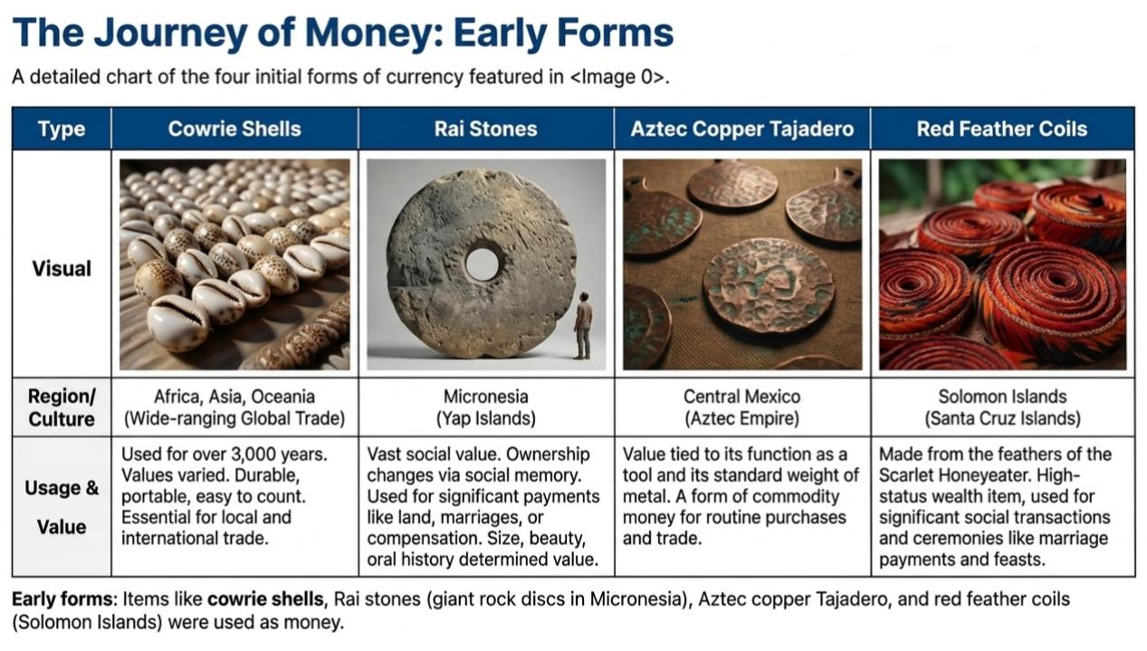
  - Today, digital payments like UPI, QR codes, and mobile banking are also used.

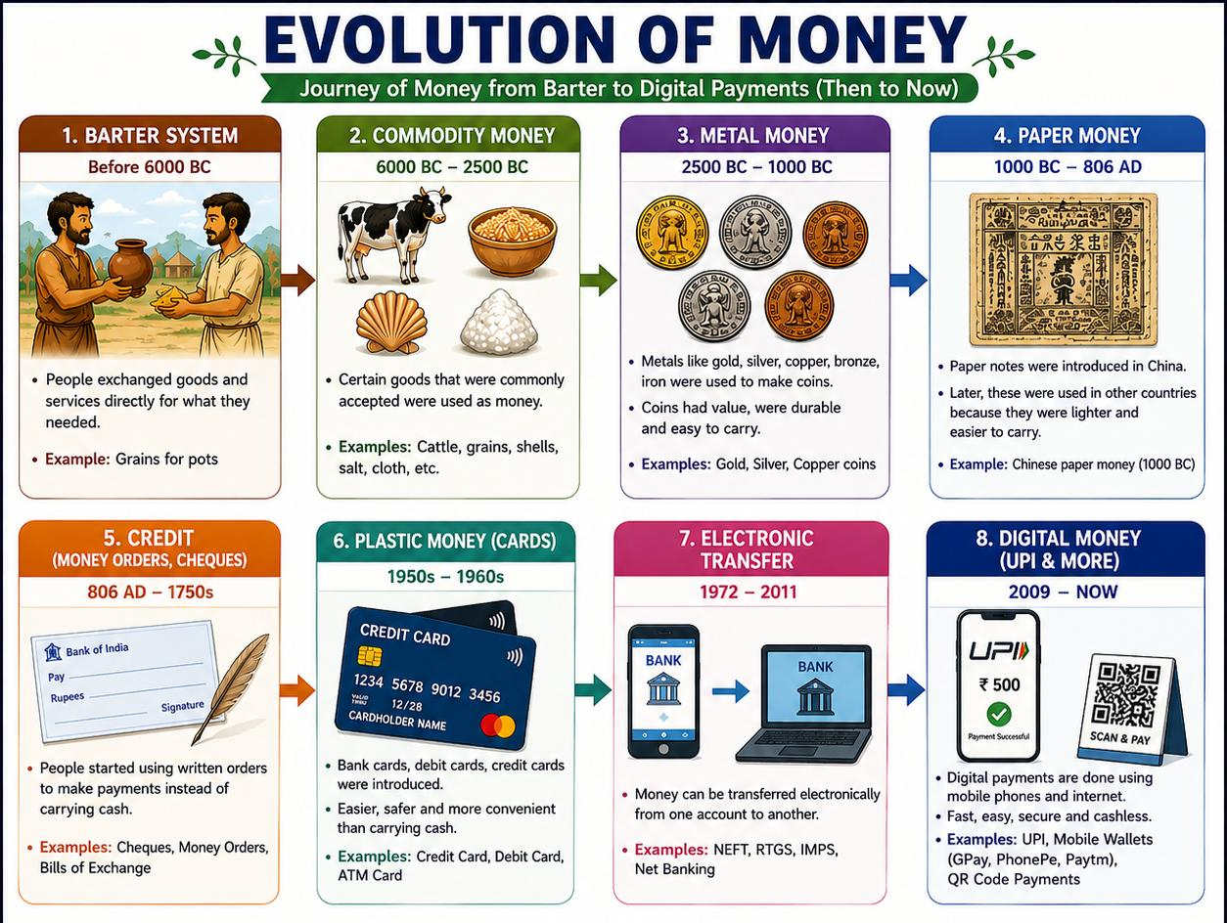

Stage of Evolution | Primary Medium | Key Characteristic |  | Major Advantage | Main Disadvantage / Limitation
1. Barter System | Goods and Cattle | Direct exchange of one commodity for another. |  | No need for a central currency or minting. | Double Coincidence of Wants: Finding someone who needs what you have.
2. Gold & Commodities | Gold nuggets, Salt, Shells | Using naturally valuable items as a standard. |  | Everyone accepted them because the material had value. | Difficult to divide into small parts or carry in large amounts.
3. Metal Coins | Gold, Silver, Copper | Pieces of metal with an official stamp or seal. |  | Standardized weight and value; easy to count. | Heavy to carry and at risk of being stolen or "shaved."
4. Paper Money | Banknotes / Currency | Government-backed paper representing value. |  | Extremely lightweight and easy to carry for large trades. | Can be damaged easily (torn/burnt) and can lose value (inflation).
5. Plastic Cards | Debit & Credit Cards | Plastic cards with magnetic strips or chips. |  | Safe; no need to carry physical cash; works globally. | Requires card machines and electricity to function.
6. Electronic Money | Digital Balance / UPI | Money exists only as numbers in a bank database. |  | Instant transfers; no physical contact needed. | Dependent on internet connectivity and prone to cyber-hacking.
7. Cryptocurrency | Bitcoin | Decentralized digital code not controlled by banks. |  | Extremely secure technology; works without a middleman. | Highly volatile (prices change fast); not accepted everywhere yet.

Why Money is Important
  - Money is accepted by everyone for buying and selling goods.
  - Money acts as a common measure of value.
  - Money is portable, divisible, and durable.
  - Money helps people save for future use.

Functions of Money
  - Medium of Exchange: Used to buy and sell goods and services.
  - Store of Value: Can be saved for future use.
  - Measure of Value: Helps compare prices of goods.
  - Deferred Payment: Useful for paying loans and debts later.

Modern Examples of Barter
  - Book exchanges where old books are swapped for new ones.
  - Trading old clothes for utensils.
  - Junbeel Mela in Assam where goods are exchanged without money

Quick Comparison

Barter System | Money System
Direct exchange of goods | Exchange using money
No fixed value | Standard value
Difficult to carry goods | Easy to carry money
Goods may spoil | Money can be stored safely

Conclusion: The barter system was useful in ancient times, but it had many problems. Money made trade easier, faster, and more convenient. Today, people use coins, notes, and digital payments in daily life.

Multiple Choice Questions

1 .Rai stones—giant discs of rock used historically as a form of money—belong to which of the following regions?

(a) Solomon Islands

(b) Yap Island in Micronesia

(c) Central Mexico

(d) Morigaon district of Assam

​2. In ancient India, coins minted from precious metals like gold, silver, and copper or their alloys were contextually known as:

(a) Rupas

(b) Varahas

(c) Karsapanas or Panas

(d) Annas

​

​3. Imagine a community where a herder wants to swap a goat for a sack of rice. A farmer has a sack of rice but wants a pair of leather shoes instead of a goat. This exchange cannot happen directly due to a failure in which specific economic prerequisite?

(a) Portability of the medium

(b) Double coincidence of wants

(c) Divisibility of structural commodities

(d) Common standard measure of value

​4. A vegetable vendor displays a card with a printed QR code on his cart so customers can scan and pay seamlessly via their mobile phones.

Which functional trait of money is directly highlighted by this setup compared to carrying bulky metal currency?

(a) Durability

(b) Standard of deferred payment

(c) Portability

(d) Legal tender authorization

​

​Q5. Match the historical commodities used as transactional mediums-
Column I (Commodity / Event) | Column II (Geographical Region)
1. Tevau (Red feather coil) | A. Central Mexico
2. Tajadero (Copper chopping knife) | B. Solomon Islands
3. Junbeel Mela (Barter Fair) | C. Yap Island
4. Rai Stones (Giant discs of rock) | D
Options:
(a) 1-B, 2-A, 3-D, 4-C
(b) 1-A, 2-B, 3-C, 4-D
(c) 1-B, 2-C, 3-D, 4-A
(d) 1-D, 2-A, 3-B, 4-C
6.Assertion (A): In modern India, it is entirely illegal for any individual, private bank, or business body other than the Reserve Bank of India (RBI) to issue currency notes.
Reason (R): The RBI acts as the centralized monetary authority that legally controls and regulates the issue of printing paper currency across the nation.

7.Assertion (A): Under a pure barter system, storing surplus wheat acquired from an exchange is an ineffective way to save wealth for future use.
Reason (R): Commodities like wheat lack economic divisibility because they cannot be broken down into smaller physical portions.
Subjective Questions
1.Explain the concept of "Double Coincidence of Wants" and highlight why it acted as one of the major limitations of the traditional barter system.

2.What are the three primary basic functions of money that emerged to overcome the structural difficulties of bartering?
​3. How did coinage help in improving trade in ancient India? Describe the importance of the rupee symbol
4.How does the Junbeel Mela show that the barter system still exists today?
5.Suman wants to buy a history reference textbook from a neighborhood bookstore. The book is priced at ₹120, but she only has a ₹50 note in her pocket. The shopkeeper agrees to hand her the book today after she promises to pay the remaining balance of ₹70 next week.
Identify and explain the specific function of money being applied in this scenario that allows transactions to occur on credit.

6.Archaeologists executing a local excavation project in a southern coastal town in Tamil Nadu discover a collection of ancient Roman gold coins deeply buried underground. Applying your understanding of early monetary systems and ancient trade, what logical conclusions can you draw from this discovery regarding historical Indian trade relationships?

​
​7.Case Study)
Read the following passage adapted from historical data mentioned in your textbook and answer the questions below: “According to the ancient text Arthaśhāstra, an annual salary of 60 paṇas could be substituted by an āḍhaka of grain per day, enough for four meals (where one āḍhaka is equal to about 3 kg). Conversely, the state imposed a fine of 100 paṇas on individuals who failed to help a neighbor in times of need.”
(A)Based on the salary substitute, evaluate what this tells us about the real purchasing capacity or value of a single paṇa in terms of daily survival goods during that period.
(B).Compare the penalty fine of 100 paṇas against the total annual salary of 60 paṇas. What deeper conclusion can you draw about the social and human values that this administrative law intended to encourage within the community?

