MINISTERS OF INDIA

SOME IMPORTANT MINISTERS OF INDIA :

- The Prime Minister of India : Shri Narendra Modi
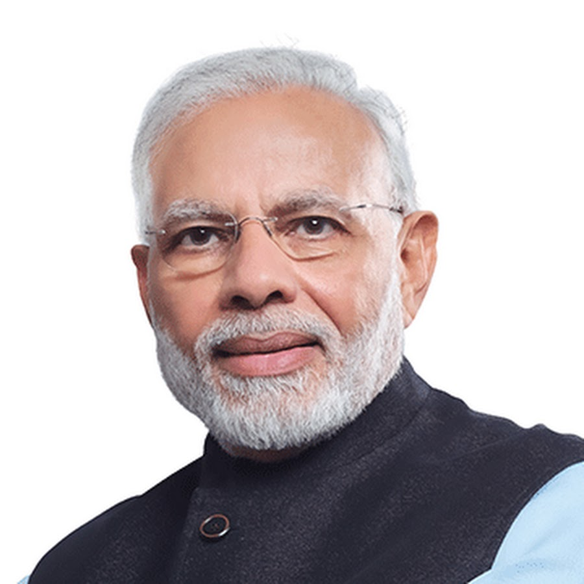

He is the leader of our country.

- The Defence Minister of India : Shri Rajnath Singh
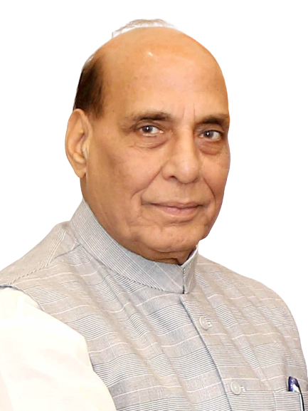

He is responsible for keeping the country safe by managing the army, navy and air force.

- Minister of Home Affairs: Shri Amit Shah
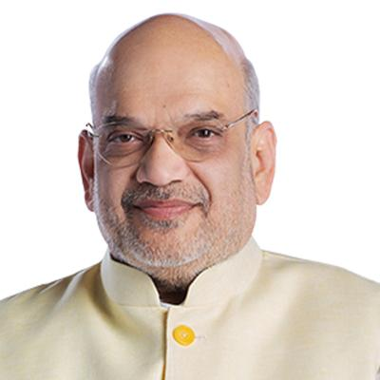

He is responsible for keeping the country safe and peaceful by managing police, and state laws.

- Health Minister of India: Shri Jagat Prakash Nadda
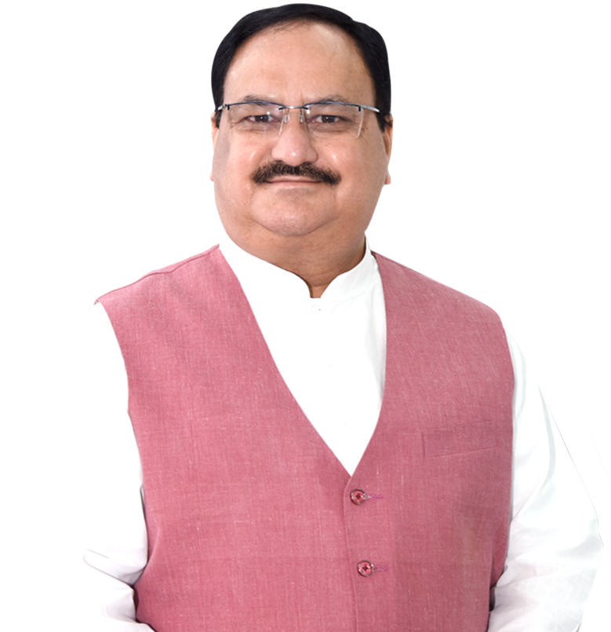

He is responsible for protecting and promoting public health.

- Finance Minister of India : Shrimati Nirmala Sitharaman
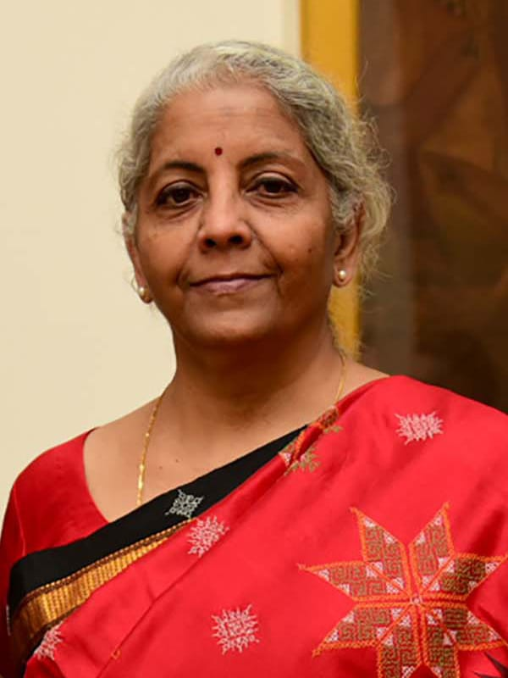

She is responsible for managing the money for the government of India.

