https://youtu.be/KFQ3xOYnzpM?si=zJZwzaknu9TU4mL7
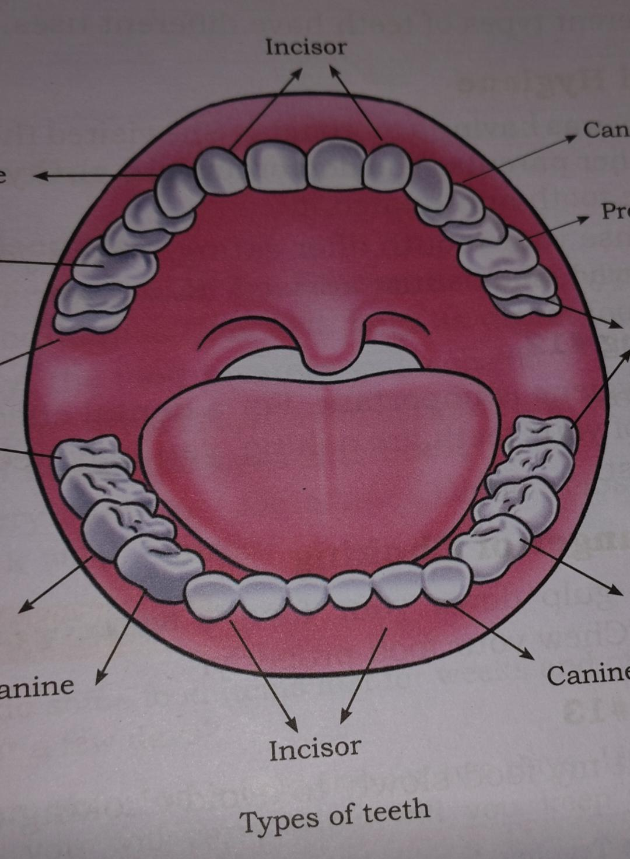
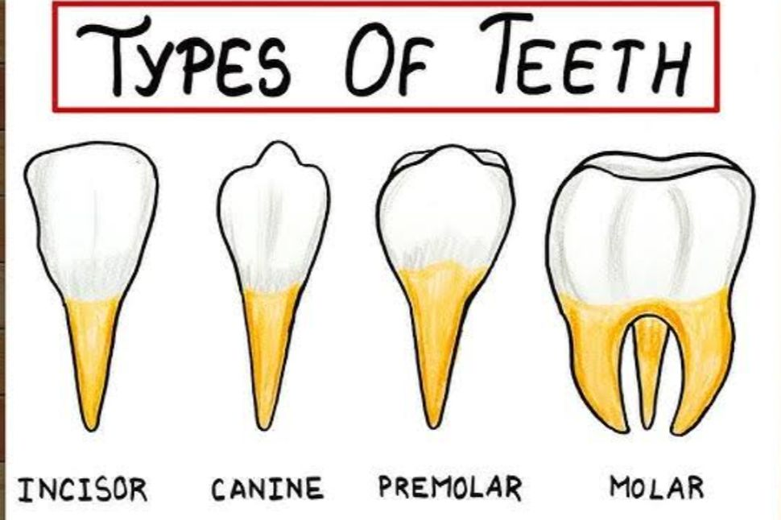

The Mystery Of Food
Q1. What are Microbes? Name some benifinicial microbes and write their function .
Answer – Microbes are very tiny living organisms that cannot be seen with our naked eyes. They can only be seen with the help of a microscope.
Example – Bacteria , Fungi, Alage
Name of Microbes | Real World Use
Lactobacillus | Making yoghurt/curd and keeping stomach healthy.
Yeast | Baking soft bread, making cake.
Rhizobium | Increase soil fertility.
Penicillium | Making antibiotic.

Q2. Riya kept a packet of butter and a jar of ghee on her kitchen shelf. After some time, her mother placed the butter in the refrigerator but left the ghee outside
Why does butter need refrigeration while ghee can be stored safely at room temperature? Explain your answer
Answer-Butter requires refrigeration because it contains water and milk solids that allow bacteria to spoil the food. Ghee (clarified butter) does not need refrigeration because the moisture and milk proteins have been completely removed during preparation, leaving only pure fat where microbes cannot survive.
Q3 . Write any two food preservation practices used at home and name the foods preserved by these methods.
Ans – By Students .

4. A farmer dries chillies in the sun before storing them. Why?

Answer: Sun drying removes water, making it difficult for microbes to grow.
5. Which method is being used when fish is covered with salt and stored for a long time?
Answer: Salting.
6. During the rainy season, papads are not drying properly. What problem may occur if they are stored like this?
Answer: They may become spoiled or develop fungus because of moisture.

