What does the picture represent? Describe any one of the following in your own words with a suitable title.
A.
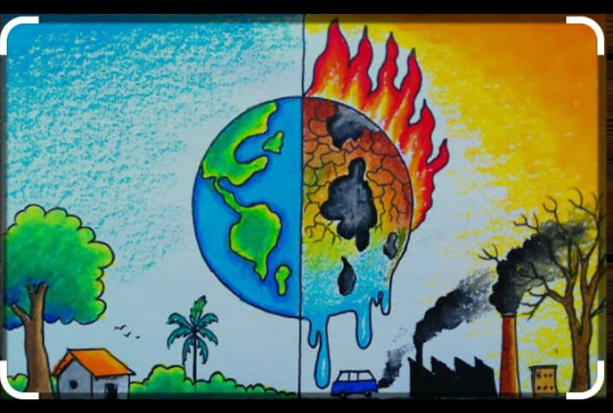

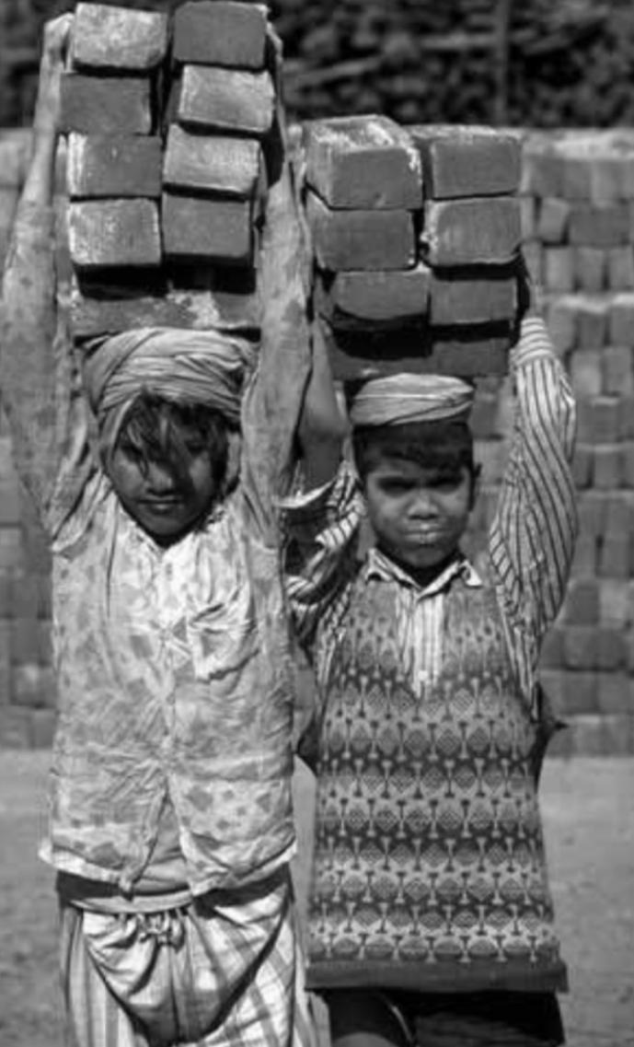
B.

