Mathematics Worksheet
Lines and Angles
Name: ______________________ | Date: ______________

Q.No. | Question Details | Marks
1 | Two adjacent angles form 178°. If one angle is 108° then the other angle will be —  (a) 170° (b) 160° (c) 70° (d) 78° | 1
2 | Direction: Consider the following statement (A) and reason (R):  A → The sum of V.O.A (Vertically Opposite Angles) is always 180°.  R → V.O.A are equal. | 1
3 | In the given figure, lines AB and CD intersect at O. Ray OE is drawn.  Find the values of x and y.  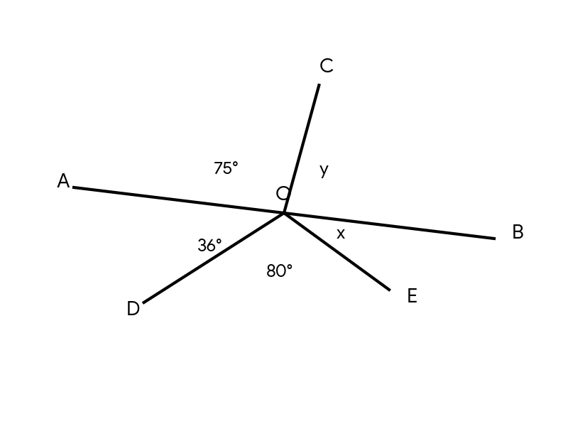 | 2
4 | In the given figure, AB || CD || EF.  Find the measure of ∠CEF.  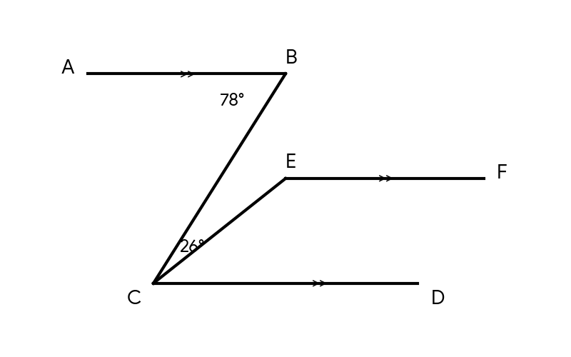 | 2
5 | Two angles are in the ratio 4:5. If they form a linear pair, find the difference between the two angles. | 2
6 | In the given figure, AB || ED || FG.  Find the measure of ∠ABC.  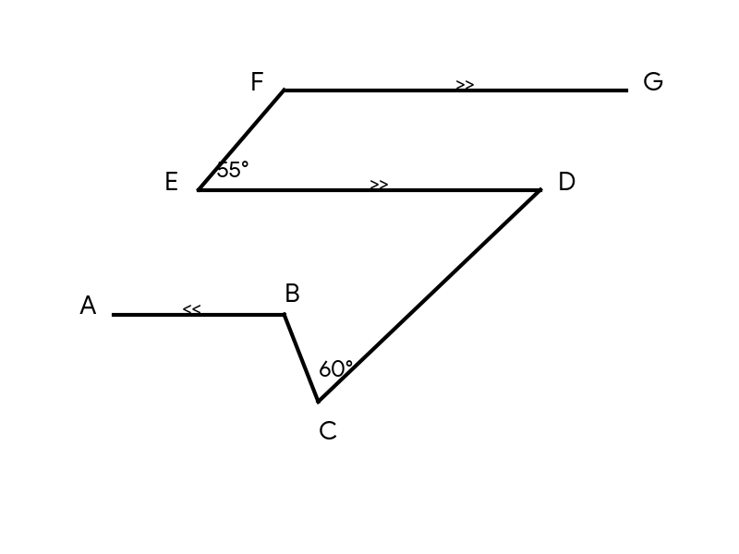 | 2

