Our school – A Happy Place
Answer the following:
1.How can you make your school Greener?
Ans by own

2. What are the various recyclers in your area called? Find out what each one collects.
Answer:
(Answers may vary)
Hint
In Delhi, recyclers include 3R Recycler (dry waste like paper, plastic), E-Waste Recyclers India (electronics, batteries), Dumpin Recyclers (paper, plastic, metal), and Green-O-Tech (office waste like paper, wood). Some NGOs also collect clothes, books, plastic, and more. Informal kabadiwalas also play a key role by collecting and selling household recyclables door-to-door.

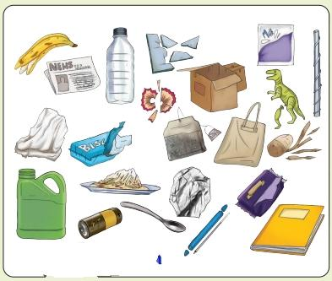
3.Observe the picture given above,separate the items in the boxes given below

Green bin | Blue bin | Items for recycler

4. List the difference between biodegradable and non – biodegradable waste
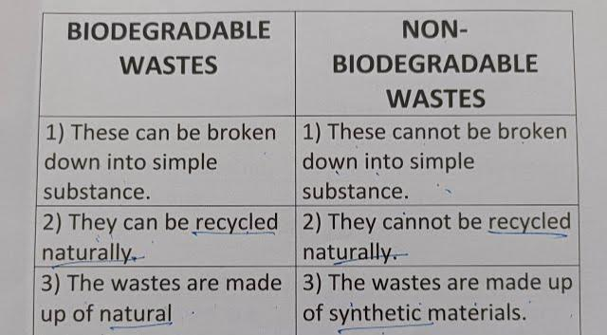

5.How can you collect and use rainwater at home or in school?
Answer:
We can collect and use rainwater at home or in school in the following ways:
- Place buckets or tubs in open areas like rooftops or balconies to collect rainwater.
- We can use rainwater to water plants or we can use it for our other household activities.
- Spread awareness among the neighbours, and collectively install rainwater harvesting systems in the locality to collect rainwater.
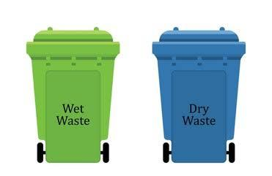
6. Draw and colour the different bin found in your school campus
7. If you have to paint the roof of your school or home white, what would happen?
Answer:
If we paint the roof of our school or home white, it will reflect the Sun’s heat instead of absorbing it. This will help to keep the rooms inside cooler. As a result, we will not only feel more comfortable, but also we can save electricity by reducing usage of fans, coolers and air conditioners.
8. Rahul is on the third floor of his school building when the fire alarm goes off. He opens the classroom door and sees thick, black smoke filling the hallway.
A: How should Rahul move through the smoke to reach the exit?
B: Why is it dangerous to stand up straight and run in a smoke-filled room?
C: If the main exit path is completely blocked by fire, what action should Rahul take?
Ans by own
9. Besides making signboards, what else can we do to improve traffic near the school?
Answer:
To improve the traffic near the school we can take the following steps:
Hint
- Request to construct a speed breaker in front of the school gate through a proper channel.
- Spread awareness about traffic safety among students and parents.
Write more points by own
10.Draw any two sign board observed near school .

