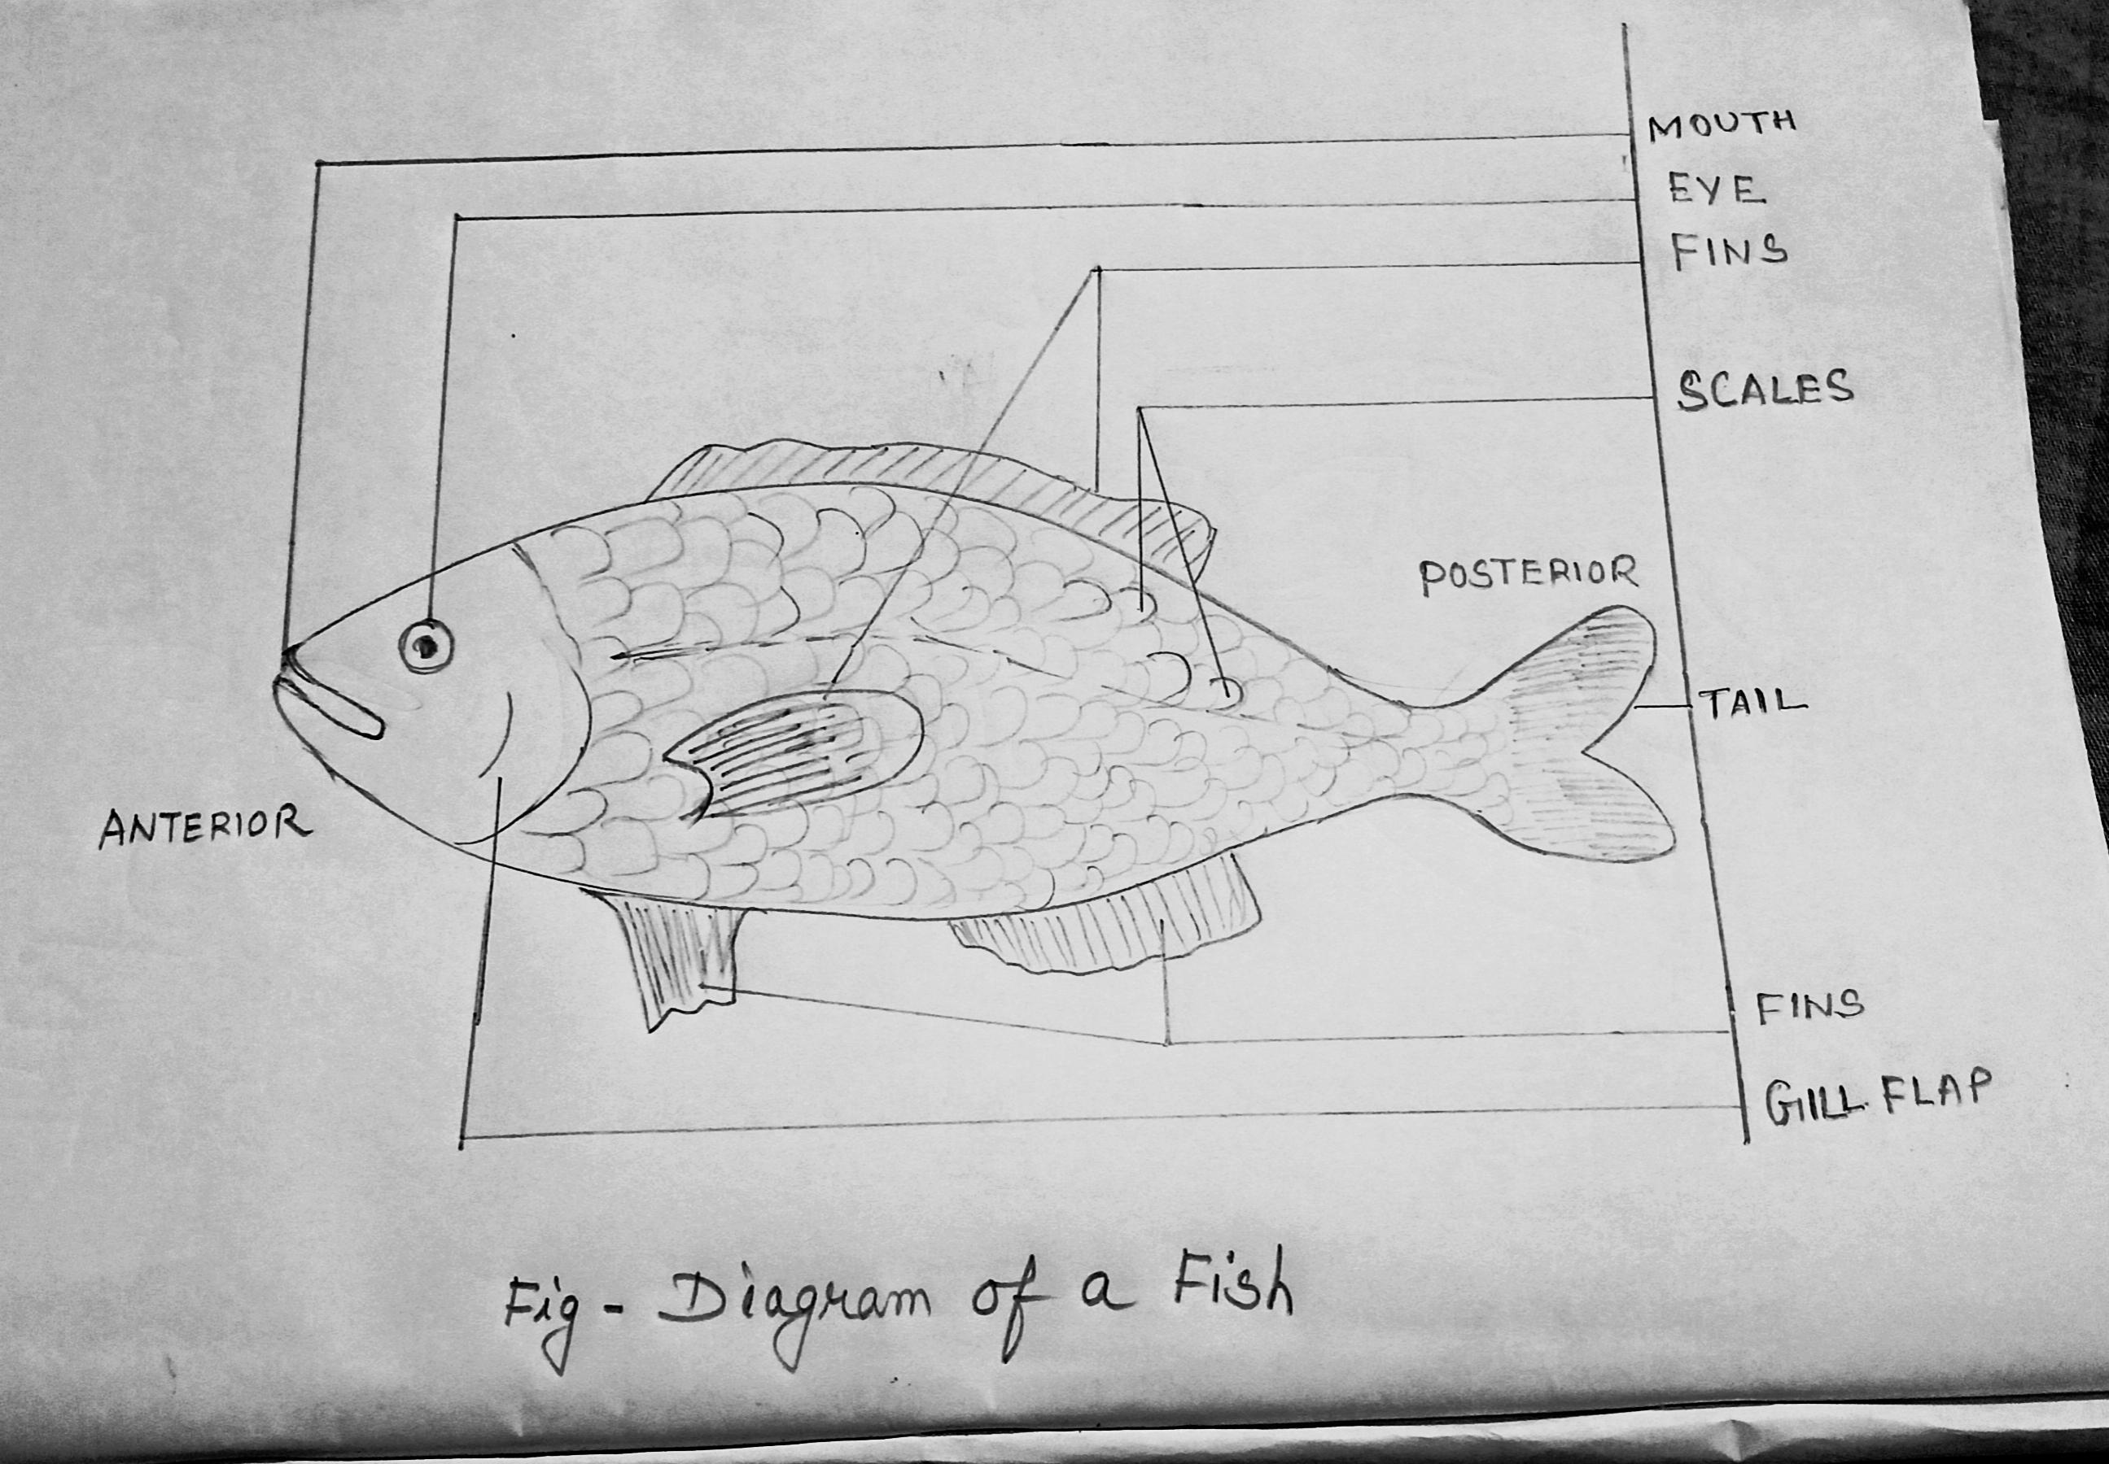
Q.no.14 Leaf venation and the function
Ans:Leaf venation is the pattern of veins on a leaf's flat surface (lamina).
Veins carry water and food to the leaf and provide structural support.
Q .15 Types of venation;
Ans: Two types –
a.Reticulate venation – The veins form a network or web like pattern. E.g- mango, rose, hibiscus etc.
b.Parallel venation – The veins run parallel to each other. E.g.- banana, grass, corn etc.

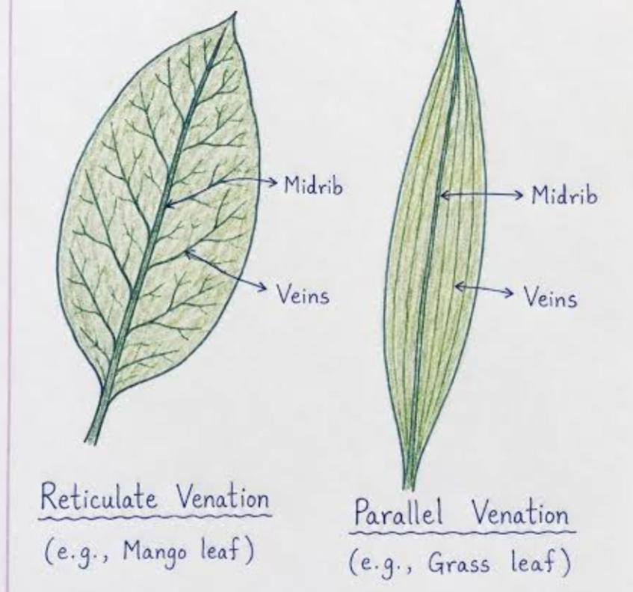
Interdependence- Plants and animals need each other to survive. Plants make food and oxygen. Animals eat plants and breathe the oxygen. In return, animals give off carbon dioxide. Plants use carbon dioxide to make food . This teamwork is called interdependence. It keeps the earth healthy.

Q16.Food chain
A food chain is a sequence that shows how food and energy pass from one living thing to another.
Eg.
Grass → Grasshopper → Frog → Snake → Eagle
Q17.Food Web
It is a group of interconnected food chains. It shows the feeding relationships among living things and helps maintain the balance of nature.
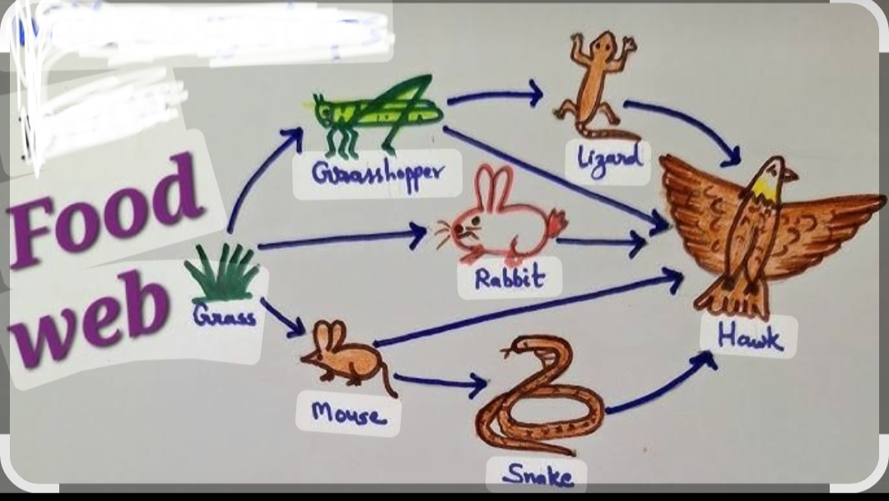
Q.18. Food pyramid in an ecosystem -
Ans: A food pyramid (or ecological pyramid) shows how energy moves through nature . It has levels shaped like a triangle. Plants (producers) are at the big bottom. Meat-eaters (carnivores) are at the tiny top. This shape shows how much food and energy exist in an ecosystem.
