AI Assistant
A Computer Science Thesis for Class 7 Students
Based on the Kaushal Bodh Grade 7 Project on Artificial Intelligence

Certificate
This thesis is submitted as a part of the Computer Science project for Class 7. It is based on the AI Assistant project described in the Kaushal Bodh Grade 7 curriculum and has been rewritten from a digital computer science perspective.

Acknowledgement
I would like to thank my teacher, parents, and friends for their guidance and support while preparing this project on Artificial Intelligence and Machine Learning.

Abstract
This thesis explains how students can design a simple AI Assistant to help a person who has recently moved into a new locality. The project introduces Artificial Intelligence, Machine Learning, data collection, image recognition, testing, and interactive AI tools such as Teachable Machine and Scratch AI. The activities are designed for Class 7 students and focus on learning by doing.

Objectives
• Understand what AI can and cannot do.
• Learn how machines recognise images and sounds.
• Collect and organise digital data.
• Train a simple AI model.
• Test and improve the AI Assistant.
• Share the final project with others.

What is Intelligence?
Human intelligence grows through experience and learning. Similarly, machines can be trained using examples. When many pictures of the same object are shown to a machine, it learns to identify common features. This process is called Machine Learning.

AI in Daily Life
AI is used in navigation apps, translation tools, image recognition, hearing aids, voice assistants, and educational applications. These examples show that AI has already become a part of our everyday lives.

AI Can and Cannot Do
Artificial intelligence can process vast amounts of data at high speeds, recognize patterns, automate routine tasks, and generate text or images. However, AI cannot feel true emotions, possess real common sense, make moral or ethical judgments, or perform genuine, original thinking outside of its training data.

Hardware and Software Requirements

Devices: You will need a computer and a microphone/speaker or a tablet with Internet access. You will also need a camera that can take photographs and record audio data. In case you do not have such a device, we can use the Smartphone of a parent/teacher.

AI Tools: Teachable Machine, Scratch, and any other tool you may find useful to build the AI Assistant.

Internet Safety and Ethics
- Students should take permission before photographing people, shops, plants, or animals. They should avoid sharing personal information online and should use the internet responsibly under adult supervision.
- Do not click strange links: Avoid links or downloads from people or pop-ups you do not know.
- Avoid public Wi-Fi for banking: Do not log into private financial accounts on unsecured public networks.
- Update your devices

Activity 1: Human vs Machine: Who is Better at What?
This activity compares human abilities with machine abilities through speed calculation, drawing recognition, and travel time prediction.

Speed Test Experiment

Maths problem | Student 1 | Student 2 | Computer
45878 x 45
342849 x 4
10985 x 3

Creative Guessing Experiment
Students use a drawing-recognition AI tool such as Quick Draw and observe whether the computer correctly identifies their drawings.
I drew | Did the computer guess it correct?

Prediction Test
Students predict how long it will take to reach school and compare their estimate with Google Maps. The comparison helps them understand how AI uses data for prediction.
Create a table and insert the following data for 5 students:
name | Time required to reach home(by student) | Time required to reach (Google map) estimate

Insert a column graph for the above data.

Observation and Analysis
Machines are generally faster in calculations, while humans are often better at creativity and understanding personal experiences. AI works best when sufficient data is available.

Activity 2: AI Can See, Listen, and Speak
Modern hearing aids for people with hearing loss use AI to suppress unwanted noises and amplify other sounds. Thus, a person can hear human speech clearly while the background noise fades into the background. AI can even improve the quality of what is spoken. Some AI tools can distinguish between different speakers, so that the user can follow conversations correctly. Thus, AI can listen.
AI can help people with visual impairment through AI enabled glasses with sensors that can detect light and images. Thus, AI can see.
AI can also use recordings of people who have lost their voice to help them speak even if they are unable to do so themselves. These recordings help AI convert whispers or stuttered speech into clear speech, with modulations and emotions. Thus, AI can speak.
Students explore AI tools such as Google Lens, Photomath, and translation applications to understand how AI processes images, text, and speech.
- BHASHINI APP
The Bhashini app is a government-backed Indian language translation platform that breaks communication barriers. It supports over 22 Indian languages, offering voice-to-text, text translation, and voice generation features.

- IndicTrans2
IndicTrans2 is the first open-source transformer-based multilingual NMT model that supports high-quality translations across all the 22 scheduled Indic languages — including multiple scripts for low-resouce languages like Kashmiri, Manipuri and Sindhi.

Source text:

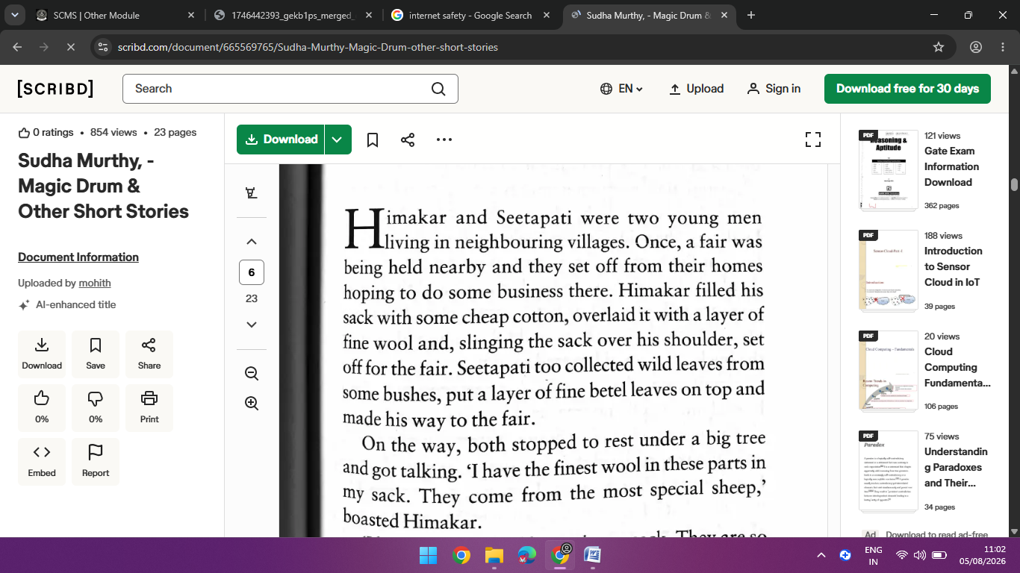

Output:

Activity 3: Is AI Creative?

We have learnt that AI can see, listen and speak. It can differentiate between what is important for the user and what is not, and provide useful information. Students write a short story about a fair, festival, or local event and then ask an AI tool to generate a similar story. They compare both versions and observe the similarities and differences.
Suppose, you had to tell someone about your trip to a mela or celebration of a festival or visit to a place of historic or tourist interest. What will your story be about? Write the idea of your story in a single sentence below: ........................................................................................................................... ...........................................................................................................................
Write about everything that made the visit special for you. Describe what you saw (e.g., colours, interesting things to eat, shops with exciting games), what you heard (e.g., music, games, laughter), about the food and drink you had, and how you felt (e.g., excitement, heat, or wind).
........................................................................................................................... ........................................................................................................................... ...........................................................................................................................

Prompts and AI Responses
A prompt is a detailed instruction given to an AI system. Better prompts usually produce better results. Students learn how to improve prompts by adding more specific details.

Now give the prompt to AI, and mention about the story that is generated.

………………………………………………………………………………………………………………………………………………………………………………………………………………………………………………………………………………………………………………………………………………………………………………………………………………………………………………………………………..

Preparing the AI Assistant

Classification Tree
Example:
Food → Snacks, Drinks, Sweets
Plants → Trees, Flowers, Crops
Animals → Birds, Insects, Domestic Animals
Places → Parks, Markets, Historical Buildings

Data Collection
Students collect clear photographs from different angles, backgrounds, sizes, and lighting conditions. At least 12–15 images should be collected for each category.

Sample Data Table
Category: Food
Sub-category: Local snacks
Type of data: Images
Source: Market, home, restaurant
Images collected: 20
Rejected images: 5

Activity 5: Teaching the Machine
Students create folders for each category and upload the images to Teachable Machine. Each category is given a clear label, such as Plant_Mango or Place_Park.

Training the Model
Steps:
1. Open Teachable Machine.
2. Create a Standard Image Model.
3. Upload categorised images.
4. Label each category.
5. Click “Train Model”.

Testing and Improvement
Students test the model using new images or a webcam. If the model makes mistakes, they add more training images and retrain the system.

Making the Assistant Interactive
Using Scratch AI or MIT AI Raise Playground, students can add a character, voice, questions, and simple animations to make the assistant more engaging.

Experimental Results
Example results:
Food recognition: 90%
Plant recognition: 85%
Animal recognition: 80%
Tourist place recognition: 88%
These values may vary depending on the quality and quantity of data collected.

Discussion of Results
The experiment shows that better image quality and a larger variety of examples improve the accuracy of the AI model. Incorrect predictions usually occur when the training data is insufficient.

Advantages of the Project
• Encourages observation of the local environment.
• Develops digital literacy.
• Introduces basic machine learning concepts.
• Promotes teamwork and problem solving.
• Connects computer science with real-life situations.

Limitations
The model depends heavily on the quality of the collected data. Poor lighting, blurry images, or too few examples can reduce accuracy.

Future Improvements
Future versions could include audio recognition, local language support, maps, emergency contacts, weather information, and voice-based interaction.

Flowchart of the Project
Identify the problem → Create categories → Collect data → Organise folders → Train model → Test model → Improve model → Share AI Assistant

Real-World Careers Related to This Project
Data Scientist
Machine Learning Engineer
Software Developer
Robotics Engineer
AI Research Assistant
Computer Vision Specialist

Learning Outcomes
After completing this project, students will be able to explain basic AI concepts, collect and organise digital data, train a simple image-recognition model, test and improve an AI system, and create an interactive AI Assistant for their locality.

Conclusion
This thesis demonstrates that Artificial Intelligence can be taught in a simple and practical way to Class 7 students. By building an AI Assistant for their locality, students learn important computer science skills such as data collection, classification, machine learning, testing, and digital communication. The project combines creativity with technology and helps students understand how AI can be used responsibly to solve real-world problems.

Bibliography
1. Kaushal Bodh – Grade 7, AI Assistant Project.
2. Google Teachable Machine Documentation.
3. MIT AI Raise Playground Resources.
4. Educational resources on Artificial Intelligence and Machine Learning for school students.

Suggested Viva Questions
1. What is Artificial Intelligence?
2. What is Machine Learning?
3. Why is data important for AI?
4. What is a prompt?
5. How does Teachable Machine help students?
6. What happens if the AI model makes mistakes?
7. Why should we collect images from different angles?
8. Can AI feel emotions like humans? Explain.
9. Name two real-life applications of AI.
10. What did you learn from this project?

