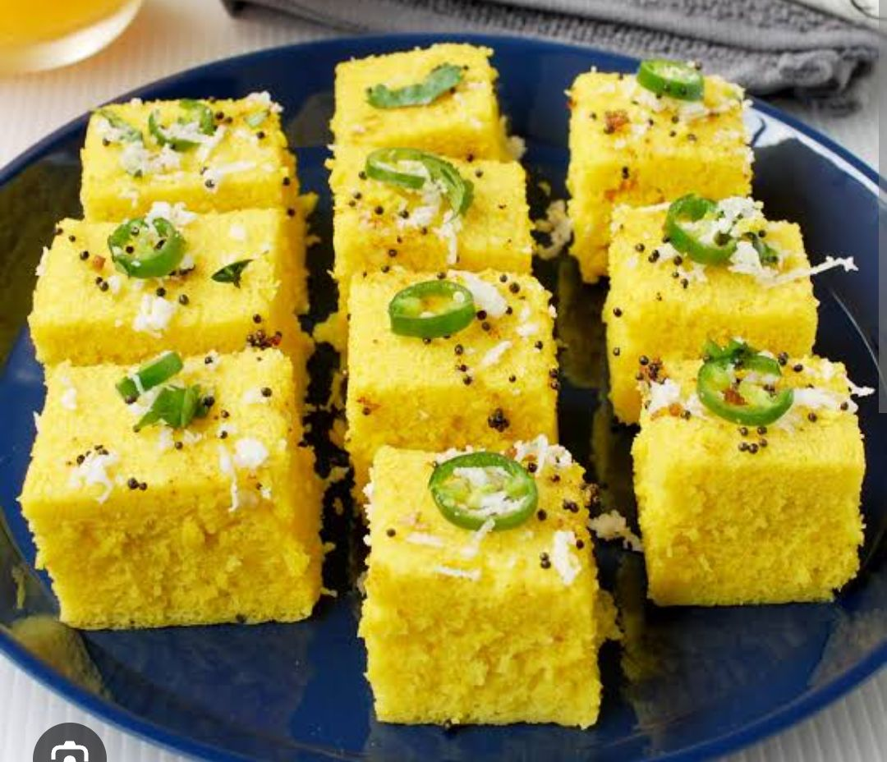
- Look at the following photographs and choose the state they depict.

2.

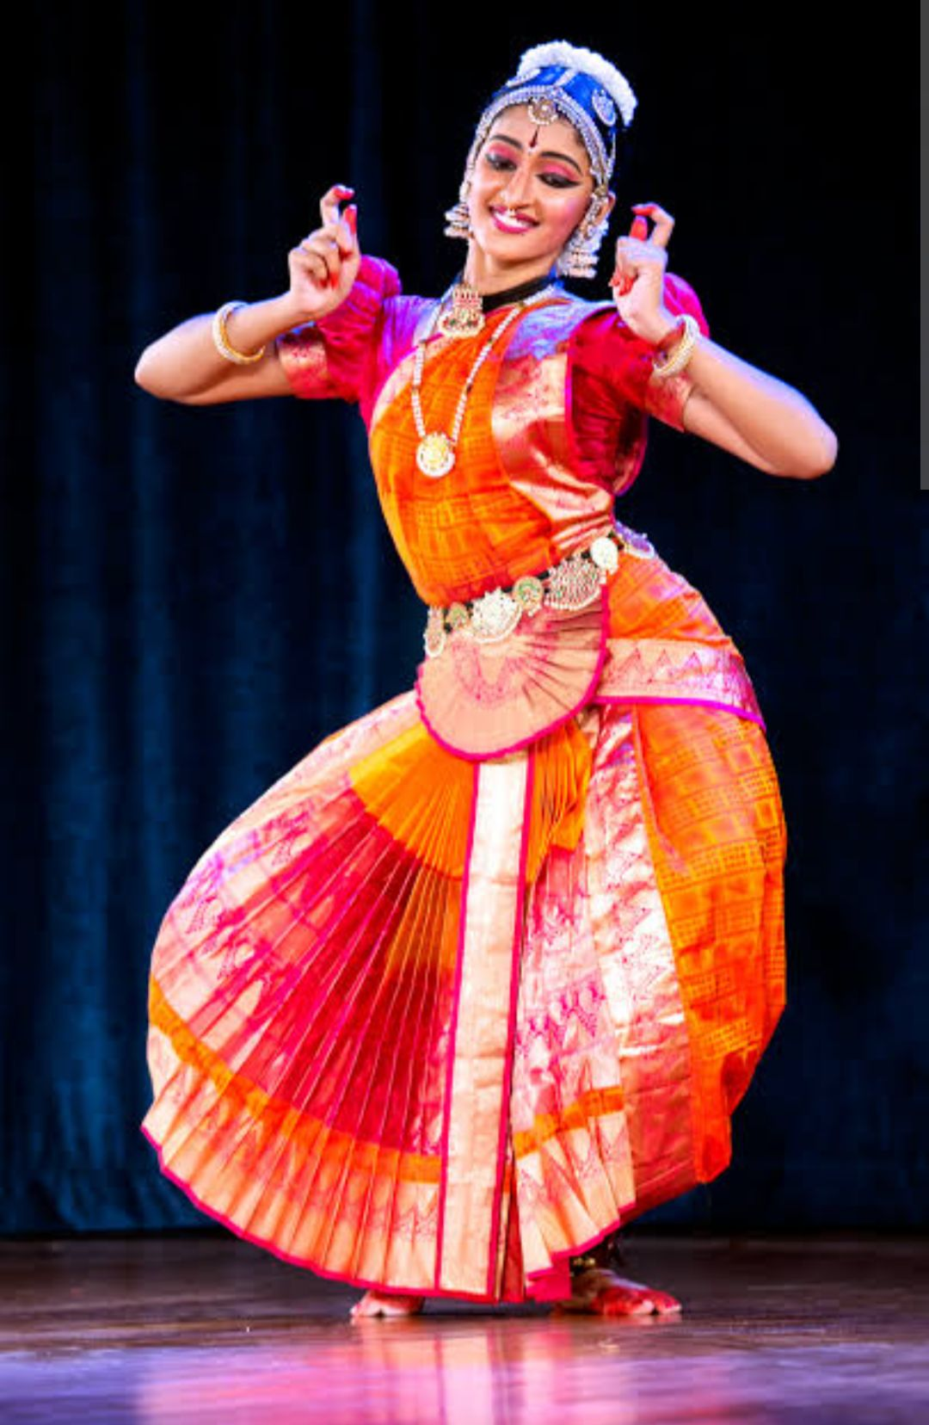
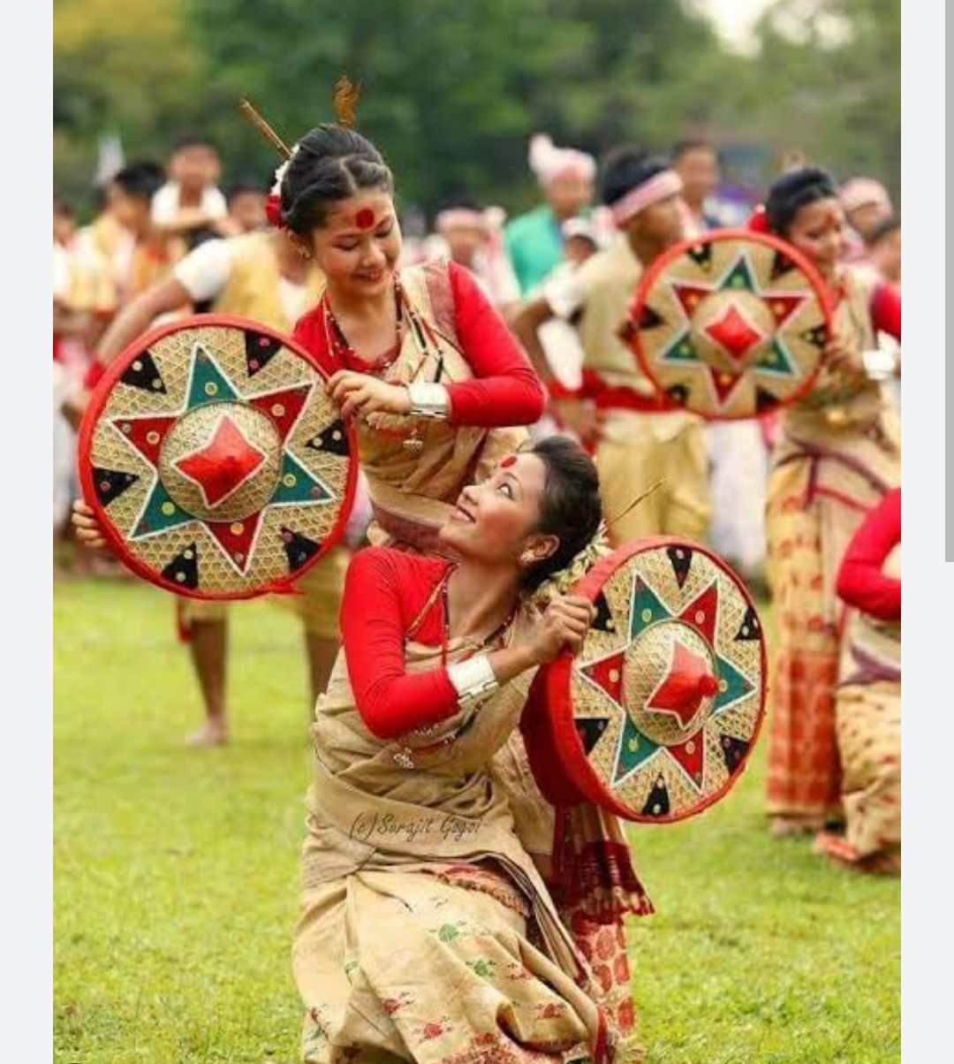
3

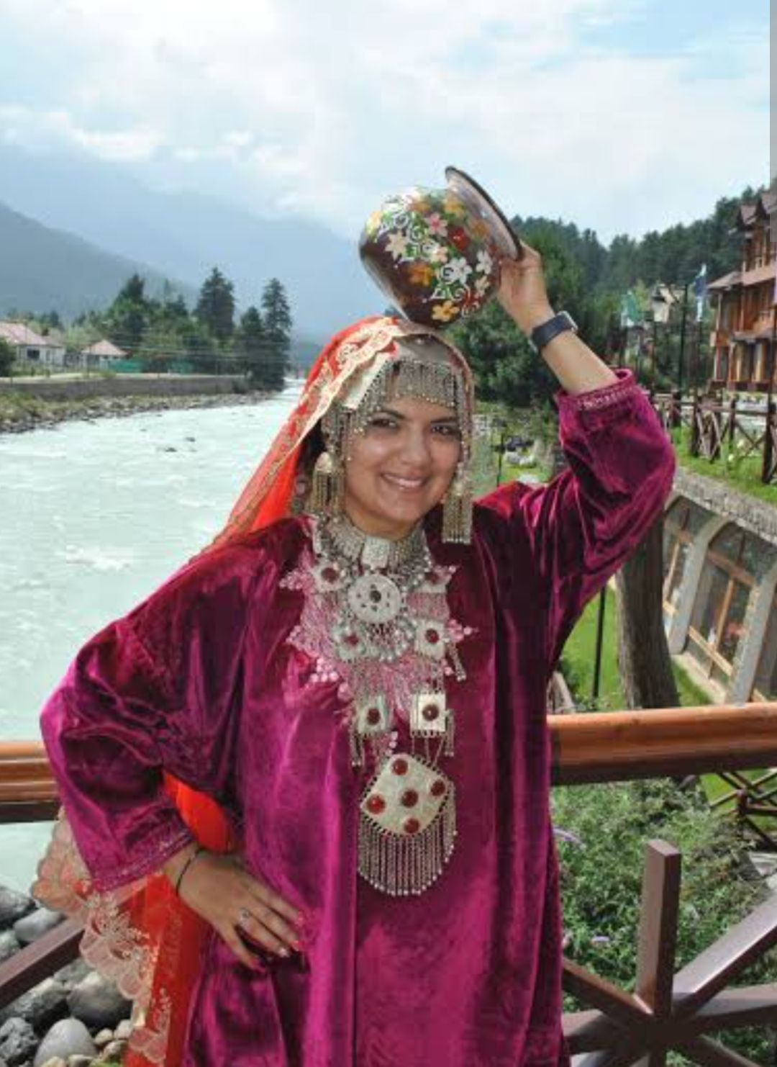
4.

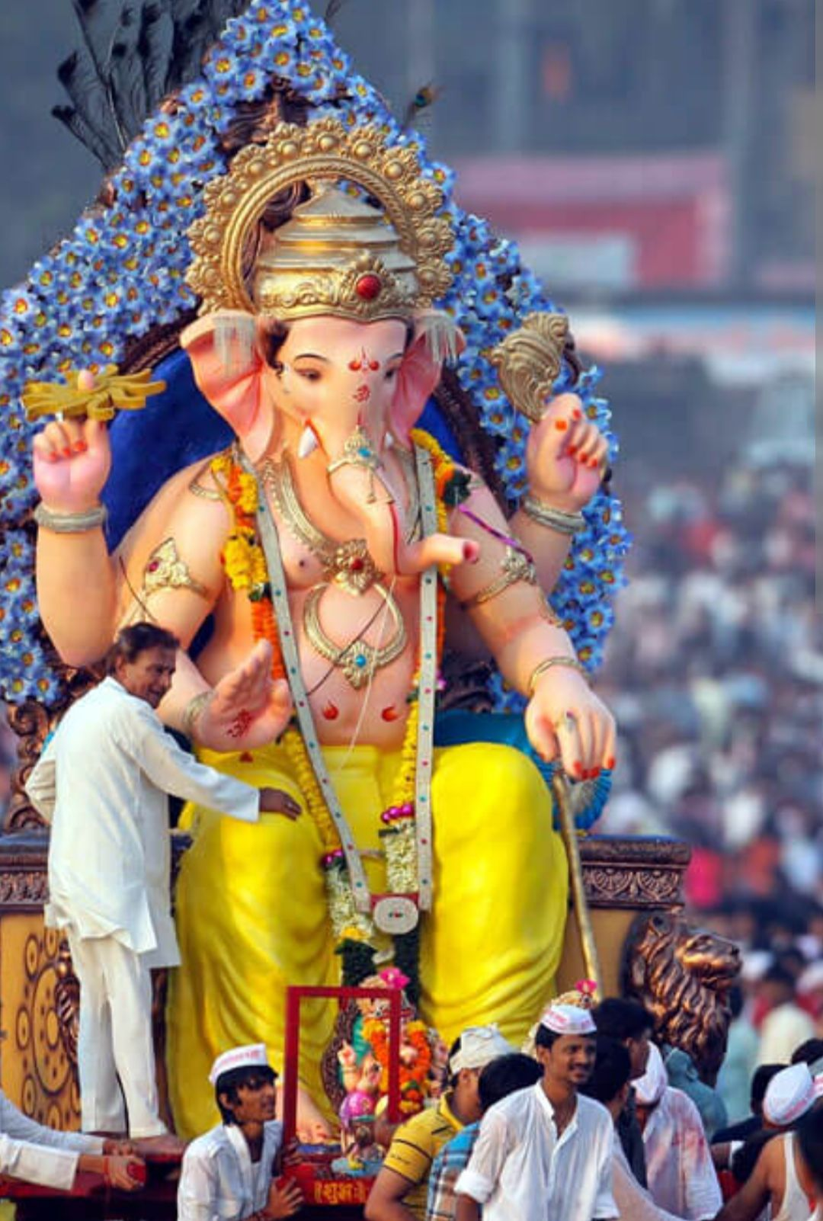
5.

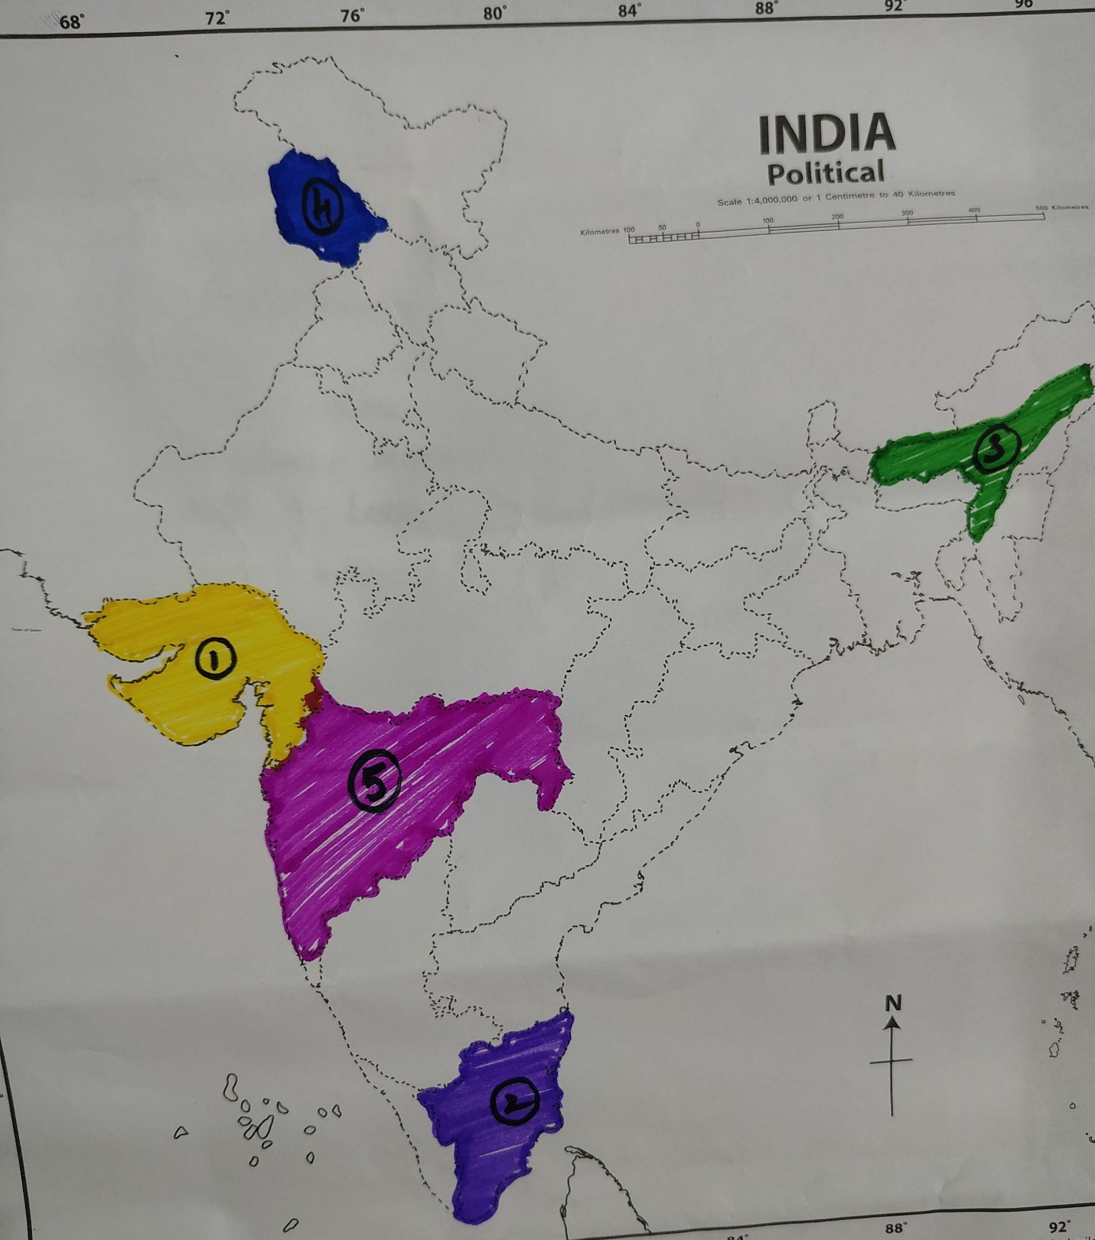

Diversity in India

NORTH INDIA
FOOD – Chole Bhature , Butter Chicken , Roti and Naan
DANCE – Kathak And Bhangra
FESTIVAL – Diwali , Holi ️

SOUTH INDIA
FOOD – Idli, Dosa , Sambar
DANCE – Bharatnatyam , Kathakali
FESTIVAL – Onam , Pongal

EAST INDIA
FOOD- Rosogolla , Fish , Rice
DANCE – Odissi , Chhau
FESTIVAL – Durga Puja and Chhathpuja

WEST INDIA
FOOD – Vada Pav , Dhokla , PavBhaji
DANCE – Garba or Lavani
FESTIVAL – Ganesh Chaturthi , Navaratri

NORTH EAST INDIA
FOOD – Momo, Thukpa
DANCE – Bihu , Cheraw
FESTIVAL – Bihu , Hornbil Festival .

“ UNITY IN DIVERSITY IN INDIA “

