CLASS TEST
THE AGE OF REORGANIZATION
FULL MARKS =10
MCQs. (1×4 =4)
1. Identify the statement that does not describe a feature of the Kushana Empire.
(a) Spread of Buddhism
(b) Greco-Roman influence on art
(c) Introduction of the decimal system
(d) Control over the Silk Road
2. Assertion (A): Pushyamitra Shunga established friendly diplomatic relations with the Kushanas.
Reason (R): The Shunga rulers succeeded the Mauryas and ruled over parts of northern and central India.
3. Statement I: The Ashvamedha Yajna was performed by kings to demonstrate their political power and sovereignty.
Statement II: The Ashvamedha Yajna was a Buddhist ritual performed in monasteries.
Statement III: The Satavahanas and the Shakas are known to have performed the Ashvamedha Yajna to expand their kingdoms.
Read the above statements and choose the correct option:.
(a) Statements I and II are correct.
(b) Statements II and III are correct.
(c) Statements I and III are correct.
(d) Statements I, II and III are correct.

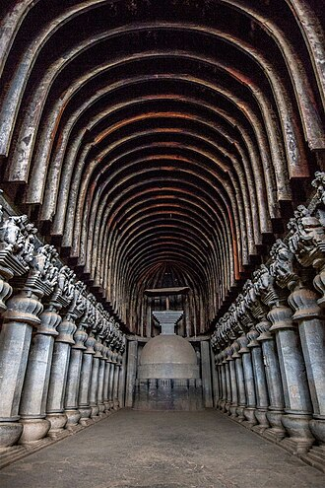
4. The monument shown in the picture is an important example of Buddhist rock-cut architecture. Which of the following features of this monument best reflects the contribution of the Satavahanas during their reign?
A. It was built as a royal palace for the Satavahana kings.
B. It contains magnificent pillars and a stone replica of a stupa carved out of a rocky hillside.
C. It was constructed as a military fort to protect trade routes.
D. It was used as the capital city of the Satavahana kingdom.

SUBJECTIVE BASED QUESTIONS ( 3×2=3)
5. Ancient Indian rulers promoted trade as well as art and culture to strengthen their kingdoms. Explain the contribution of the Sātavāhanas to trade and cultural development. (1.5+ 1.5 = 3)
6. Differentiate between the Gandhara and Mathura styles of art by comparing their important features (3)

