EVS class test -7 FM:10
(Surprise)
Date- 7/8/26
Assertion -Reason (6x1=6)
1. Assertion (A): Sparrows have short, hard beaks.
Reason (R): They mainly eat seeds and grains.
- Both A and R are true, and R is the correct
explanation of A.
- Both A and R are true, but R is not the correct
explanation of A.
C. A is true, but R is false.
D. A is false, but R is true.
2. Assertion (A): Solar panels create smoke while
making electricity.
Reason (R): Solar panels do not burn any fuel.
- Both A and R are true, and R is the
correct explanation of A.
- Both A and R are true, but R is not the correct
explanation of A.
C. A is true, but R is false.
D. A is false, but R is true.
3. Assertion (A): Natural colours are used in many
traditional folk art forms.
Reason (R): These colours can be made from flowers, leaves,
soil, and other natural materials.
- Both A and R are true, and R is the correct
explanation of A.
- Both A and R are true, but R is not the correct
explanation of A.
C. A is true, but R is false.
D. A is false, but R is true.
4. Assertion (A): The pistil is the female part of a flower.
Reason (R): Sepals cover the flower bud before it opens.
- Both A and R are true, and R is the correct
explanation of A.
- Both A and R are true, but R is not the correct
explanation of A.
C. A is true, but R is false.
D. A is false, but R is true.
5. Assertion (A): All food chains start with plants.
Reason (R): Plants make their own food using sunlight.
- Both A and R are true, and R is the
correct explanation of A.
- Both A and R are true, but R is not the
correct explanation of A.
C. A is true, but R is false.
D. A is false, but R is true.
6. Assertion (A): Frogs are mammals.
Reason(R): Mammals have well developed brain.
- Both A and R are true, and R is the
correct explanation of A.
- Both A and R are true, but R is not the correct
explanation of A.
C. A is true, but R is false.
D. A is false, but R is true.
7.
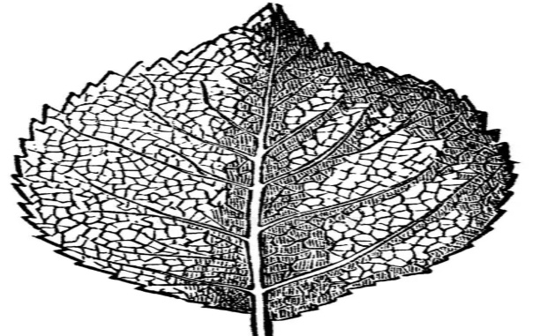
Observe the leaf and write two points.(2)
8. Draw an animal that you observed in your
School Biology lab and write it’s name.(2)

