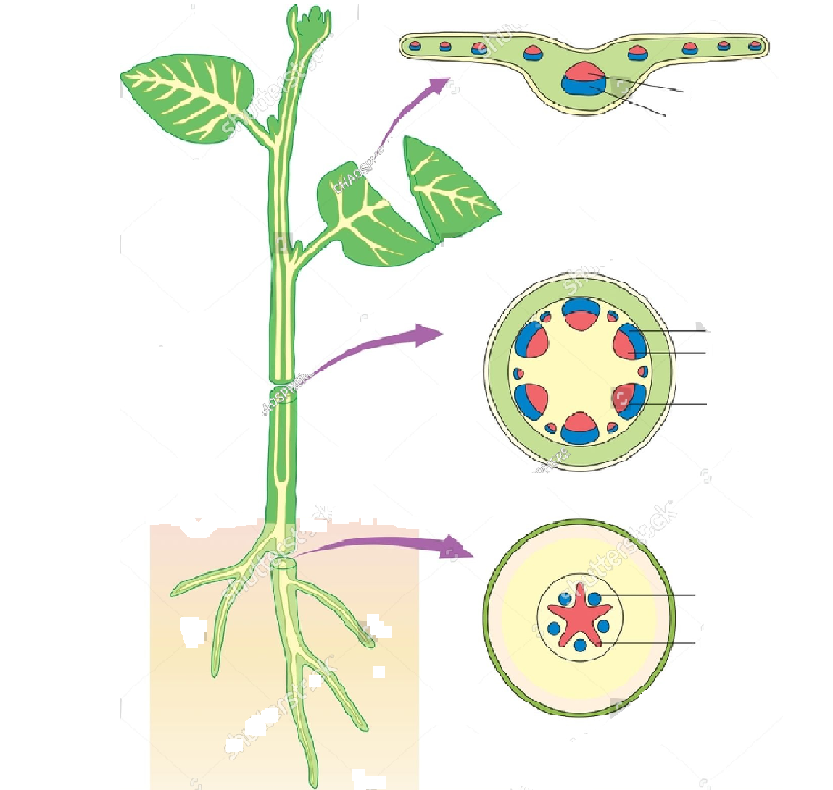
VASCULAR BUNDLE

FEATURES AND FUNCTIONS OF COMPLEX PERMANENT TISSUE
Complex permanent tissues are made up of more than one type of cell working together to perform a common function. They are mainly found in plants and are responsible for the transport of water, minerals, and food.
XYLEM
Features:
- Made up of four types of cells: tracheids, vessels, xylem parenchyma and xylem fibres.
- Mostly consists of dead cells, except xylem parenchyma.
- Forms a continuous network from roots to leaves.
Functions:
- Transports water and minerals from roots to other parts of the plant.
- Provides mechanical support to the plant.
PHLOLEM
Features:
Made up of four types of cells: sieve tubes, companion cells, phloem parenchyma and phloem fibres.
Mostly consists of living cells, except phloem fibres.
Transports food through the plant.
Functions:
- Transports food (mainly sugars) from leaves to other parts of the plant.
- Helps distribute food to growing and storage regions.
______________

