COMPUTATIONAL THINKING
Question 1
A person walks 5m towards the east and walks 10m after taking a left and then he takes a right and walks 3m and then he takes a right and walks 20m and finally he takes a right and walks 3m. What is the direction of the person with respect to his starting point ?
A south B southeast C northeast D east
Question 2
A person walks 5m towards the south and walks 5m after taking a left and then he takes a right and walks 5m and he again takes a left and walks 5m and finally, he takes a left and walks 10m. In which direction is the person with respect to the starting position?
A north B south C west Direction Sense D east
Question 3
A person started walking from his home towards his office. He started towards his east and walked 9 metres. He then took right and walked for another 12 metres and reached his office. In which direction is he facing now and what is the shortest distance between his home and his office?
A 15 metres, North B 12 metres, South C 14 metres, West D 15 metres, South
Question 4
There are 8 houses in a line and in each house only one boy lives with the conditions as given below:
- Jack is not the neighbour Siman.
- Harry is just next to the left of Larry.
- There is at least one to the left of Larry.
- Paul lives in one of the two houses in the middle.
- Mike lives in between Paul and Larry.
If at least one lives to the right of Robert and Harry is not between Taud and Larry, then which one of the following statement is not correct ?
A Robert is not at the left end.
B Robert is in between Simon and Taud.
C Taud is in between Paul and Jack.
D There are three persons to the right of Paul.
Question 5
A, B, C, D and E are sitting on a bench. A is sitting next to B, C is sitting next to D, D is not sitting with E who is on the left end of the bench. C is on the second position from the right. A is to the right of B and E. A and C are sitting together. In which position A is sitting ?
A Between B and D B Between B and C
C Between E and D D Between C and E
Question 6
Introducing a boy, a girl said, "He is the son of the daughter of the father of my uncle." How is the boy related to the girl?
A Brother B Nephew C Uncle D Son-in-law
Question 7
If D is the brother of B, how B is related to C? To answer this question which of the statements is/are necessary?
- The son of D is the grandson of C.
- B is the sister of D.
A Only 1 B Only 2 C Either 1 or 2 D 1 and 2 both are required
Question 8
If A + B means A is the brother of B; A x B means A is the son of B; and A % B means B is the daughter of A then which of the following means M is the maternal uncle of N?
A M + O x N B M % O x N + P C M + O % N D None of these
Question 9
Which diagram shows the best relation among Readers, Writers, and Poets?
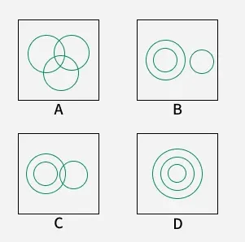

Question 10
In the following figure, the triangle represents teachers, the square represents musicians, and the circle represents athletes. Which part of the diagram represents the teachers who are musicians but not athletes?
