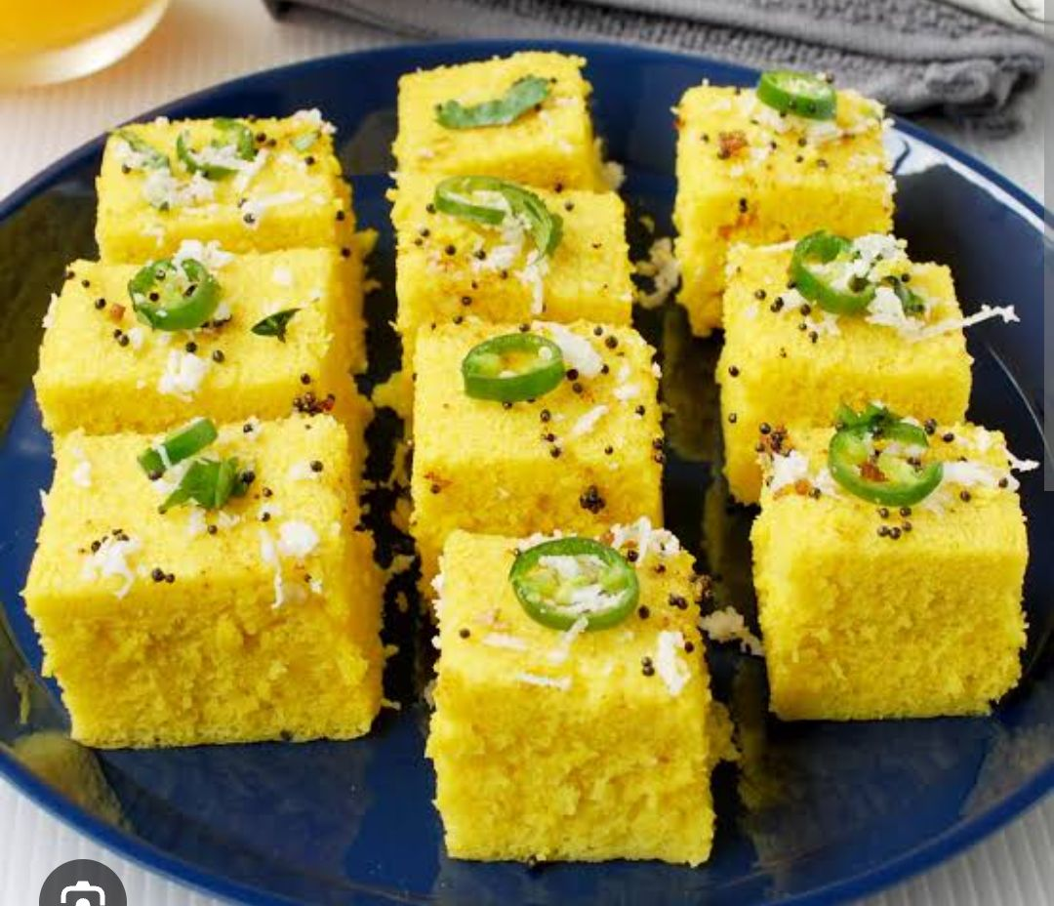
- Look at the following photographs and choose the state they depict.

2.

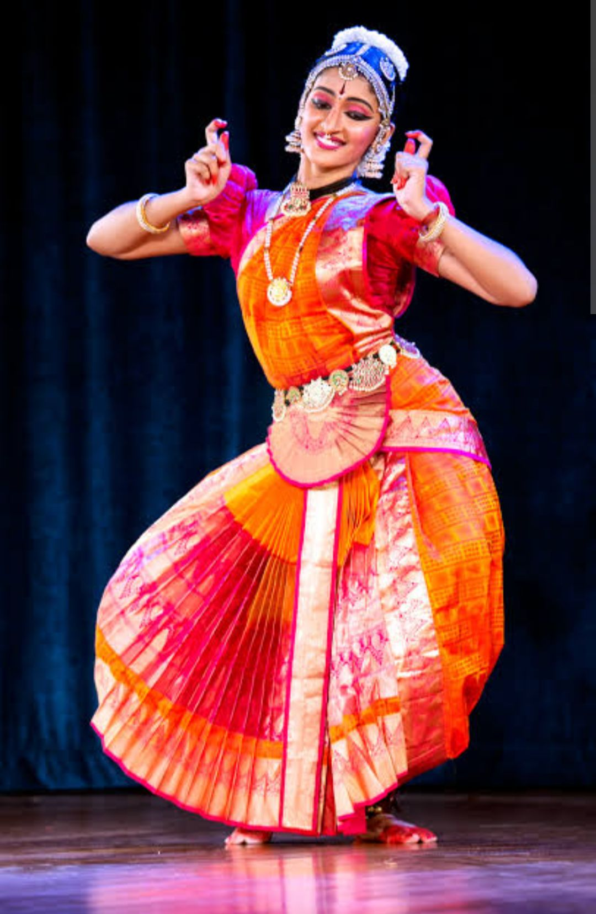
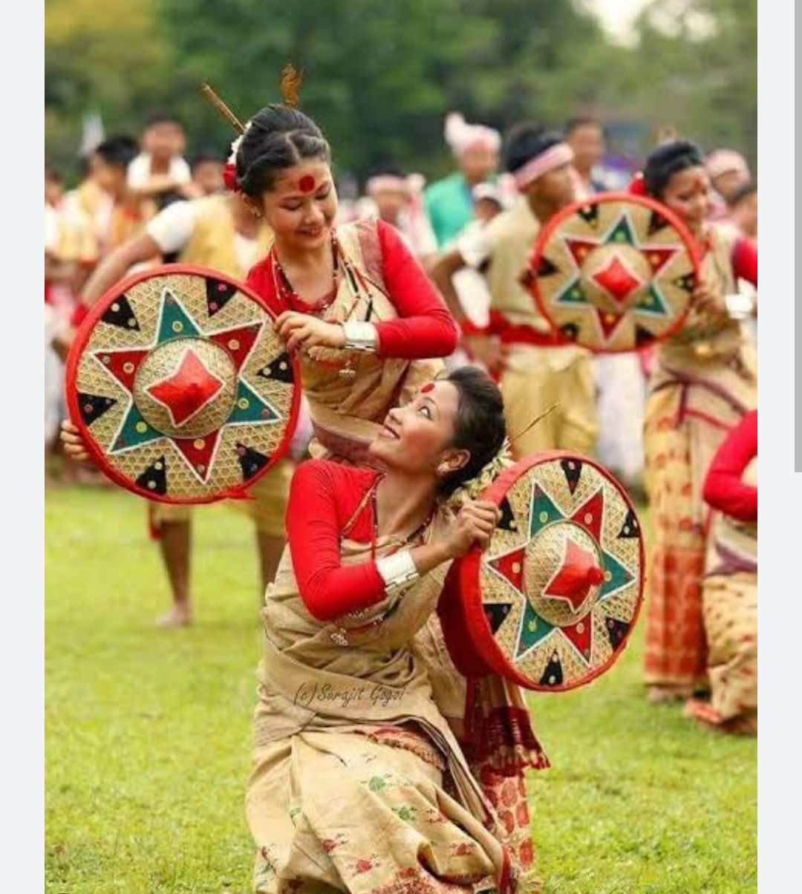
3

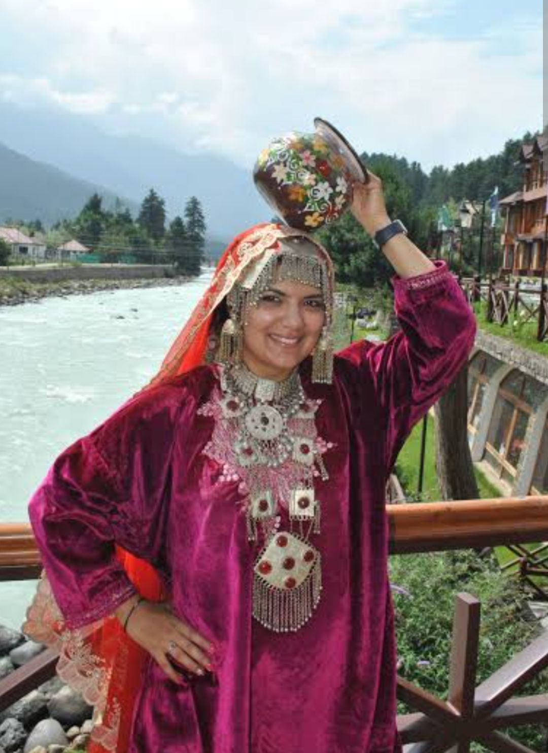
4.

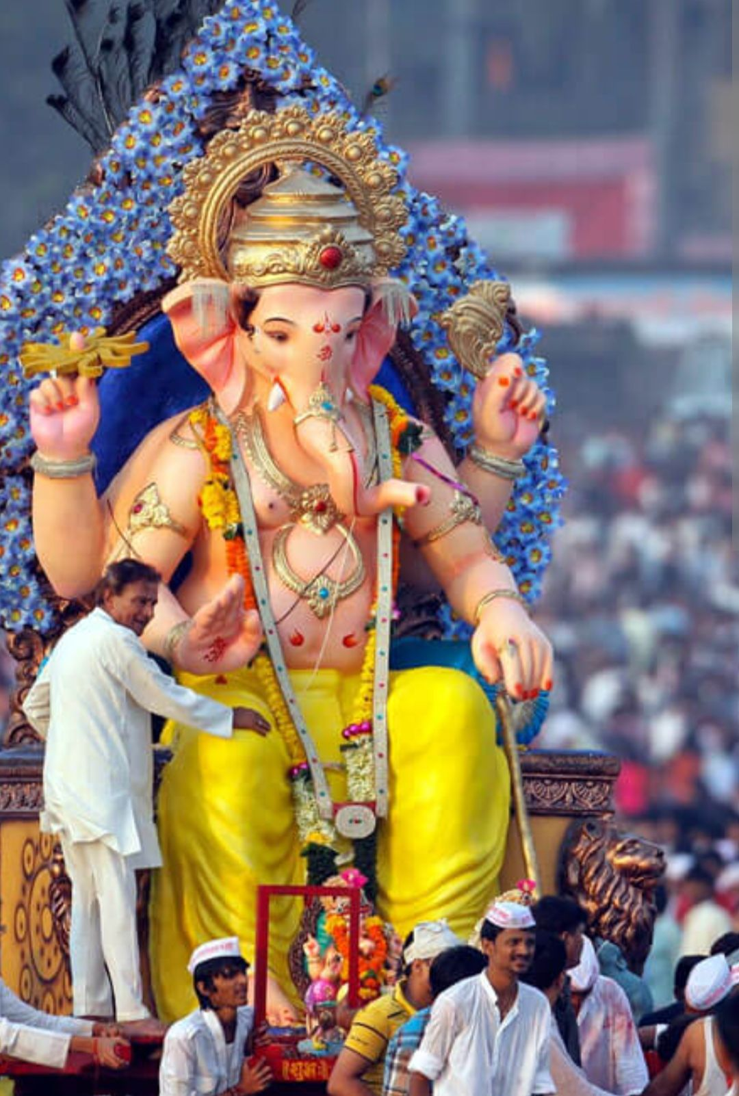
5.

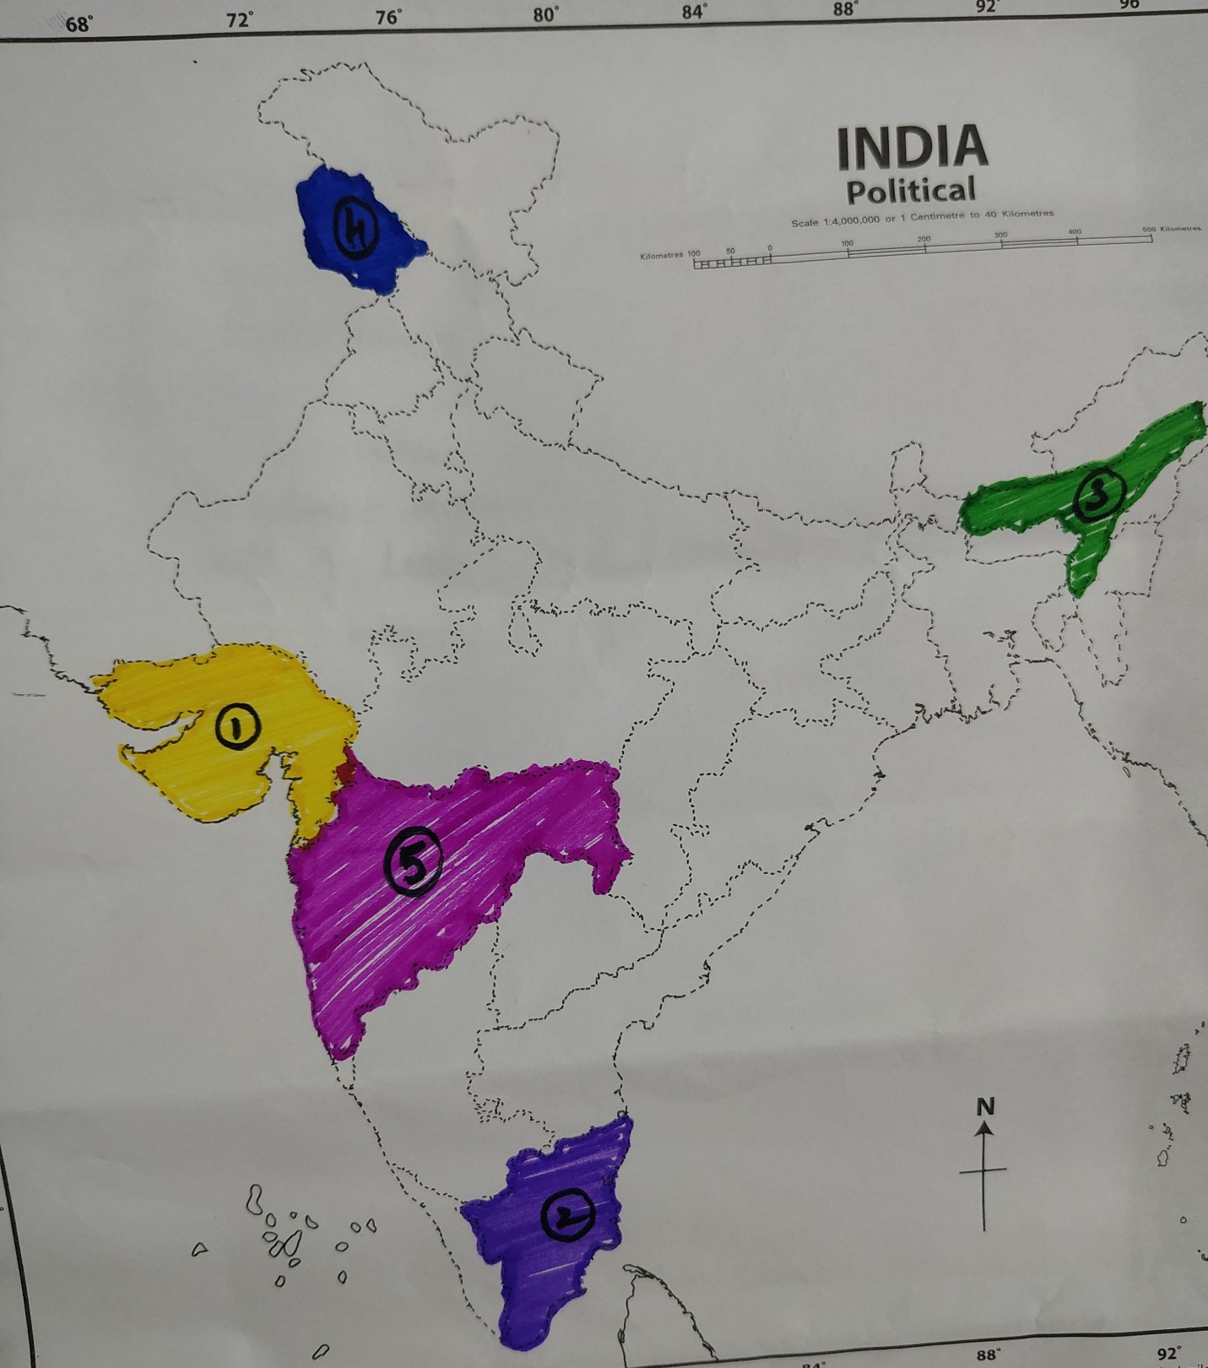

Diversity in India

NORTH INDIA
FOOD – Chole Bhature , Butter Chicken , Roti and Naan
DANCE – Kathak And Bhangra
FESTIVAL – Diwali , Holi ️

SOUTH INDIA
FOOD – Idli, Dosa , Sambar
DANCE – Bharatnatyam , Kathakali
FESTIVAL – Onam , Pongal

EAST INDIA
FOOD- Rosogolla , Fish , Rice
DANCE – Odissi , Chhau
FESTIVAL – Durga Puja and Chhathpuja

WEST INDIA
FOOD – Vada Pav , Dhokla , PavBhaji
DANCE – Garba or Lavani
FESTIVAL – Ganesh Chaturthi , Navaratri

NORTH EAST INDIA
FOOD – Momo, Thukpa
DANCE – Bihu , Cheraw
FESTIVAL – Bihu , Hornbil Festival .

Answer the following questions.
- Aman’s family is travelling from West Bengal to Kerala. They notice that the food, language, clothes and festivals are different.Why is India called a country with “unity in diversity”?
Answer : India is called a country of “unity in diversity” because people have different languages, foods, clothes and festivals, but they live together peacefully as one nation.
- Tourist visits a famous historical monument and wants to write about its importance.Write about importance of protecting India’s historical and cultural heritage?
Answer: Protecting India’s historical and cultural heritage is important because:
- It preserves our history and traditions for future generations.
- It helps us understand and respect our rich culture.

- What does India’s secularism teach us about respecting people of different religions?
Ans by Students.

- Identify the instruments
a) It is played by blowing air through it and has holes to change the sound.
b) Name the Indian musical instrument that is commonly played with two sticks and has two heads.

MAP POINTING
Different Dance Forms in India
- Chhau – West Bengal
- Bihu- Assam
- Bharatanatyam – Tamil Nadu
- Kathakali – Kerala
- Manipuri – Manipur
- Ghoomar – Rajasthan
- Kathak – Uttar Pradesh
- Cheraw – Mizoram
- Lavani – Maharashtra
- Garba – Gujarat

