SATISH CHANDRA MEMORIAL SCHOOL
HALF YEARLY/MID TERM EXAMINATION (2026-27)
CLASS - III
MATHEMATICS

Time allowed: 3 Hrs Maximum Marks: 80
GENERAL INSTRUCTIONS

General Instructions:
- This Question Paper has 5 Sections A, B, C, D and E.
- Section A has 20 MCQs carrying 1 mark each
- Section B has 5 questions carrying 02 marks each.
- Section C has 6 questions carrying 03 marks each.
- Section D has 4 questions carrying 05 marks each.
- Section E has 3 case based integrated units of assessment (04 marks each) with sub- parts of the values of 1, 1 and 2 marks each respectively.
- All Questions are compulsory.
- Draw neat figures wherever required.
- Use of calculator is not permitted.

SECTION – A [1 X 20 = 20]
[Q1-Q20] MCQ TYPE QUESTIONS: CHOOSE THE CORRECT OPTION: -

- Which number when divided by 14 gives a quotient of 6 ?
(a) 88 | (b) 70
(c) 84 | (d) 120

- Find the missing number .
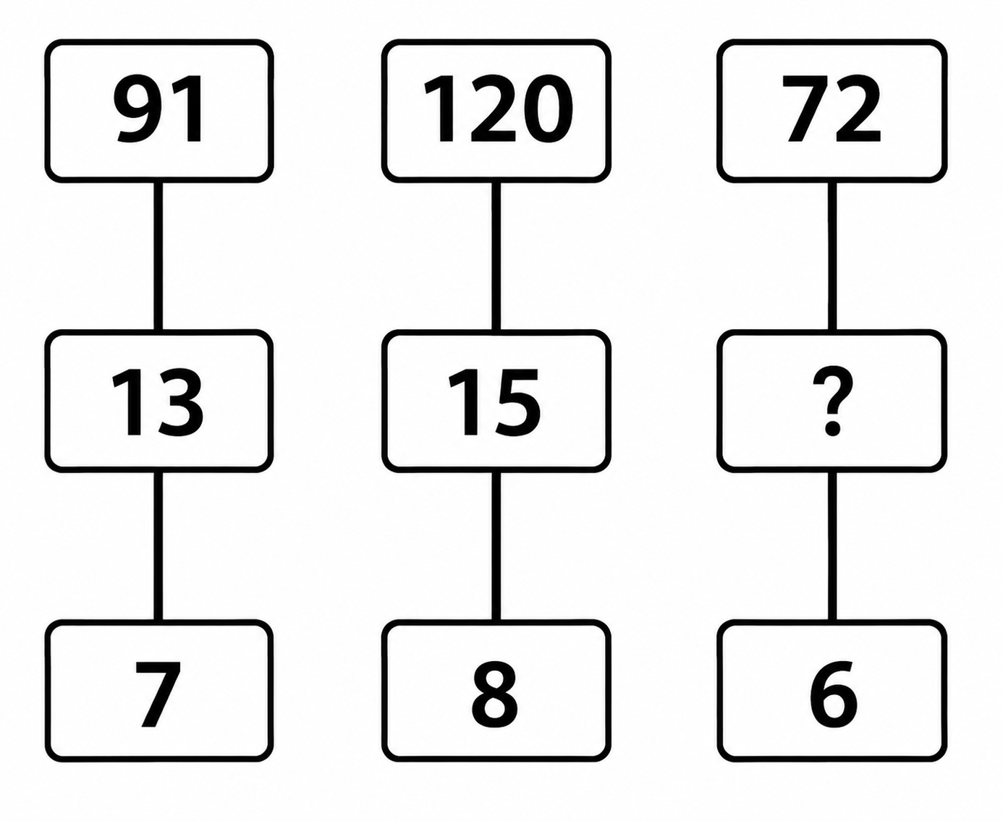
(a) 12 | (b) 6
(c) 9 | (d) 14

- Shreya is 5 times of Riya's age. If Riya is 16 years old, how old is Shreya ?
(a) 98 years | (b) 55 years
(c) 80 years | (d) 13 years

- Find the missing number: ? − 1284 = 2752
(a) 3847 | (b) 4036
(c) 4786 | (d) 2870

- Form a 4-digit number using the digits 6, 9, 1, 5. Place the largest digit in the tens place, the smallest
digit in the thousands place and the second largest digit in the ones place. Find the number .
(a) 1596 | (b) 1965
(c) 6915 | (d) 5697

- Find the mirror image .
QUESTION FIGURE ANSWER FIGURES
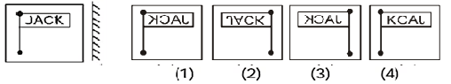
(a) Answer Figure 3 | (b) Answer Figure 4
(c) Answer Figure 2 | (d) Answer Figure 1

- I am a polygon with 8 sides. What am I ?
(a) Octagon | (b) Heptagon
(c) Square | (d) Decagon

- A shop had 6529 toys. It sold 3416 toys. How many toys are left in the shop ?
(a) 5642 | (b) 1745
(c) 3113 | (d) 3004

- Complete the series: 4 : 64 :: 8 : ?
(a) 512 | (b) 247
(c) 548 | (d) 304

- Paw : Cat :: Hoof : ?
(a) Dog | (b) Horse
(c) Frog | (d) Hen

- Which of the following shows 4 × 9 written as repeated addition ?

- 4+4+4+4+4+4+4+4 | (b) 4+4+9+9
(c) 9+9+9+9 | (d) 9 x 4

- Find the sum of the number 5073 and its reverse .

(a) 9874 | (b) 7845
(c) 6845 | (d) 8778

- WHITE : ZKLWH :: BLACK : ?

(a) EODFN | (b) CLCDK
(c) CMBDL | (d) EPDEN

- Find the mirror image .
QUESTION FIGURE ANSWER FIGURES
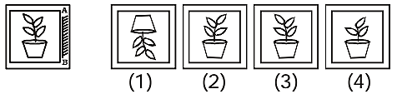
(a) Answer Figure 2 | (b) Answer Figure 3
(c) Answer Figure 1 | (d) Answer Figure 4

- One bus can carry 105 passengers. How many passengers can 5 buses carry ?

(a) 580 | (b) 672
(c) 525 | (d) 987

- Find the missing number .

11 | 9 | 7
7 | 2 | 8
3 | 8 | 3
54 | 88 | ?

(a) 106 | (b) 60
(c) 94 | (d) 45

- There are 96 pencils to be distributed equally among 6 children. How many pencils will each child get ?
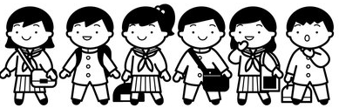
(a) 17 | (b) 24
(c) 36 | (d) 16

- A _______ extends to both sides and has no end point .
(a) Straight line | (b) Line segment
(c) Point | (d) Polygon

- Assertion (A ) : 275 ÷ 0 = 0
Reason (R) : No number can be divided by 0.
- Both A and R are true and R  is correct explanation of A. | (b) Both A and R are true and  R is not correct explanation of A.
(c) Assertion is false but Reason  is true. | (d) Assertion is true but  Reason is false.

- Assertion (A ) : Cube is a 3 D shape.
Reason (R) : A Cube has 6 faces, 12 edges and 8 vertices.

- Both A and R are true and R  is correct explanation of A. | (b) Both A and R are true and R  is not correct explanation of A.
( c ) Assertion is false but Reason  is true. | (d) Assertion is true but  Reason is false.

SECTION – B (2 ×5 = 10)
[Q21 – Q25] SHORT QUESTIONS

- Find the Dividend :
Divisor - 9 Quotient - 25 Remainder – 7
- Draw a line segment of length 10 cm.
- Find the difference between the greatest and the smallest 4-digit numbers formed by the
given digits - 6, 2 , 5, 0
- Draw a 2D shape that has 3 sides and 3 corners. Write one example of this shape.
- Write any 2 multiplication facts of 40.

SECTION – C
[Q26 – Q31] LONG QUESTIONS ( 3 x 6 = 18)
- Find the value of a, b, c : (3)

7 b 9
- 4 5 a
c 3 3

- Simplify : 76 + 45 ÷ 5 - 12 x 6 (3)
- Write all the possible 3- digit numbers that can be formed by using 7 , 4, 9 without
repeating any digit . (3)
- There are 42 chairs in a classroom . How many chairs would be there in 17 such
classrooms ? (3)
- I have 6 rectangular faces , 8 vertices , and 12 edges . Draw the shape and write one
example of this shape . (3)

- (a) Find the total alphabetical value of the word “ PENCIL” . (2)
(b) Write 2 division facts of 6 × 8 = 48 . (1)

SECTION – D
[Q32 – Q35] LONG QUESTIONS ( 5 x 4 =20]
- (a) A toy shop has 254 toy cars. The shopkeeper buys 21 more toy cars. He packs all the toy cars
equally into 5 boxes. How many toy cars are there in total ? How many toy cars are
packed in each box ? (3)
(b) Divide using the Repeated subtraction method : 32 ÷ 8 (2)

- (a) Complete the table : ( Copy the table ) (3)
SHAPES | FACES | EDGES | VERTICES
Sphere | 1 | ? | 0
? | 2 | 1 | 1
Cylinder | 3 | 2 | ?

(b) Find the quotient and remainder : 756 ÷ 8 (2)

- (a) Find the missing number: (Copy the table ) (4)
16 | × | 5 | = | ?
+ |  |  |  | +
4 | × | ? | = | 40
= |  |  |  | =
? | + | 100 | = | ?

(b) A truck has 8 wheels . How many wheels are there in 13 trucks ? (1)

- A room has different types of floor tiles such as square, circle, triangle and hexagon .
Answer the following questions based on the information given :
(a) Which of these are polygon ? (1)
(b) Which shape has greatest number of sides ? How many sides does it have ? (2)
(c) Draw a hexagon . (2)

SECTION – E (4 x 3 = 12)
[ Q36 – Q38] CASE STUDY BASED QUESTIONS ( 1+1+2)
- Answer the following questions based on the information given below :

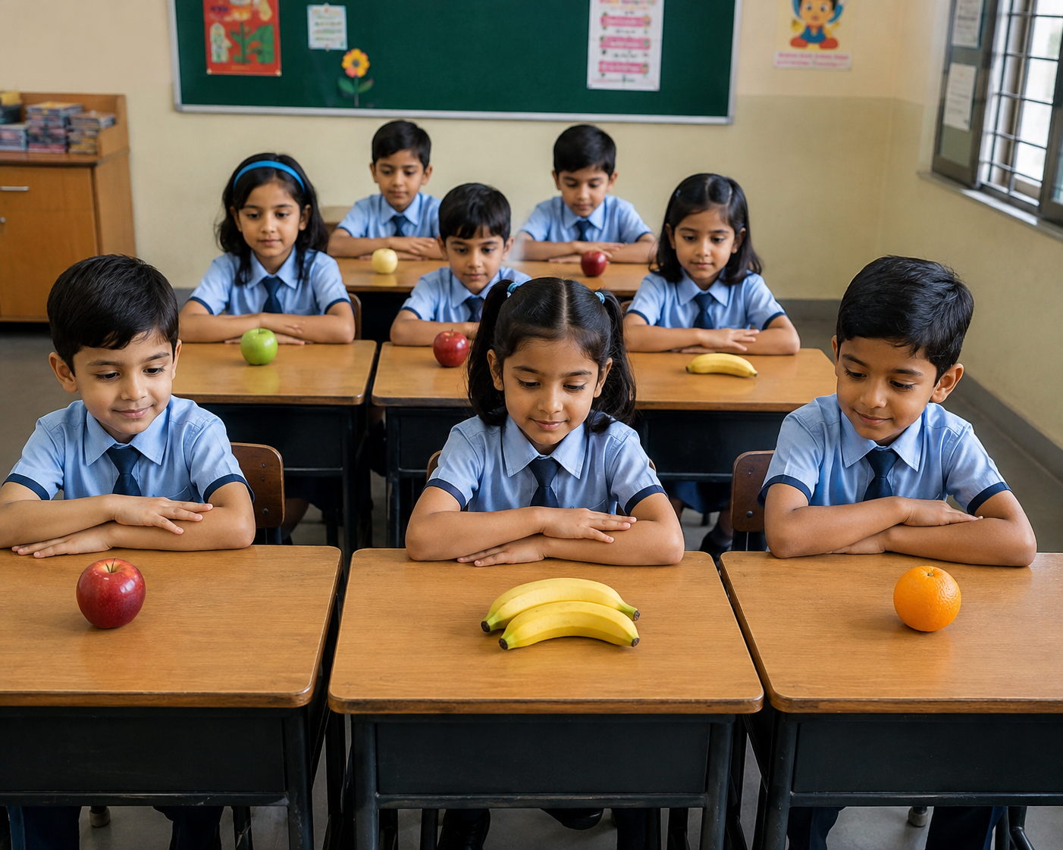
Every Friday , the students bring healthy fruits to the school . The teacher counted the fruits
brought by different groups.
Group | Red | Green | Blue | Yellow | Purple
No. of fruits | 148 | 176 | 205 | 189 | 250

- Which group brought the maximum number of fruits ?
- Find the difference between the number of fruits brought by the Blue and Green group.
- If a teacher wants to make 5 equal fruit baskets using the fruits from the Blue group , how
many fruits will be in each basket ?

- Answer the following questions based on the information given below :

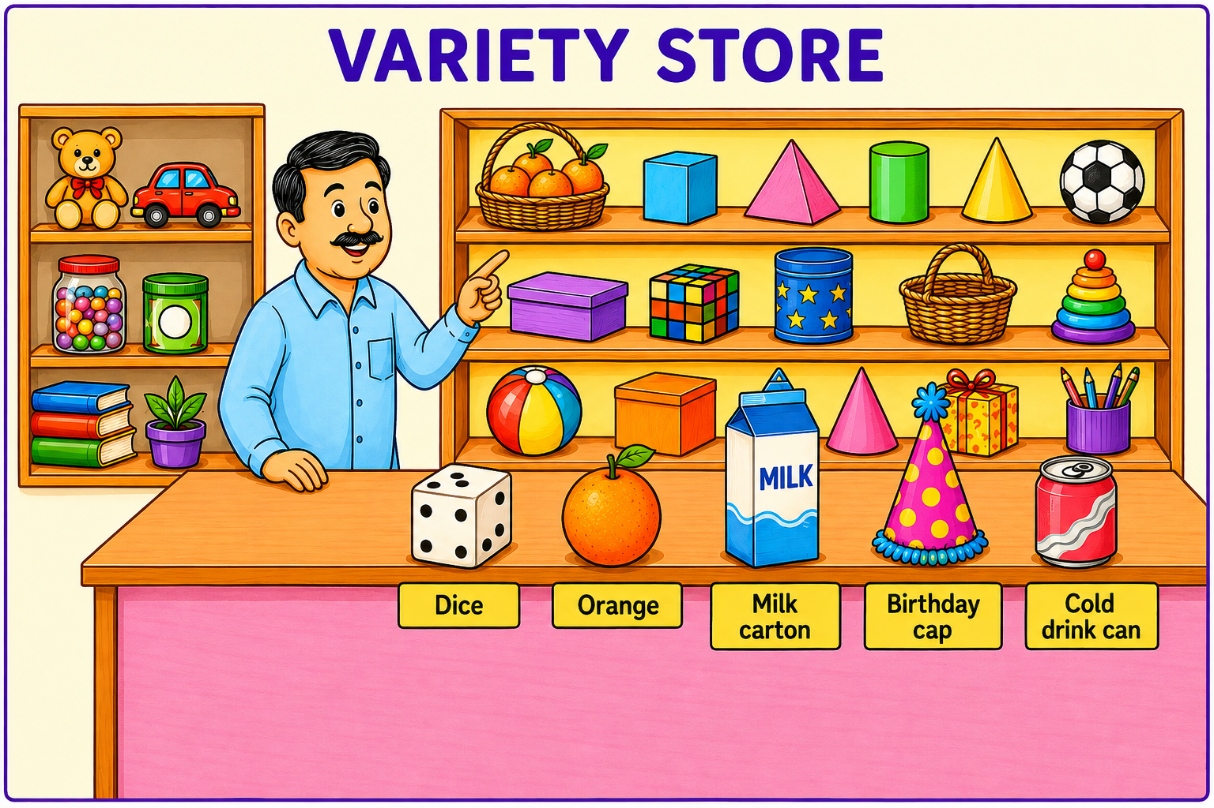

- Name 2 objects that can roll .
- Write the name of one object from the above picture that is shaped like a cube .
c) A cold drink can costs ₹ 46 . Find the cost of 9 such cans .

- Answer the following questions based on the information given below :
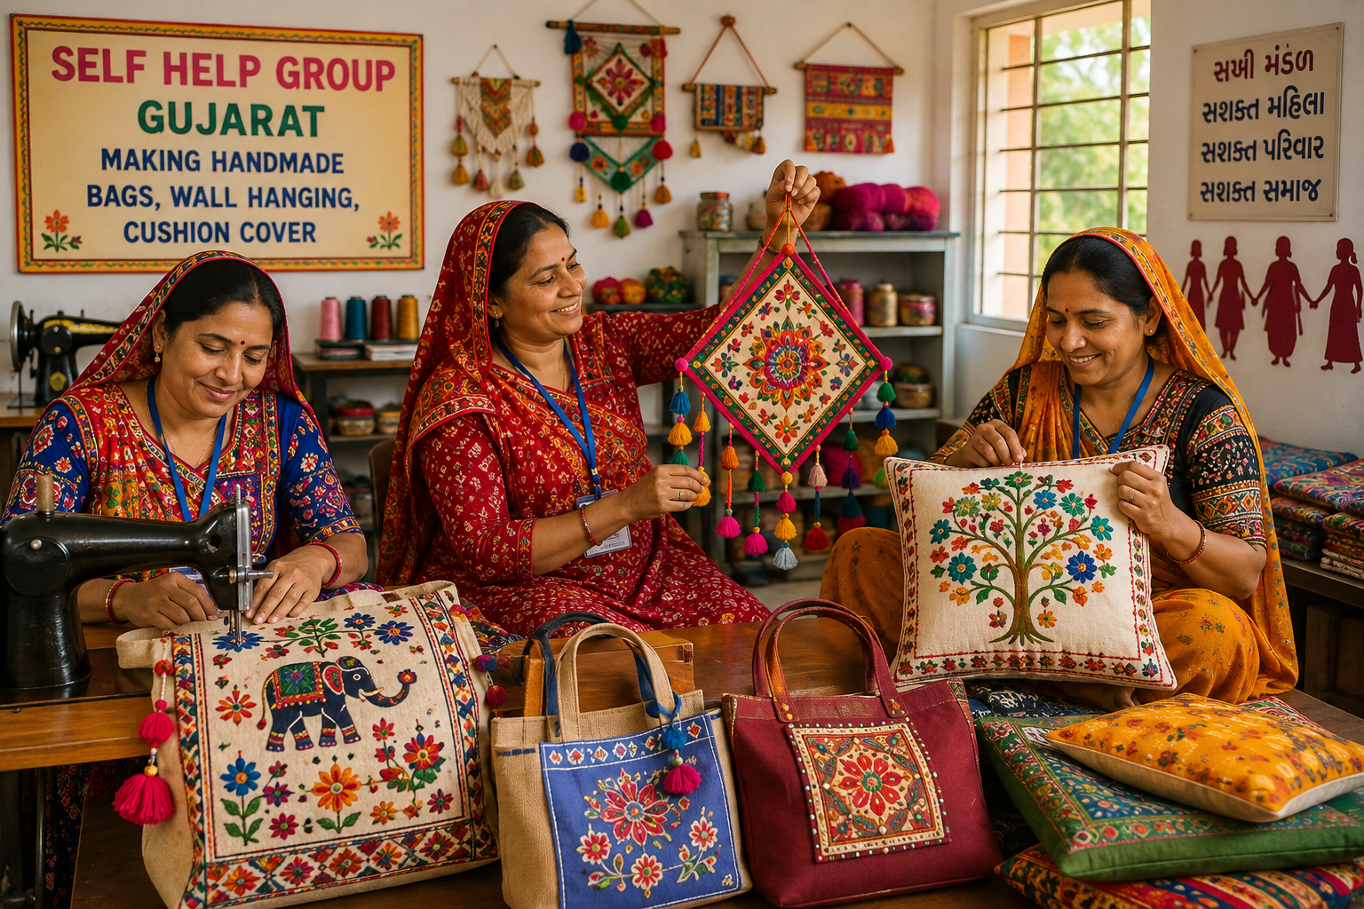
In a village in Kutch , women run self - help groups. They make colourful handmade
bags , wall hangings , cushion covers and sell them in the local market . The price of each
item is listed below :
Bag | Wall hanging | Cushion cover
₹ 125 | ₹ 70 | ₹ 35

- If they make 26 bags in one day , how many bags will they make in 1 week ?
- Find the difference between the cost of one bag and one cushion cover.
- Find the total cost of 1 bag and 7 wall hangings .

