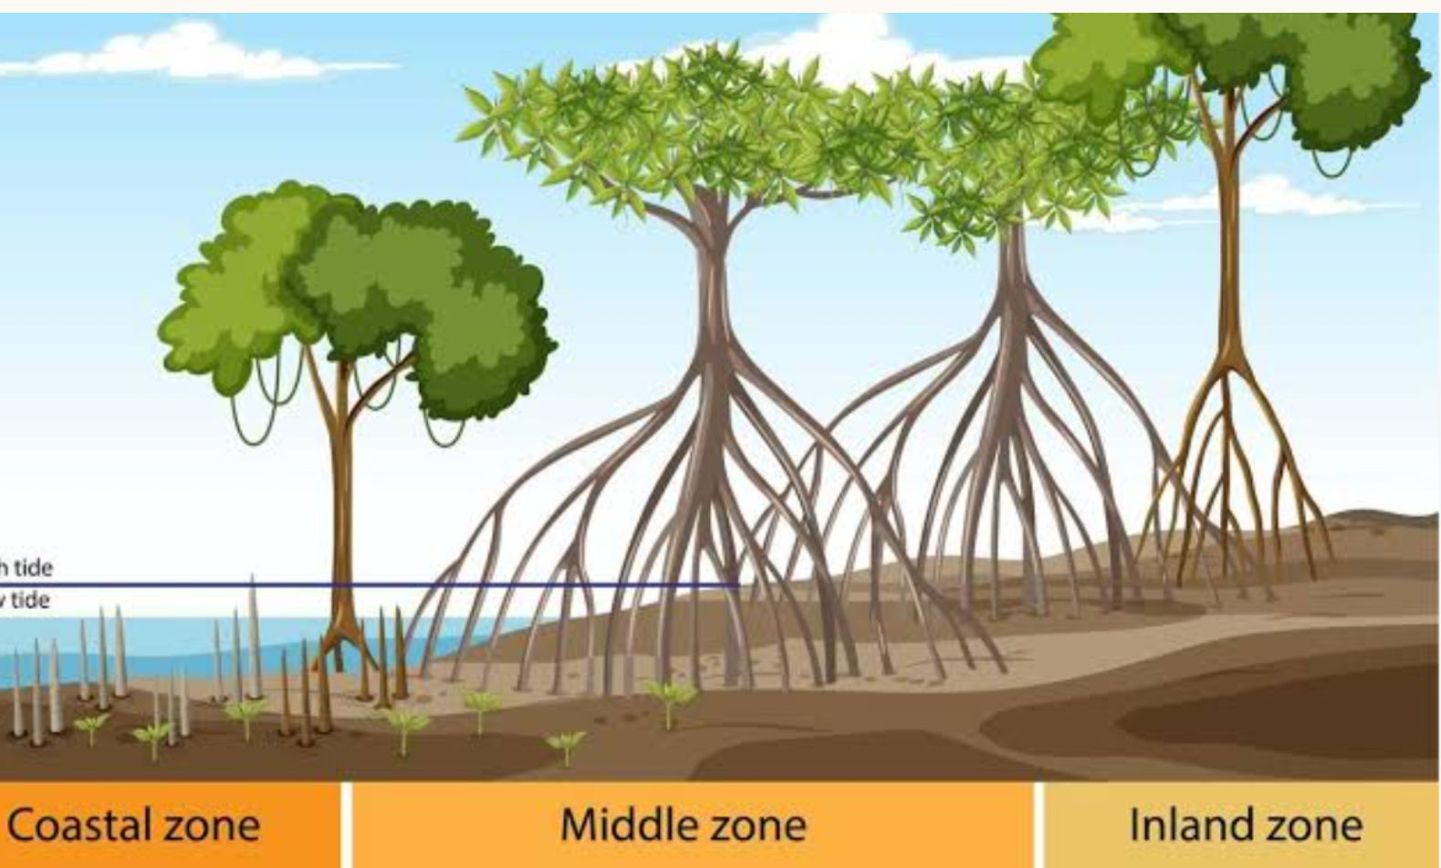
Notes :
Islands- An island is a land surrounded by water on all sides. There are over a thousand islands in the seas around India that are part of the country.
Coral reefs -Coral reefs are the colonies of tiny living creatures that are found in oceans. They are the underwater structures that are formed of coral polyps that are held together by calcium carbonate.

Answer the following questions
1.Describe the unique adaptation found in mangrove roots within the Sundarbans.
Ans: Mangrove roots grow vertically upwards out of the oxygen-poor, salty mud into the open air. These specialized roots, called pneumatophores, feature tiny pores that allow the tree to breathe in oxygen directly from the atmosphere.
Q2. Distinguish between India's two southernmost landmarks: Indira Point and Kanyakumari.
Ans: Indira Point is located on the Nicobar Islands and represents the absolute southernmost point of the entire Indian territory. Kanyakumari is located at the tip of Tamil Nadu and represents the southernmost point of the Indian mainland.
Q3. Explain how a living root bridge is constructed in Meghalaya.
Ans: Members of the Khasi and Jaintia tribes guide the flexible, living roots of rubber trees across rushing rivers using hollow bamboo structures. Over many decades, these roots grow across the water, take root on the opposite bank, and thicken into exceptionally strong, living pedestrian bridges.
Q4. In what ways do people in Sundarbans depend on the mangrove forests?
Ans by own
Q5. Outline the ecological importance of the Western Ghats.
Ans: The Western Ghats act as a vital global biodiversity hotspot containing an immense variety of plants and animals. This mountain range blocks monsoon winds to bring rain to peninsular India and shelters endangered species like the Lion-tailed Macaque.
Q6. Detail the successful conservation effort surrounding the Hargila bird.
Ans: Local communities in Assam transformed their traditional views from treating the Hargila stork as an unwanted pest into viewing it as a pride of their village. Local women formed conservation groups to actively protect nesting trees, effectively saving the species from local extinction.
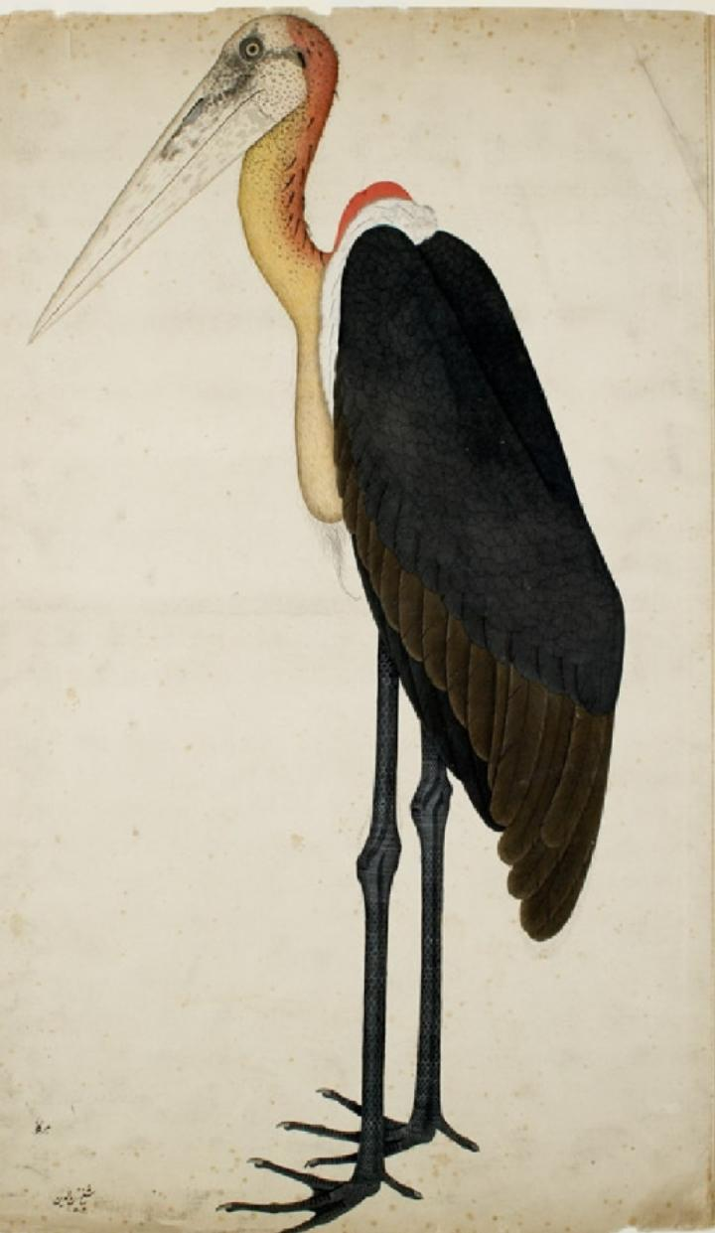
Draw and colour

